***Project Title - ‘A Modern ‘Business Inventory and Management System for Small Businesses to manage and avoid potential disasters’.***



***Project Report***

**School of Science & Technology**

**Hamza Bari M00668318**

**Software Development Project**

**Supervisor – Ralph Moseley**

**Module No - CST3990**

***Contents***

***Abstract*** 4

***Chapter 1: Background & Literature Review*** 5

**Introduction** 5

**Introducing the Problem** 5

**Solution to the problem** 5

**Introducing the papers** 7

**Pen & Paper** 7

**Microsoft Excel** 7

**Inflow Cloud** 8

**QuickBooks** 12

**Info Cloud vs QuickBooks** 14

**Other Existing Software** 15

***Chapter 2: Requirements Analysis & Design*** 16

**Purpose of the project** 16

**Target Audience** 16

**Project Scope** 16

**Software Architectural Sketch** 17

**User Requirements** 18

**User Requirement List** 18

**Wireframes/GUI Mock-Ups** 21

**Registration & Login** 21

**Main Menu** 22

**Help Guide** 24

**Suppliers** 25

**Orders** 28

**Orders List** 30

**Onsite (Shop)** 32

**Warehouses** 36

**Employees** 41

**Business/Disaster Recovery** 45

**Finance** 49

**Jobs** 53

**ERD for the Database** 47

**UML Case Diagram** 49

**UML Sequence Diagram** 50

**Navigation Design** 51

**Backup Design Architecture** 52

***Chapter 3: Implementation & Testing*** 53

**Implementation** 53

**Tools & Technologies used in duration of the implementation** 53

***Starting of the program*** 59

***Intuitive User Interface*** 60

***User Authentication*** 61

***Main Menu*** 63

***Suppliers*** 65

***Orders*** 68

***QR Code Scan*** 71

***Onsite*** 79

***Orders History*** 84

***Warehouses*** 86

***Employees*** 92

***Jobs*** 97

***Help Guide*** 99

***Disaster Recovery*** 100

***Finance*** 105

***Backup Application*** 117

**Testing** 122

**Issues related to testing** 127

***Chapter 4: Evaluation*** 128

**Evaluating Project** 133

**Evaluating Requirements** 134

**User Evaluation** 134

**Evaluating Implementation Process** 135

***Chapter 5: Conclusion*** 137

**Project Overview Summary** 137

**Recommended Improvements for future developments** 138

**Final Opinion** 140

***Appendix*** 141

**Appendix 3 – Test Plan** 141

**Appendix 4 - Unit Testing** 147

**Finance Controller Test Class.** 148

**Order-History Controller Test Class.** 151

**Essex-Warehouse Controller Test Class.** 153

**View-Employees Controller Test Class.** 154

**User-Authentication Controller Test Class.** 155

**Supplier Controller Test Class.** 156

**Appendix 5 – User Testing Questionnaire & Results** 157

***References*** 161

# ***Abstract***

In this project a business inventory management system and disaster recovery software prototype desktop application are being developed for small businesses who are struggling to manage their business epically during crisis. In this project, different functionalities and techniques have been implemented which are used for managing small businesses and helping them in recovering from disasters. A detailed background research and a literature review has been included in chapter 1 which shows the existing applications in the area of business inventory management systems and disaster recovery’s, and the features used in them. The process of the software development has been documented in chapter 4, 5, 6, and 7. The results produced have been reviewed in a great detail during the testing and evaluation phases.

During world crisis small business owners have been worried in terms of what will happen if their business gets affected such as natural disasters, power cut, fire, data loss etc. These things can result in businesses being bankrupt. This application will support small business owners to manage their business during the disasters and support them, to keep the business continuity going. Small businesses will be supported in their areas of suppliers, orders, products, employees, finance, business plans, jobs, invoices, and backing up their whole data via the software application. Whenever a crisis occurs, for example there might be a power cut on the location which may result in shutting down the machines, which can lead to data loss. In order to look after the business data an automatic backup system will backup data regularly and send it over to the FTP-Server which will have the most updated version of the data that can be recovered quickly. This will support business owners to manage and keep their businesses safe during the crisis time.

# ***Chapter 1: Background & Literature Review***

## **Introduction**

### **Introducing the Problem**

Over the past few months during this Covid-19 pandemic starting from 21st March 2020, there has been a lot of close research on small businesses which includes small grocery stores on your local high streets for: departments e.g., a pound shop (Poundland), grocer e.g., a shop which sells food and household items, greengrocer e.g., a shop which sells vegetables and fruits, bakeries, and chemists etc. After the completion of the research, a critical analysis is done on how business can have a negative impact due to the following **situations/disasters: poor business plan, bad stock management, unforeseen events, financial hurdles, and owners facing issues e.g., health issues**. These negative impacts and disasters have caused major issues to small businesses which includes the following: **business bankrupting, businesses facing a huge loss, bad reputation to business in terms of their customers, serious damage to all their products, and bad reputation to business in terms of their suppliers which may further affect their future business relations**.

### **Solution to the problem**

An idea has been proposed of a **‘A Modern Business Inventory and Management System for Small Businesses to manage and avoid potential disasters’** software architecture system, which will support businesses in managing their stocks/products/inventories data, suppliers data, orders given to the suppliers data, locations e.g., warehouses and shop location management, money/finance management to track their profit/loss, balance, and cash/flow, sales, expenses, and businesses budget, and based on those figures the software automatically generates reports which can be viewed and printed out, and in addition to that those documents can be review to for analysing and making important business decisions it terms of making changes, employees data can be viewed in terms of their job and salary, and developing new job positions. This will improve business management as everything is organised. The QR codes will be used for scanning product details to automatically load up data onto the system e.g., input fields, and also users can just type the name of the employee, product, supplier, or the order to search, which will display the results on the screen, this way it makes things quicker within a business and saves time therefore, the business management team can concentrate on other areas, such as how to increase their sales, which results in an increased profits, rather than focusing on these small issues for almost nothing.

In addition to that, avoiding potential disasters by making their own business and disaster recovery plans as digital documents and videos are provided within the software, which makes it more affective the reason being, when this software system is used on a day to day basis, the management team can constantly review their plans and update instantly when required to do so, and by keeping updated there are better chances for the management team to understand what they need to do as well as how they need to do it. Finally a solution to backup data regularly is, that the database is connected to a content management system where all the business data is stored and, the CMS is connected to an FTP-Server which will backup data automatically and regularly onto the separate servers. Those servers will be located in a variety of different locations, which will avoid disasters, for example, if one server is damaged then, the other will still be active. This way the business data is secured and backup up, which makes it very unlikely that, they will lose their data completely. The software system will be secured as it contains access rights, which stops users from editing, accessing private data therefore, the chances are very less for the business data being leaked, such as an employee whistle-blowing. In addition to that, it will include a user authentication login system therefore, no random person can access the application because there might be cases where your machine might be stolen but, your application cannot be accessed by a third-party member, which keeps your business data certainly secured.

The software system will also have the following features: help guide within the software to support users about what this software is about, and how it will be used which is especially supportive for the people who are non-IT related or have less knowledge in the area of technology. In addition to that, the software system will have a non-trivial intuitive graphical user interface therefore, it becomes easier for users to understand and use the application without any issues.

### **Introducing the papers**

This software system will be analysed and designed by reviewing the top existing software’s and its benefits. It will be used for comparing and contrasting the different features and picking up areas which will be useful for this project, that resolves business issues. This is what is going to be discussed throughout this background and literature review papers.

**The following methods and existing technologies the businesses are currently using:**

## **Pen & Paper**

Even today in the 21st century businesses are still using the pen and paper method to manage their stocks and finance. *“Today,*[*Lightspeed*](https://t.yesware.com/tt/6bdec90b3f90d2e5e82e39ef20ed872f380edada/d8216032ba4ae589df2bd55375d6c1f6/e130d2639357a268e3642926d9697a51/www.lightspeedhq.co.uk/)*and*[*SaveTheHighStreet.org*](https://savethehighstreet.org/)*reveal that more than a third of UK independent businesses are still using pen and paper to manage vital parts of their businesses such as managing inventory and ordering stock. Of the 2,000 businesses surveyed from the SaveTheHighStreet.org database, only 15 per cent indicate they had an EPOS system installed to help them run day-to-day operations.” [1]*. There are many problems regarding this method such as: there are high chances of mistakes the reason being, as there is a lot of heavy workload on the owners as, a result that can cause a lack of concentration in the records, data is not secured as, a paper can get stolen, ruined, or misplaced, *“It’s easy to run out of space on a sheet of paper or reach the last page in a notebook, and once that happens, it can be difficult to keep all of the relevant information together.” [2]*, and finally *“Another issue with tracking inventory on paper is the lack of easy backups. Your business lives in your records, and while paper is convenient, it can also be affected by spilled coffee or other office mishaps. You can scan or take photos of your orders and product lists, but that time spent creating backups could otherwise have been spent managing your business.” [ibid]*.

## **Microsoft Excel**

The businesses also use Microsoft Excel Software to build an Inventory system to manage their stocks, accounting and finance, HR, and payrolls, and finally organisation and management. As, MS Excel provides integrated tools, features, and formulas to make spreadsheets working dynamically and interactively therefore, its capable of managing a very small and basic Inventory management system only. The problem is that as, the business gets older the number of data and statistics increase each year meaning that businesses are going to come across many limitations for example, lack of control and security: *“When a data file is too large, it can make the Excel program run very slowly, especially if all the data is in one file. Trying to break the data down into smaller files can lead to some of it being lost or misplaced. Excel is not user-friendly, and the application rounds off very large numbers using imprecise calculations, which compromises accuracy.” [3]*this is the reason why it’s not recommended, unsuitable for backing up data: *“Data in spreadsheet systems is rarely kept in a single place - invariably they are in the hands of non-IT personnel, unfamiliar with storage and back-up best practices. If a major disaster strikes it can be very difficult, even impossible to make a full data recovery.” [ibid]*, MS Excel requires a bit of IT expertise knowledge **(To work on MS Excel you must know the formulas and features or you’re going to struggle)** which not everybody will have as a result, there are high risks of human errors which will affect the data that can cause major issues in future. Fraud: *“Fraudulent manipulations in company Excel files have already resulted in some million-pound losses. The main underlying reason behind this spreadsheet vulnerability is the inherent lack of controls (see above) which makes it so easy to alter formulas, values, or dependencies without being detected.” [ibid]*.

## **Inflow Cloud**

Inflow Cloud is a software which is known to be one of the best software for managing business inventories for their ERP systems. This has been proved from the latest published webpage on the *“business.org” [4]* website. It is known for the *“Best budget buy” [ibid]. “inFlow Inventory is a Windows- and Microsoft SQL-based inventory management system suitable to the needs of mid-sized and large enterprises across industries. These include manufacturing, healthcare, wholesale and retail, government, and ecommerce. Its core functionality includes order management, stock management, invoicing, and reporting. The software can be deployed either as a cloud or on-premises system. Its dual deployment mode makes this inventory system unique. You can start with a low-capital cloud plan, then deploy the system locally once the budget permits. The vendor claims its desktop version is one of the most downloaded apps in the software category. inFlow has advanced modules for shipping, supplier, warehouse, and reorders management. Other notable features are RFID, barcode, inventory forecasting, kitting, reorder and custom pricing.” [5]*.

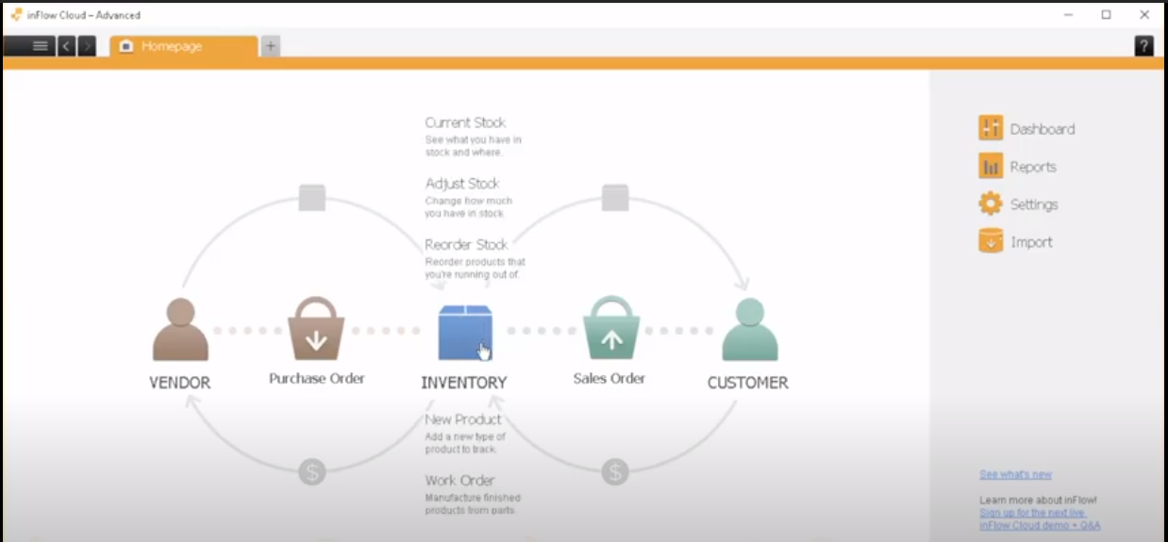*[6]*

*Figure 1 – Homepage*

This is the homepage where the users can navigate through the different sections.

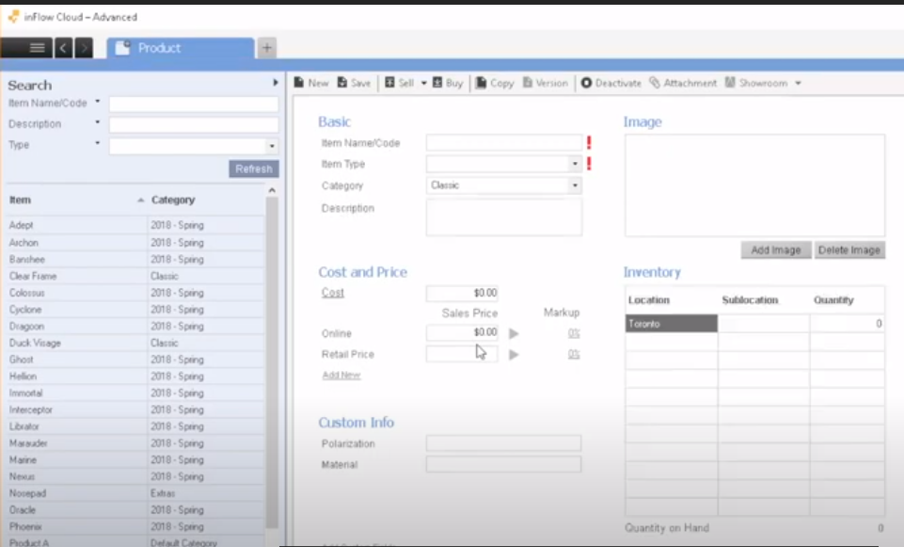*[ibid., 6]*

*Figure 2 – view products details*

This is the products page where users can perform the following tasks: click on the products to view their details shown in the figure 2.

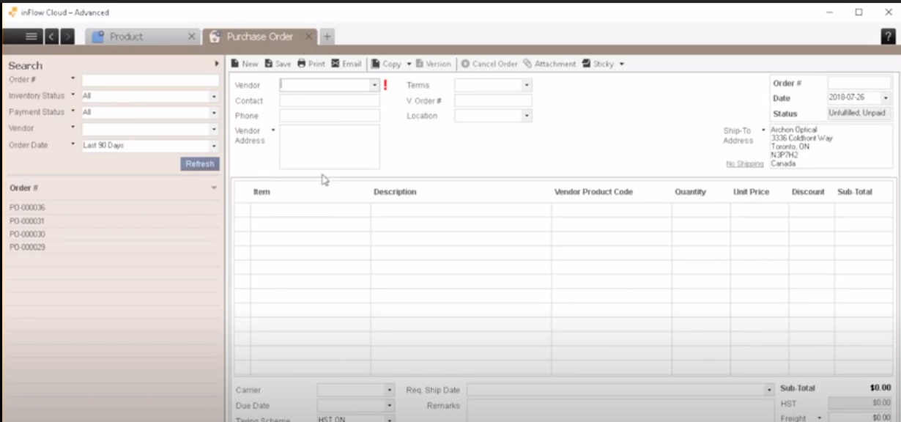*[ibid., 6]*

*Figure 3 – Ordering Stock Form*

When the number of stocks becomes low for certain products then, this is the purchase order form where you would order more stock.

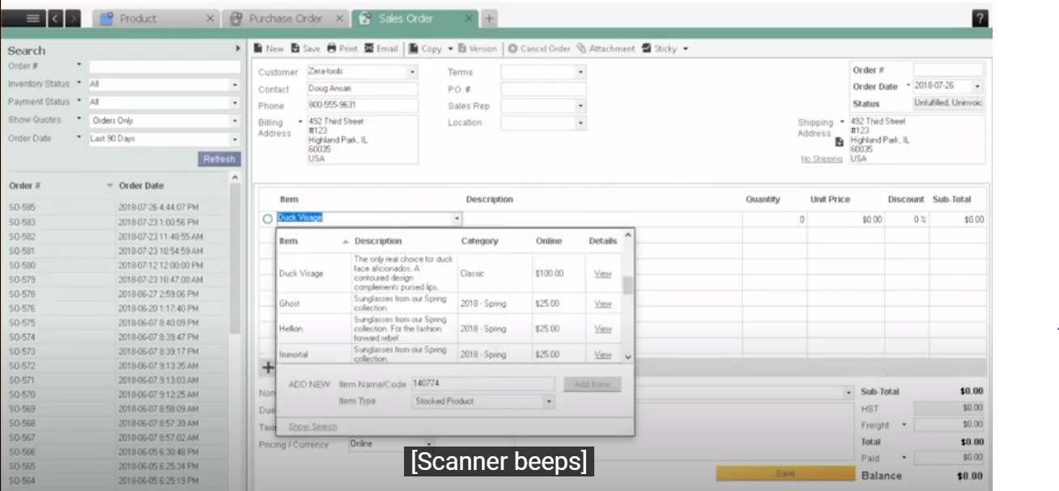*[ibid., 6]*

*Figure 4 – Sales Orders*

In Figure 4 you can see the sales order form which is used for selling orders to the customers. The way this works is that you can enter the customer name in the input field only once, then it will auto-fill all the customer data in the remaining input fields e.g., customer address. There are 2 options the user can prompt, first: save the order, second: send the order, *“this way the invoice will be created which will be sync with a software called QuickBooks online” [ibid., 6]*. **(Refer to QuickBooks under its own section)**

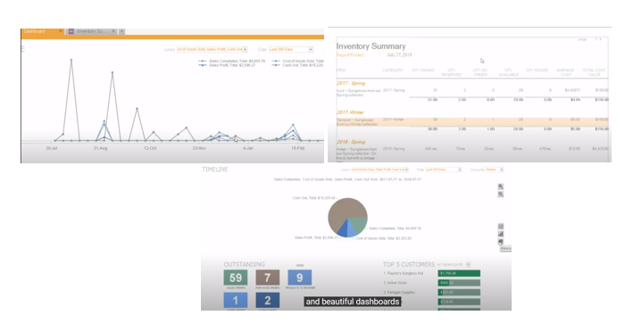

*Figure 5 – Sales Report*

These are all the business reports shown in Figure 5. Using these reports, you can do the following: *“You can visualise top-selling products, gain insights on your most profitable customers” [ibid., 6]*, or view the full inventory report to see all the extended details e.g., which product was sold in which, month, date, time and how much stock was left after it was sold.

In the duration of my research on inFlow software I found some useful customer satisfaction reviews and in addition to that the number of customer satisfaction is 98.7%. Those reviews have come from the owners. Below you can witness some of those reviews:

*“We needed the ability to run a small number of inventory items outside of our current ERP. However, we quickly realized how much better and easy to work in inFlow was, so we’ve been migrating over for the past year. It’s a great powerful tool and I highly recommend it!*

*Rachel Wu | Griffin Distribution., President” [7]*

*“inFlow has proven to be the most reliable, user-friendly, and cost-saving software tool to manage our inventory, sales and purchases all together.*

*Dominga Vitale | MedcOR Medical Systems., CEO” [ibid]*

## **QuickBooks**

*“QuickBooks is an accounting software produced by Intuit. It is mainly meant for helping small and medium-sized businesses in their accounting and bookkeeping operations. Many owners of commercial ventures find it difficult to keep a proper track of their business transactions which makes it difficult to ensure the success of the business in the long run.” [8]*. QuickBooks can handle and monitor the businesses financial transactions this way it can support in the areas of *“managing and tracking cash procedures” [ibid]* and *“determining the output of the business” [ibid]*.

QuickBooks is a software which is used by many small businesses for managing their sales & income, generate reports: balance sheet, profit and loss report, statements of cash flow, run payroll, sales transactions, viewing expenses transactions.

The two main requirements of the software development project are to avoid businesses making poor business plans (finance is considered as a very important factor in a good and very decent business plan) and avoiding financial hurdles which includes: Lack of Cashflow, keeping to the budget, viewing unforeseen expenses, and most importantly marketing.

QuickBooks is a software which is used by many small businesses for their finance area which includes: **Payroll**, **Financial transactions**, **Invoices, Expenses**, **Financial Reports, Bank accounts, and Money Management**.

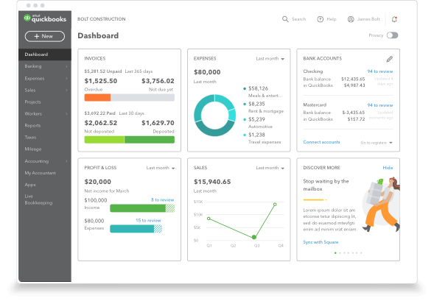*[9]*

*Figure 6 – Finance Dashboard*

This is the first view of the window you will view when the software opens. This is known as a ‘Dashboard’. This is where you can view a brief information about the reports such as for the following: invoices, expenses, bank accounts, profit & loss, and the sales. On the left-hand side there is also a navbar which is used for viewing the financial area in detail.

**Below you can witness some customer satisfaction reviews:**

*“Accounting is not my forte. QuickBooks helps me see my finances visually with graphs and things. Libby Hockenberry and Cary Smith, The Victorian”. [ibid]*. By witnessing this customer review, it can be said that if the owners’ strong point is not accounting and finance then, by using QuickBooks they can still understand what happening around that area as, it makes it so easy, concise, and very precise which helps the owners to understand.

*“With QuickBooks, I feel like I always have my finger on the pulse of my business. Jennifer & Ben Johnson, West Egg” [ibid]*.

## **Info Cloud vs QuickBooks**

There are comparisons which are made between the two software’s which shows their areas of strengths and weaknesses in different areas. Info Cloud is best for: *“inFlow is designed to run and manage any item based business. Suited for wholesalers, distributors, retailers, manufacturers, and online sellers. Customers are in over 90 countries.” [10]* whereas, QuickBooks is best for *“Editions dedicated to contractor, manufacturing and wholesale, non-profit, retail, and more.” [ibid]*. Both use the following features and functions: Forecasting, Manufacturing Inventory Management, Product Identification, Reporting/Analytics, supplier’s management, and warehouse management. Info Cloud tends to have a better inventory management system as, it uses more spaces in its inventory system and, as the system gets larger than it optimizes, whereas, in QuickBooks it gives you limited spaces and doesn’t allow you to optimize. Info cloud also has a better backup system as it uses the cloud to backup all its data whereas QuickBooks uses third-party hard drives. Info Cloud and QuickBooks both use report and analysis but, QuickBooks seems to use more detailed analysis by using a variety of graphs which makes it more concise therefore, it’s understood more easily than the reports produced in Info Cloud, which shows long written reports and only a couple of graphs. In general Info Cloud is better if you want to manage your inventories in the best way possible whereas, QuickBooks is better if the business wants to get rid of their financial hurdles the best way possible as, they are provided with the best tools to do that.

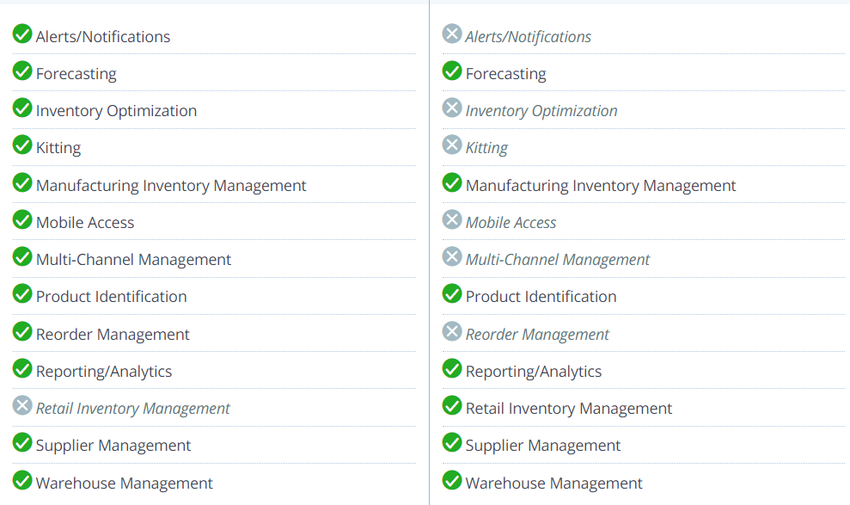*[ibid., 10]*

*Figure 7 – Comparisons*

In figure 7 you can see the debate between Info Cloud vs QuickBooks which shows which software has the most features and functions. The key point is that Its completely understood that, Info Cloud has more features and function then QuickBooks but, its main functions and features are just regarding the Inventory management system which are the following: Manufacturing Inventory system, product identification, supplier management, and warehouse management as, the rest of its other features apart from these are in less detail which can sometimes help, but probably not if required in a great amount of detail. Whereas, I completely understand QuickBooks has less features compared to Info Cloud but, the main features of QuickBooks are reporting/analytics, and forecasting which are very detailed and concise to support organisations in their area of accounting and finance even if they have less knowledge in that area.

## **Other Existing Software**

These are other similar existing software’s which include: NetSuite, Zoho IOS mobile application, TradeGeko, DEAR Systems, ABC Inventory, ORDORO, Upserve, CIN7, FishBowl manufacturing & warehouse, SAP business one professional, Cougar Mountain Denali Summit, AcountMate, Open Systems Traverse, Acumatica, **Info Cloud**, and **QuickBooks** etc. All these software’s which I’ve researched have similar features regarding business inventory system, financial management, and project management. These software’s are rated one of the best ones, which are out there in the market. Therefore, I chose two software’s to review, which were the best out of all these, and have slightly better features, functions, and customer satisfaction reviews then others. Due to the fact of features, functions, and customer satisfaction reviews I decided to choose those two. Those two were **Info Cloud** and **QuickBooks**.

# ***Chapter 2: Requirements Analysis & Design***

## **Purpose of the project**

The purpose of this analysis and design section is to design my ***‘A Modern Business Inventory and Management System for Small Businesses to manage and avoid potential disasters’*** software. Then, using the software design to develop this project using the required technologies.

## **Target Audience**

This modern business inventory and management system is very useful for owners who are managing small businesses and in addition to that, it can also be useful for employees who are working within the small business.

## **Project Scope**

The purpose of this modern business inventory and management system software is to manage and sort business inventories with more ease. Search for inventories with more ease by just using a code to search the product. Managing their suppliers and order invoices with more ease. Managing their employees with more ease e.g., their job role and wages. Keep the business continuity going during disasters as this application will have all the data backed up frequently. Keeping a track record of businesses profit and loss, where businesses can see, where they are making a profit or a loss, which will help them analyse and make changes if required. Finally create regular disaster recovery and business plans as well as saving and editing them, which is a useful technique for a business. This develops a convenient system, and an easy to use application for business owners to manage their business and support them during disasters.

The software system (Desktop Application) is based on the backend content management system application which is a relational database which communicates with the desktop application to store and retrieve data e.g., this includes different types of data for example business inventories.

The content management system communicates with the FTP-Server. There will be a variety of servers which will be connected with the business FTP-Server account. Using those servers, the data can be accessed from the CMS. The desktop application will also be designed considering some of the UX and UI techniques which will give users a great experience when using this software system.

See the sketch of the software system below.

## **Software Architectural Sketch**

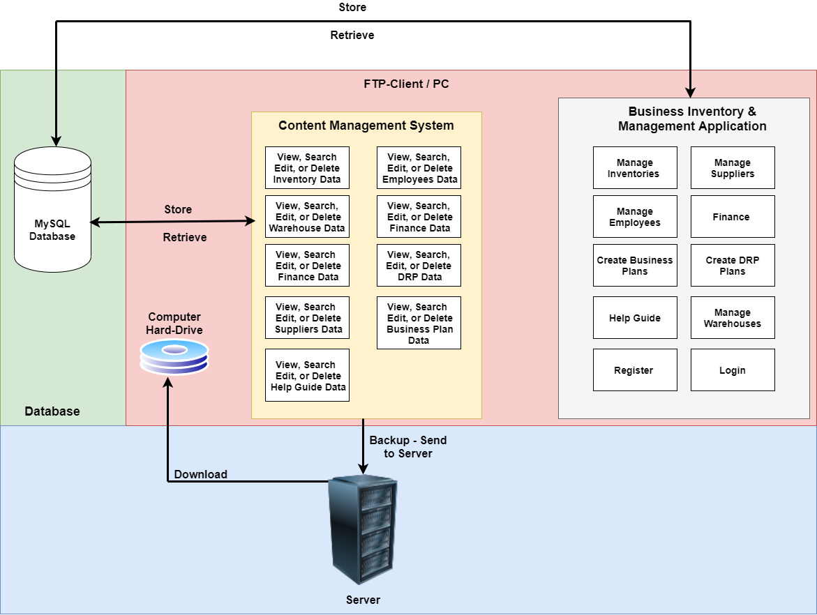

*Figure 10 - Software Architectural Sketch with Communications showing the System Concept*

Figure 10 shows the system concept, where it can view the architecture of the proposed software system.

## **User Requirements**

These are the user requirements specifications which will specify what the user will expect the software to do. There are two types of users who will be using this software system and, those following users are: business owners and team of employees.

### **User Requirement List**

User requirement list is in the table below:

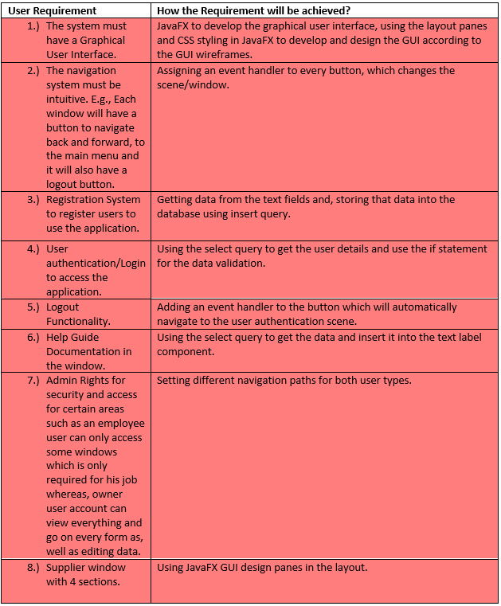

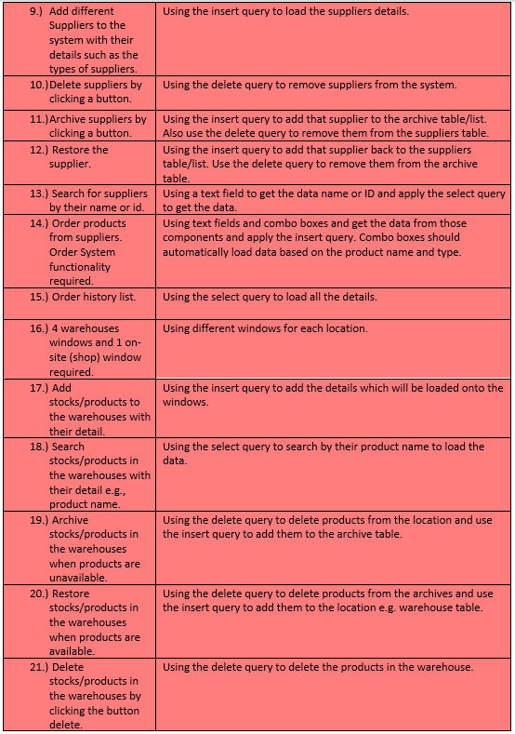

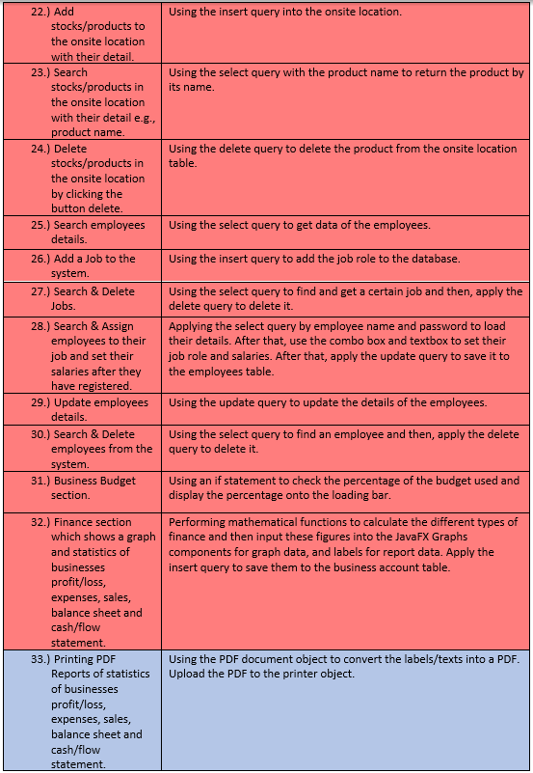

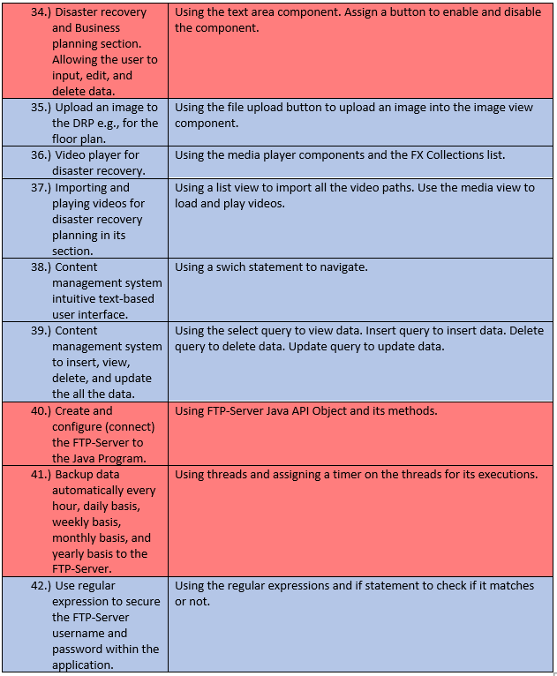

*Figure 11 – User-Requirements Table*

The requirements highlighted in light-red are majorly required. The requirements highlighted in light-blue are requirements which are not majorly required.

## **Wireframes/GUI Mock-Ups**

### **Registration & Login**

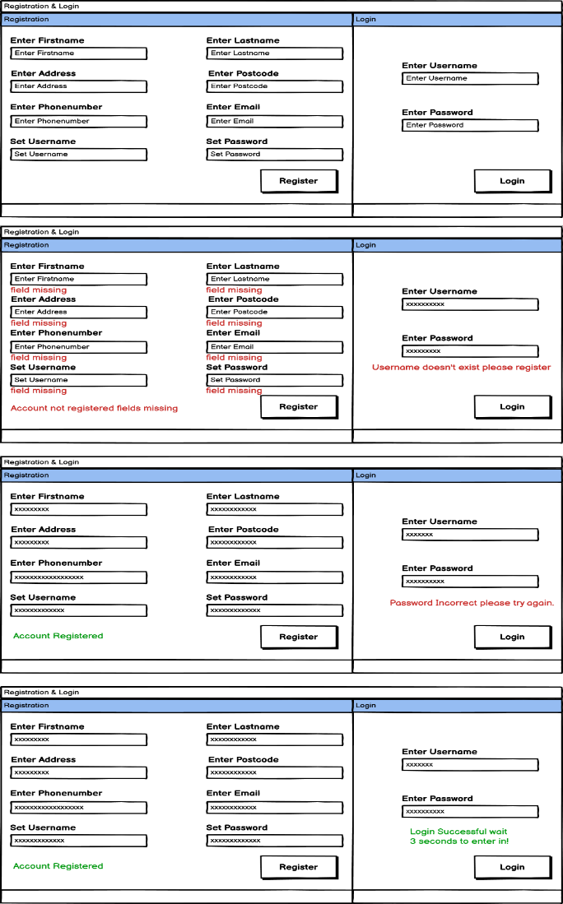

This is the Registration & Login GUI wireframe. Each input fields including the Registration & Login sections have a label on top of them and in addition to that, there are placeholder values to support users, so they know what needs to be typed into the input fields, which makes less chances of a mistake.

You can also witness that there are red label messages underneath the input fields which are used to indicate input errors made by the users such as, they forgot to input a field, added the wrong information, username didn’t exist as they may have forgotten to register or, the password is incorrect. Red message explicitly shows what type of mistake has been made.

Green messages indicate the message of success for the users, such as if they have inputted the correct fields, then it will return a message of success in a green to make them aware that their account is registered. For login it returns a message of success in green saying ‘access the application in 3 seconds’ meaning the user has successfully logged in and is waiting to access the application.

The ‘register’ and ‘login’ buttons are made slightly big and bold in terms of design because, it allows users to understand where they need to click.

*Figure 11.1 – Registration & Login Wireframe*

### **Main Menu**

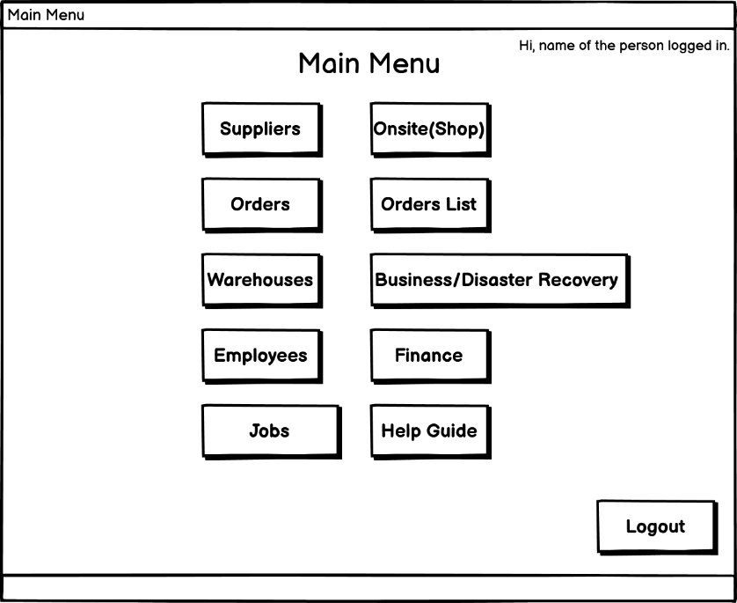

*Figure 11.2 – Main Menu Wireframe*

Figure 11.2 shows the main menu wireframe which was a requirement needed for the ease of navigation as, the users can use the main menu to access all the different parts of the software system, this is the reason why homepage style main menu was developed. The user can read the text on the buttons and easily access any area when required to do so. The user accesses the main menu after successfully going through the registration and login after 3 seconds. On the top-right corner of the window, a text label is used to alert the user with their name, this is used to alert the user that they are logged in successfully. On every other windows there is an option to go back, which makes the user interface intuitive as, you can witness from other wireframes that every window has a button to navigate back. Finally, there is a logout button which, indicates to the users that, if they wish to leave then, they can press the logout button as, by pressing the logout button the application will be redirected back to the registration and login as, a result the user will have to login again to re-access the application. The application can only be accessed using user authentication which is good for security reasons.

### **Help Guide**

It’s understood that not everybody is a technology expert this includes the management team members as well. Therefore, this section was designed for a simple help guide documentation. The users just need to read and understand as, this is a basic training for the new users who have recently joined. Once, they get the hang of it then, those users don’t really need to use it, unless they forget due to some reasons.

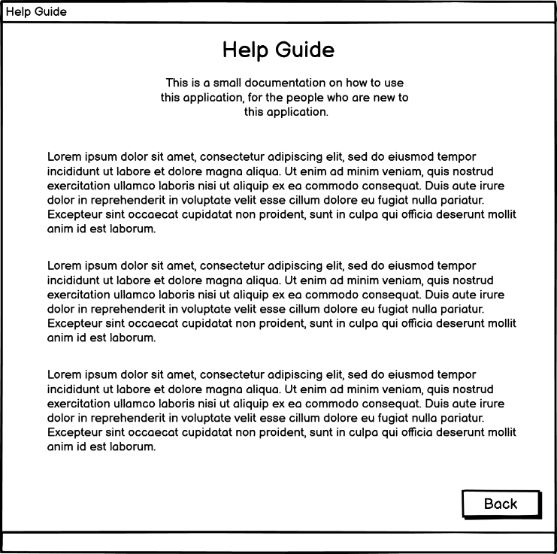

*Figure 11.3 – Help Guide Wireframe*

### **Suppliers**

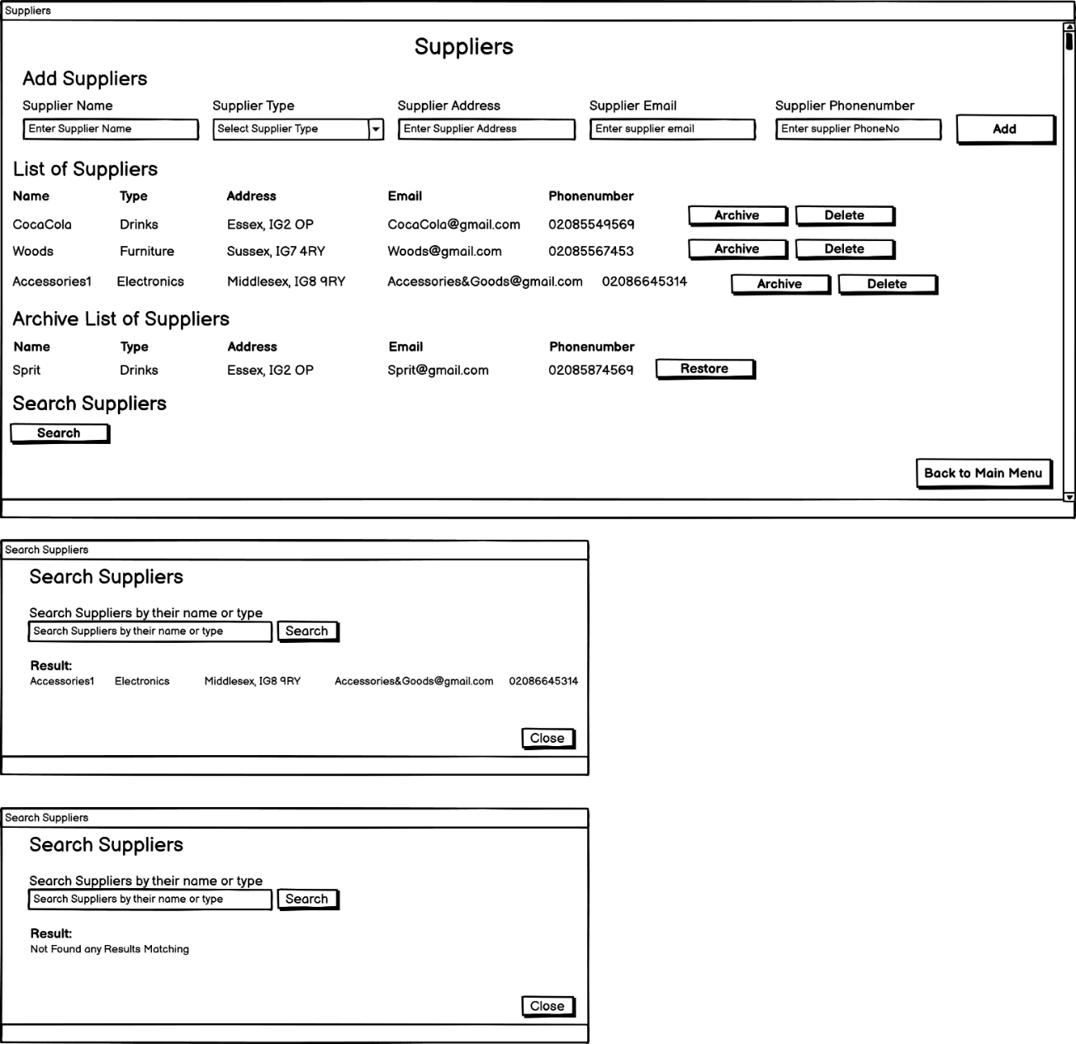

The suppliers section is split up into four sections which are the following: add suppliers: where there are input fields and placeholder values included with an ‘Add’ button, this is where the user can prompt to add new suppliers to their system, list of suppliers: under the list of suppliers section the users can view a list of suppliers with all their details, who are registered to this system, the list will be displayed using a while loop to display all members of the suppliers. In many cases, its understood that suppliers might not be available currently therefore, in the list we have an archive button which is used to archive the supplier from the list and display them in the archive list, which is seen below list suppliers section therefore, it alerts other users that this supplier is unavailable at the moment, and the archive list of suppliers will display a restore button to unarchive the supplier, when the supplier returns back, this way the supplier will go back into the list of suppliers which shows to the users that they are available again. There is also a delete button option in the list because, the supplier may no longer be available or perhaps the business may not use their services anymore therefore, by pressing the delete button the supplier would be deleted out of the system meaning, they would no longer exist in any system-lists. This will reduce memory off the system as well.



There is a search supplier button which is included in the last section of the suppliers window.

The user clicks onto the search button which, opens up a separate search supplier modal dialog window with a search box to search for the supplier by name and a button to search that supplier, after that, it will either return the details of the suppliers who was searched or, an error message if the user prompts an incorrect data, in both cases, the return message will be displayed under the result label which alerts the user from beforehand that this is where you would expect to see your message after searching for the supplier. There is also an option to close this window if the user wishes to not use search supplier section anymore.

The separate modal window for the search suppliers section was required as a design process as, there was too much data on the suppliers window which was making things confusing therefore, the solution of a separate modal window was decided.

Horizonal and vertical scroll bars in the design made it easier for the users to view data on the GUI rather then, one large window making it look confusing.

*Figure 11.4 – Search-Suppliers Wireframe*

By using the sub-headings on top of each section the users will know which section is going to be used for what purpose therefore, they can easily differentiate between the different sections.

### **Orders**

The user needs to select a product type and the product name first from the drop-down list after that, some of the information will automatically be loaded up into the sections such as: product price, product description, product status, product quantity available, and the supplier name and type. If the user first selects the supplier name and type, then when the user comes to choose the product, then they can only choose the products available from the supplier they selected. This way its better in terms of design because, it makes it easier for users as, they don’t have to remember information of by heart and in addition to that, there are more chances of a mistake if the users type in manually. The users will have to input the product quantity themselves based on that the total price which will ascend or descend. The date ordered on will automatically be generated according to the current date. The user would choose their expected delivery data by using the date picker, therefore the date is accurate because, if the user manually types in their date, then, there are more chances of a mistake which will lead to confusions.

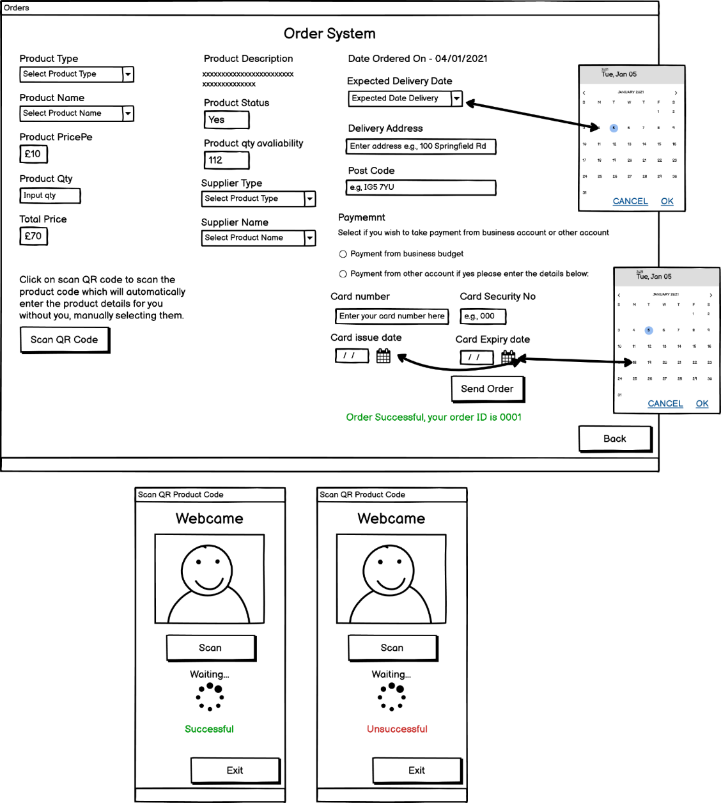

For selecting a payment type we decided to design that using the radio buttons because, by using radio buttons you can only select one options as, there are no multiple options and we only require one type of payment. After that, the user must fill in their card details and, select a card issue and expiry date using the date picker to insert the accurate date with chances of less mistakes. After that, the user can send the order which will either return a message of success and generate an order id or, it will return an error message if something is missing or any information which is incorrect such as the card date might be outdated.



Webcam Capture-Java API will be used for capturing the machine webcam.

Google-Zxing API is used for detecting the QR code from the webcam.

Loading bar is used for the waiting time as, the scan is still trying to search the QR code.

*Figure 11.5 – Order System Wireframe*

The button allows scanning the product QR-code therefore, it opens a modal dialog window. That windows allows you to scan a product code by your PC camera. If it is successful, then it will return a message of success and automatically fill in all the details, else it will return an error message if the QR-code is incorrect. This allows things to be processed quicker saving time, that is why it was considered in this design process.

### **Orders List**

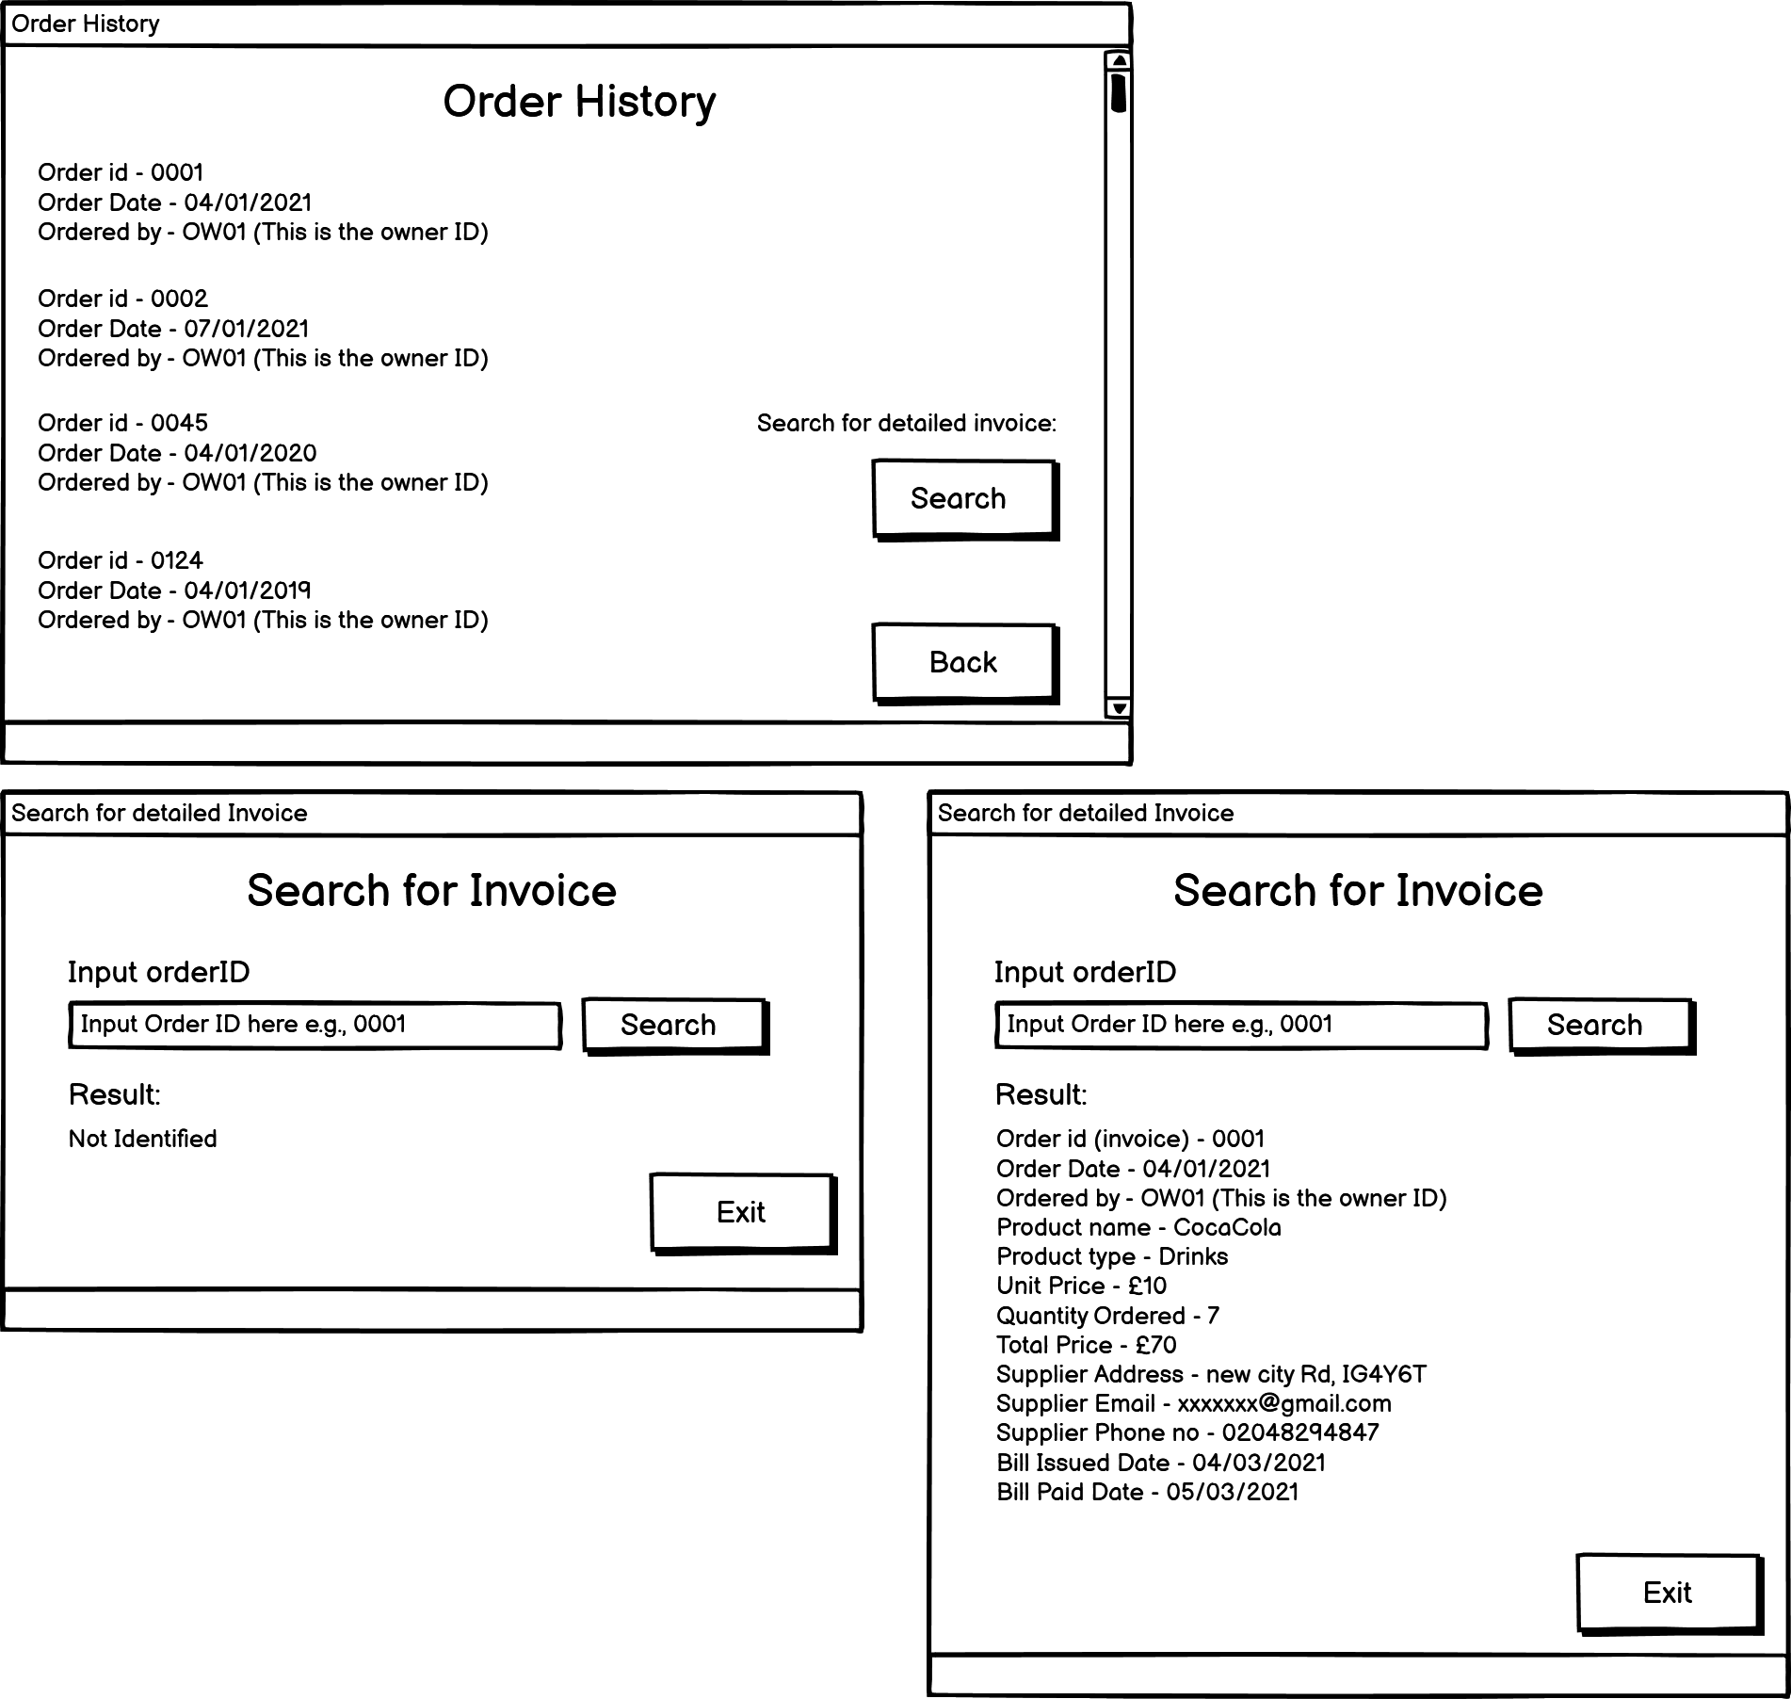

This is the order list section, where the users can view all their orders, they have made previously. The data will be displayed on the GUI using the while loop, which will display all the data. It has a vertical scroll bar because, there are too many orders so it won’t be appropriate to make a design which has a long window therefore, the decision was made to have a reasonable size for the window and use a scroll bar therefore, the users can use this to view their history of orders. Users can search for orders by pressing the search button.



*Figure 11.6 – Orders History Wireframe*

After pressing the search button a modal window will open with a search box and a button. The user has to input their order id, which was generated by their order and, then the result will be displayed showing all the invoice details for that particular orderID which can be viewed on the wireframe above. If the user inputs an invalid orderID, then it will return an error message saying, ‘not identified’. The reason, it was decided to have an extra window for searching the orders is because, list of invoices is large as, everything won’t fit in one window.

### **Onsite (Shop)**

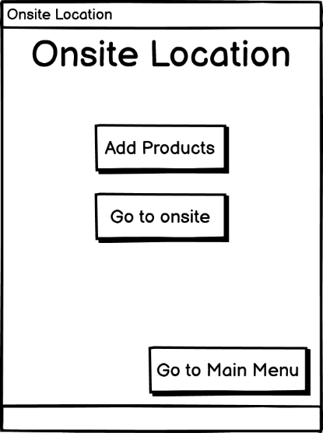

*Figure 11.7 – Onsite Location Wireframe*

The reason why there is a menu for this is because, it’s quite a large section therefore, it’s not possible to have everything on a single window. and that will make it look more complicated and less user-friendly. Therefore, by having a separate menu for this section and splitting up the two sections: add products and go to onsite is making the design clearer and easier to understand therefore, the users can easily navigate between the different sections. It makes it more intuitive as the user can click the main menu button to navigate back to the main menu window to access other sections.

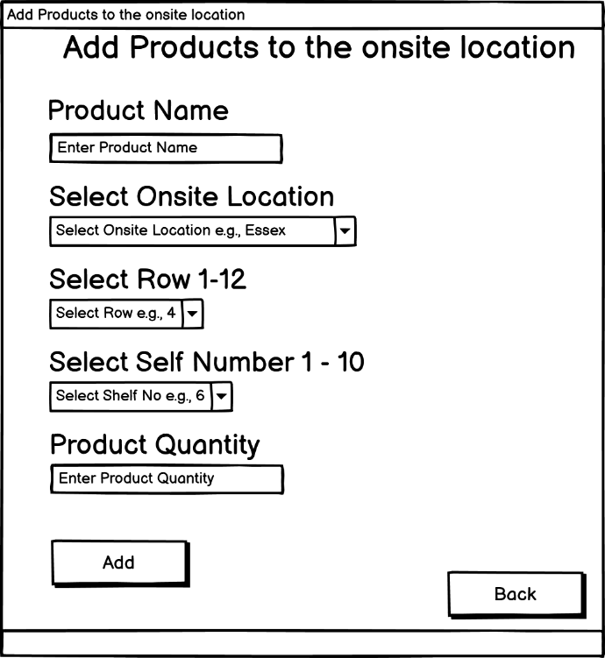

*Figure 11.8 – Add Products to Onsite Location Wireframe*

This is the add products section for adding the products to the onsite location. The user has to locate their products inside the onsite shop location. Typically, in a shop you have rows, and in each row, you have a shelf, and inside the shelf there are those products in quite a large numbers. Therefore, its used that same pattern to locate the products via the application. When the user enters these add details input fields then, they are basically locating the product inside the store. This form has been designed using subheadings, input fields with placeholders therefore, the users understand what they need to input.

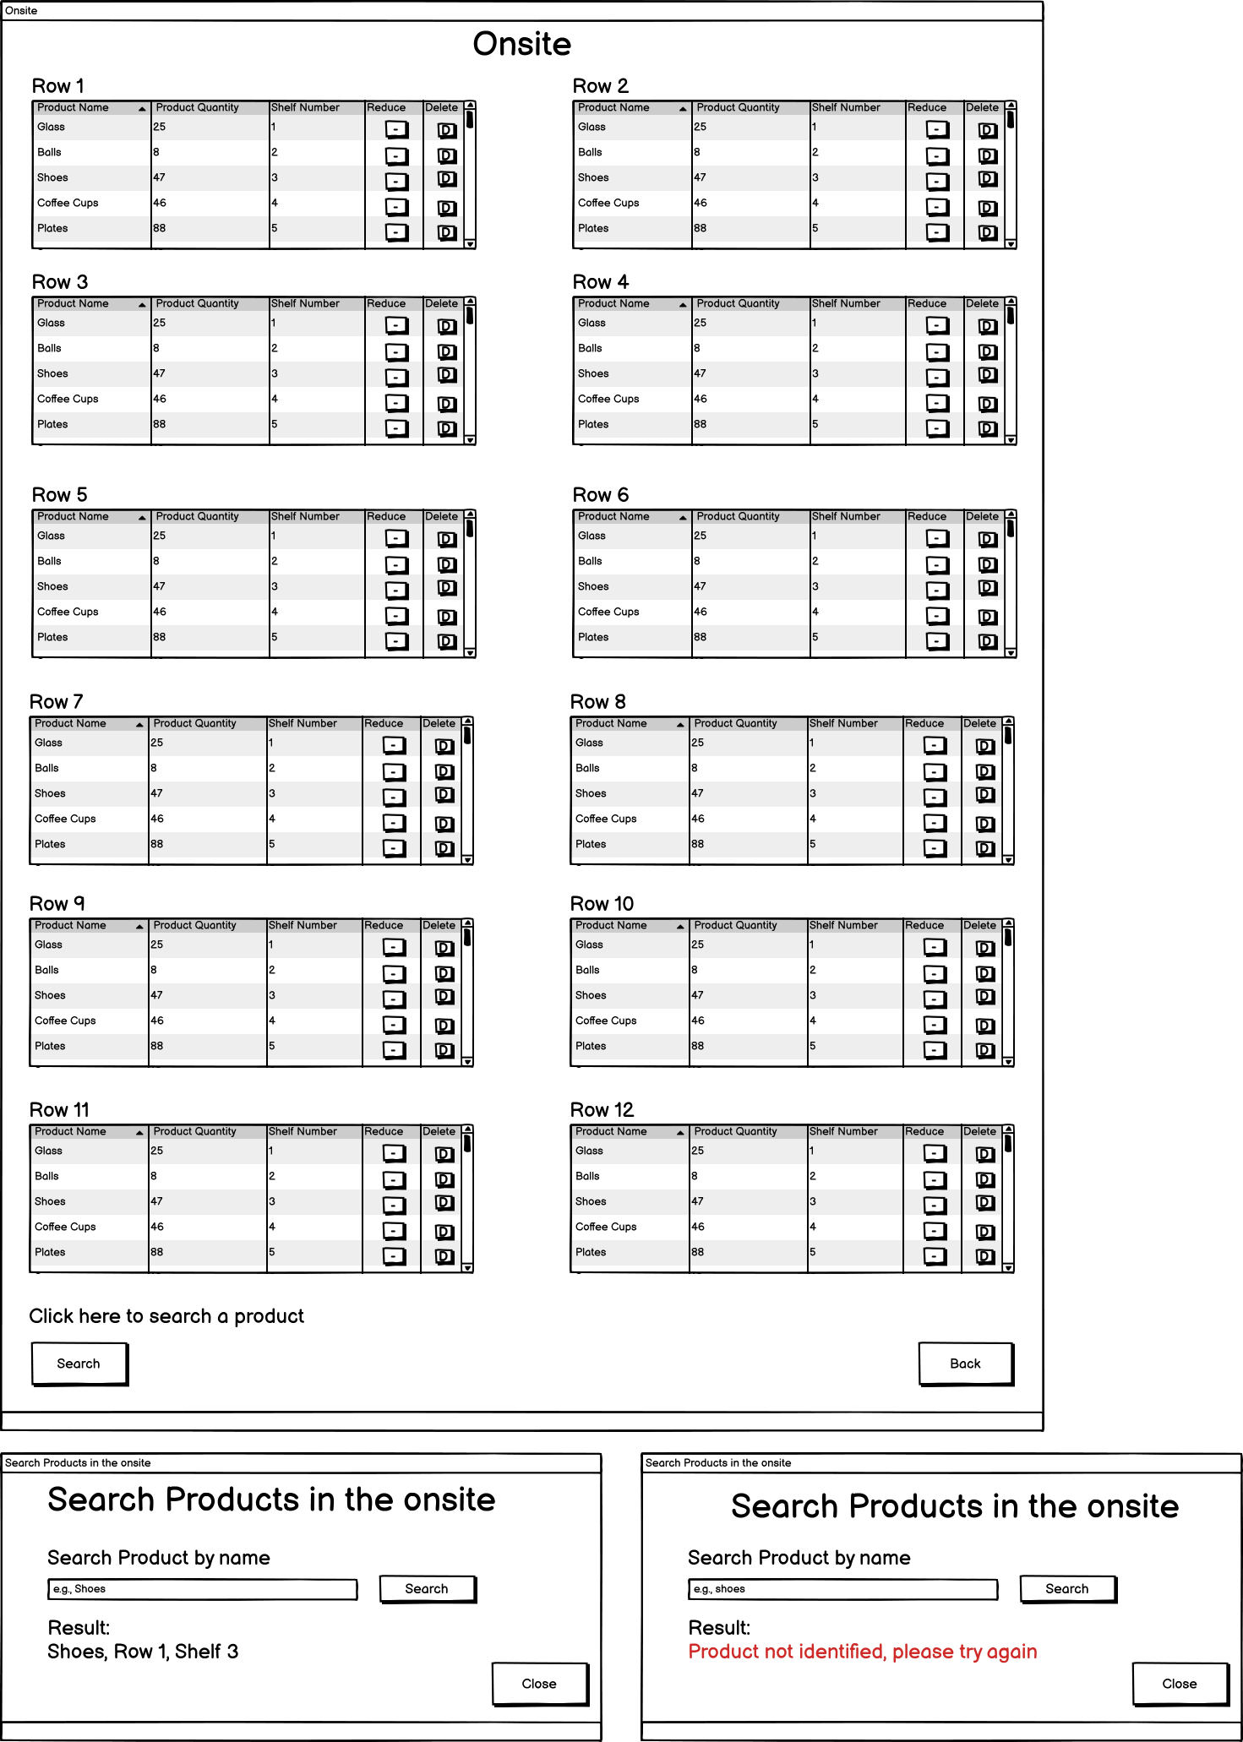

At some point there will be a time where the product is out of stock therefore, it can delete the product from the onsite using delete button therefore, all the records are kept updated and there are no confusions.

There is also a button to reduce the product quantity for example, if the product is sold then, you can use this this to reduce the product quantity according to the availability.

Each row has a product name, the amount of product quantity, product located in which shelf. When the users add the product then, this is how its displayed.

There are a variety of products which are located in each row therefore, a vertical scroll-bar has been attached so, the users can use this to view all their products in the rows.

*Figure 11.9 – Add Products to Onsite Location Wireframe*

In the section ‘go to onsite’ is where it can view the products which currently available in store. In many cases, when customer comes on store then, they are looking for a certain product and if they can’t find that product, they would come to an employee to ask them for guidance therefore, by using this design showed in figure 11.9 the employee can instantly find out, in which row and shelf is the product located or check if this product exists or not therefore, the employee can give an instant replay back to the customer rather than wasting time searching it for them themselves. Another quick feature which the employees can use is by searching the product by their name.



*Figure 11.10 – Add Products to Onsite Location Wireframe*

Figure 11.10 shows the search window. This allows the users to quickly search for one specific product to check if its located in store or not. The user has to input the product name in the search bar. After that, an if statement is used for checking if the product exists in store or not and if it does then, it returns the product name, row number, and the shelf number else, it returns a message in red to alert the user, that the product is not identified, the possible reasons for that could be because the product is not in store yet or the name inputted is incorrect.

### **Warehouses**

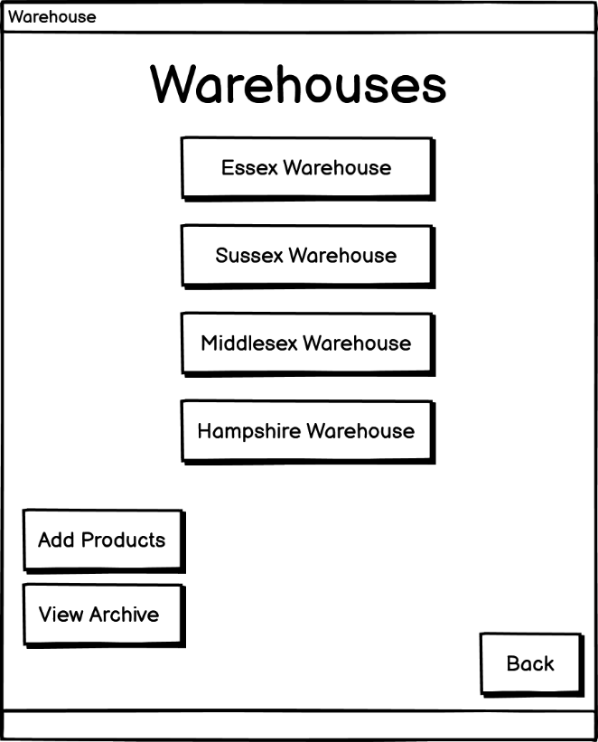

*Figure 11.11 – Main Menu for Warehouse Locations Wireframe*

This section works the same as figure 11.2 and 11.7. It can be witnessed that in the warehouse section there are six buttons which the users can click, for example Essex Warehouse, Sussex Warehouse, etc. The design decision to develop a sub-menu with buttons for every sub-section was decided therefore, it supports the users achieving their tasks quicker and makes the warehouse section user friendly. This is also designed for the other sections of the software as e.g., employees, DRP Plans etc.

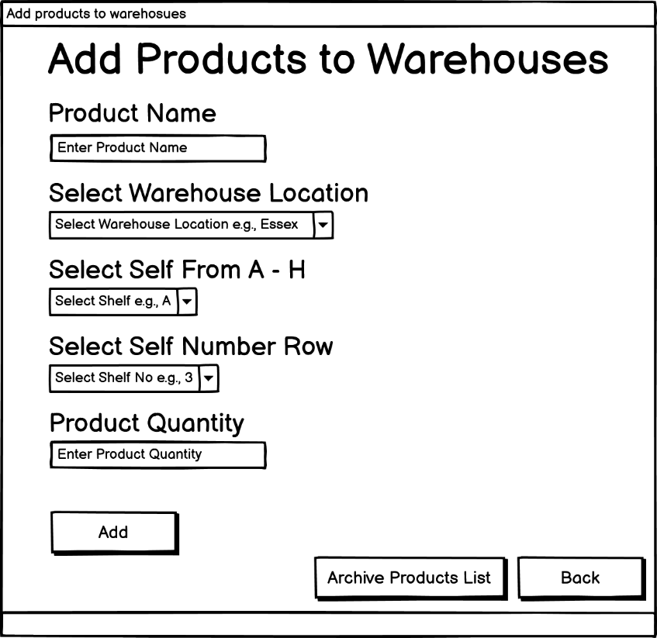

*Figure 11.12 – Add Products to Warehouse Wireframe*

This section works the same as its shown in figure 11.8. The only difference is that figure 11.12 section has one extra section called *“Archive Products List”*. The users can use this to add products into the warehouse.

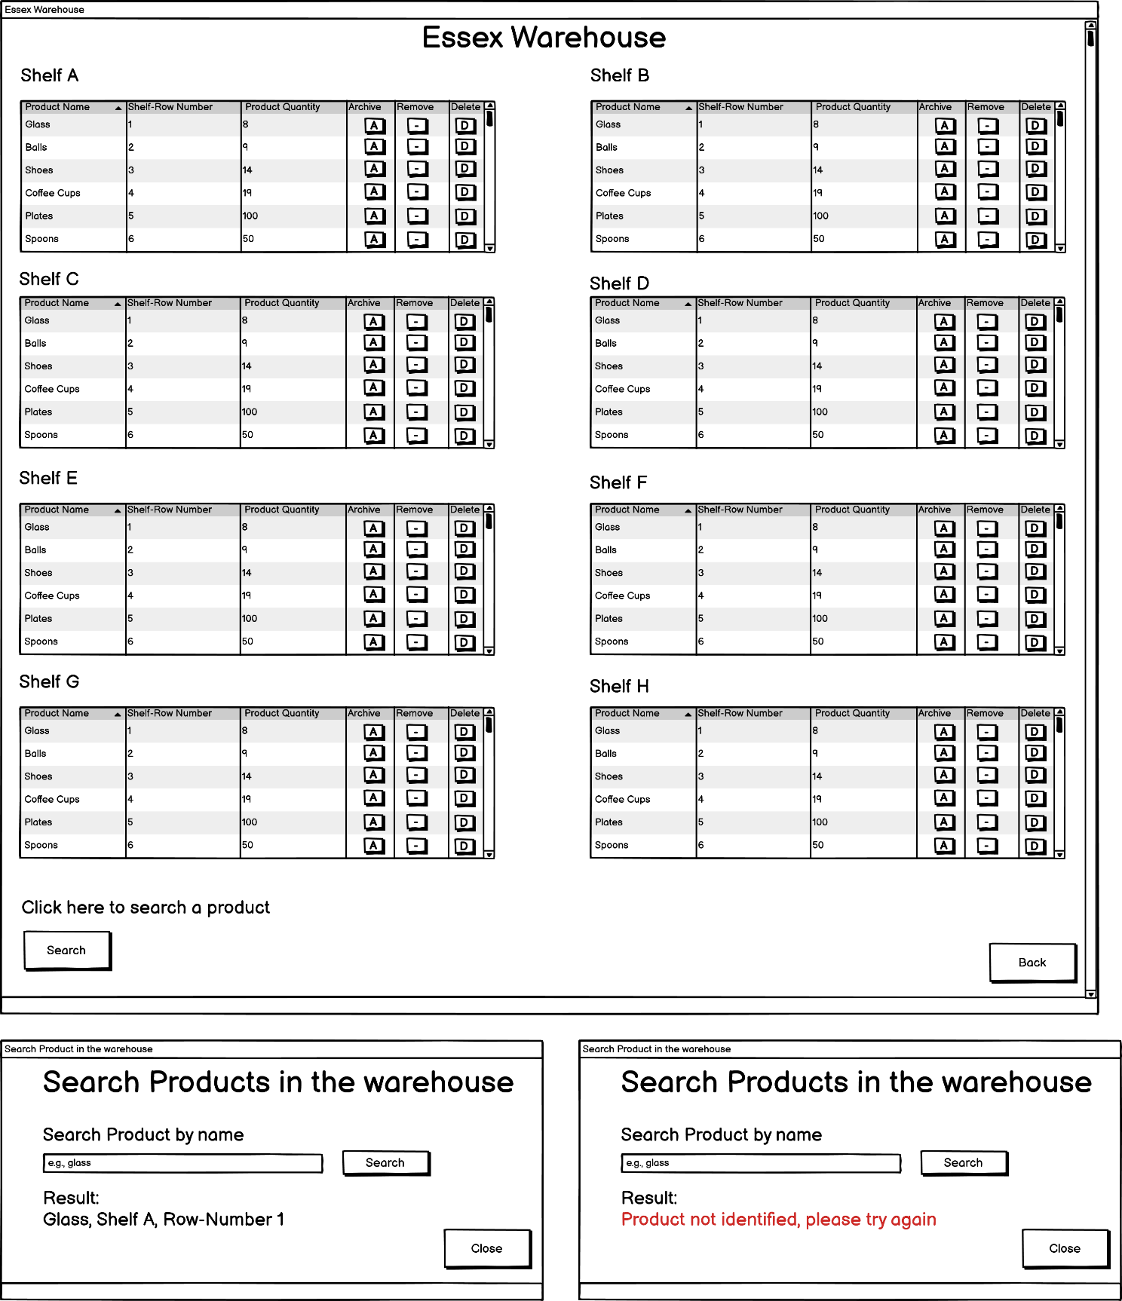

*Figure 11.13 – Products inside the warehouse Wireframe*

This section works very similar to the section shown in figure 11.9. The only difference is that each product has an archive button which is used to archive a product and add it to the archive product list section if the product is unavailable.



*Figure 11.14 – Search Products in the warehouse Wireframe*

This section works exactly the same as figure 11.10. The user can use this to make an extensive search of a single product, rather than searching it through the whole warehouse section shown in figure 11.13, which can be tedious for users.

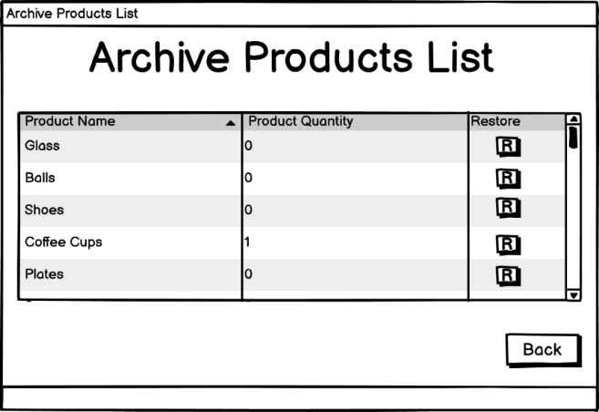

*Figure 11.15 – Archive list of products for warehouses Wireframe*

In this section the users can view all the products which they have archived from the warehouse. The table of archived product uses a scroll bar therefore, users can easily scroll down and view a large list of products then, having a large window which will make it more difficult to view and, the archived products list might be so large that it may not fit the window.

### **Employees**

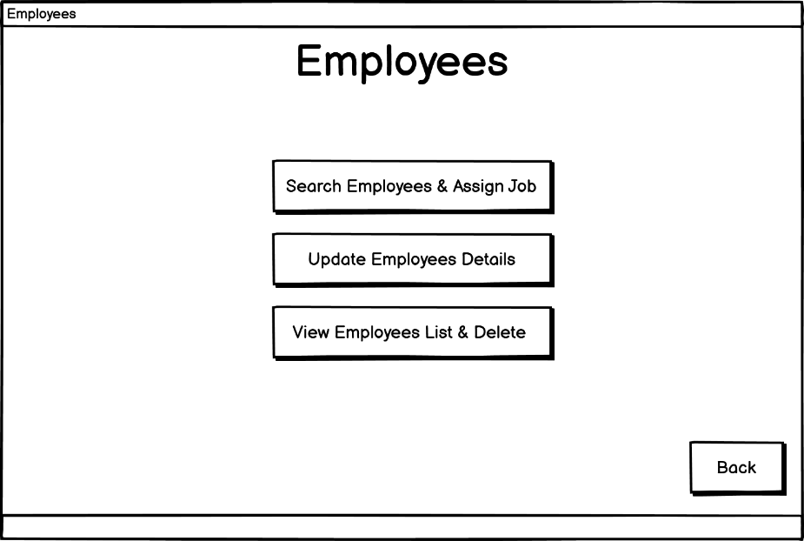

*Figure 11.16 – Main Menu for Employees Wireframe*

This section works the same figure 11.2, 11.7, and 11.7 and its used for the same purpose.

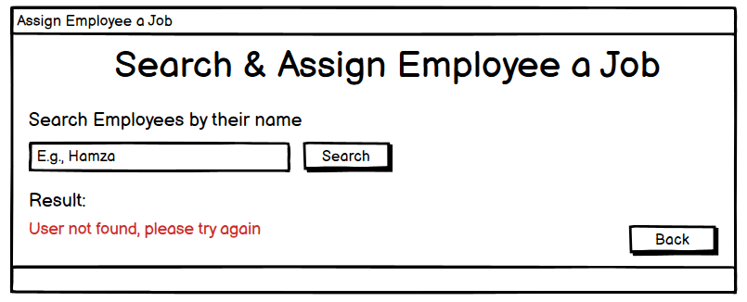

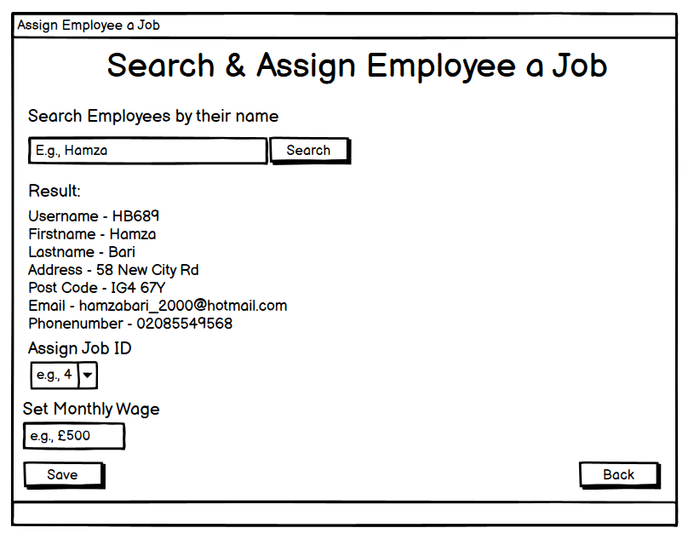

*Figure 11.17 – Search & Assign Employees Wireframe*

When an employee joins a company, they have a job role and a fixed monthly wage therefore, this search bar allows them to search their name which loads all the employees details. After that, using the combo box a job id can be selected to assign a job and, the user/owner can input the monthly wage as well. By clicking the save button all the details will be updated to the database.

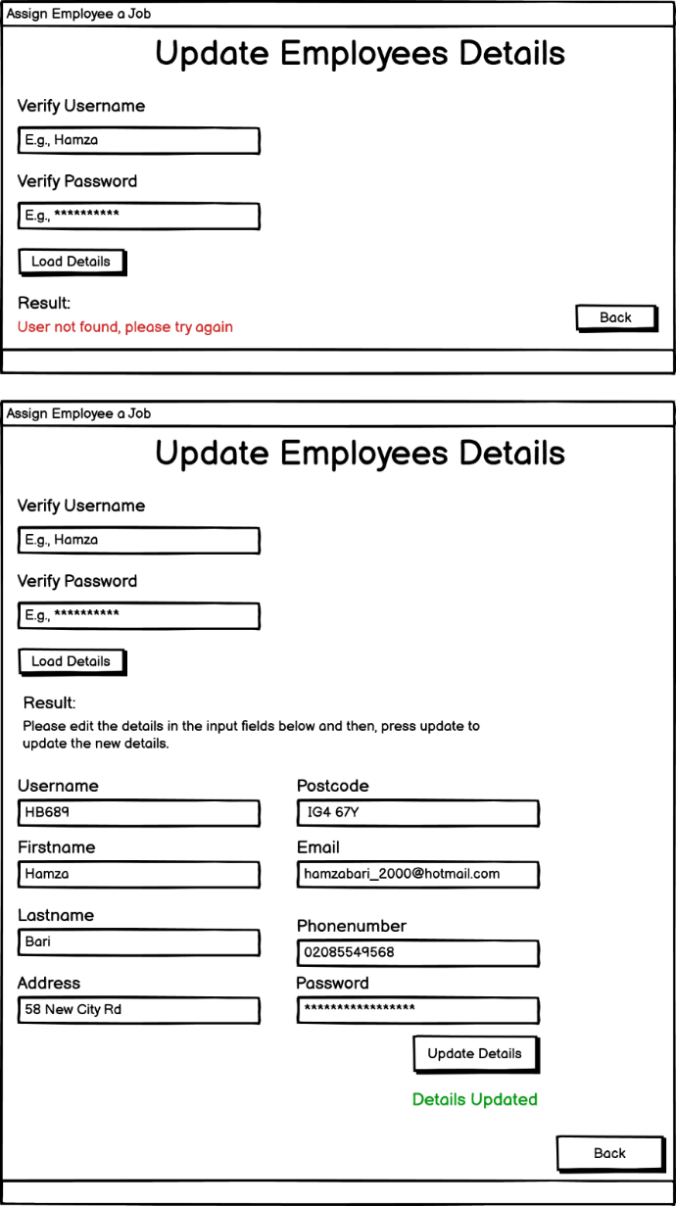

It must be understood that at some point the employees might need to change they’re details for some reasons. This is why there is a section created for the update employees details. This section will allow employees to enter their username and password just like the login system to load all their details. After that, the employees can view all their details which are currently saved in the software database. The users can use the text fields to change their details including password after that, by clicking on the update details button all the details will be updated into the database.

*Figure 11.18 – Update Employees Details Wireframe*

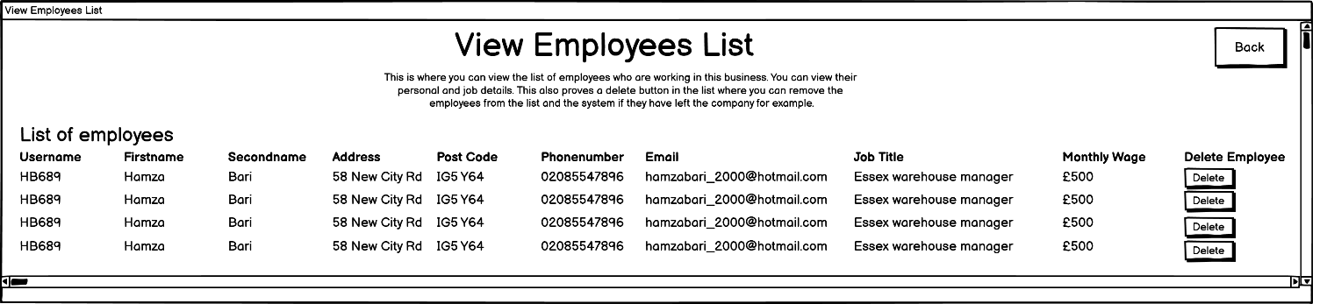

*Figure 11.18 – View Employees List Wireframe*

This section is used for two following reasons: employee details check, and an employee will leave the company at some point. This section will display the full-details for all the employees. There are a large number of employees, therefore the users can use the scrollbar to search for the employee they want. By clicking on the delete button the details for that employee will be deleted from the database.

### **Business/Disaster Recovery**

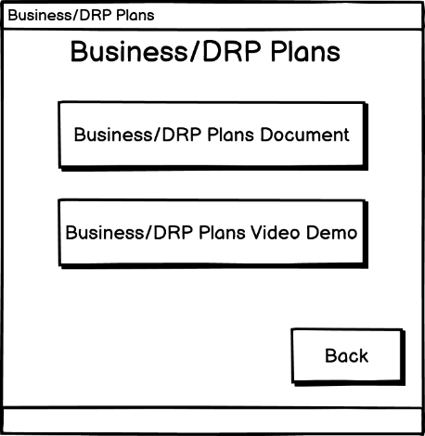

*Figure 11.19 – Business/DRP Plans Wireframe*

This section works the same figure 11.2, 11.7, 11.11.

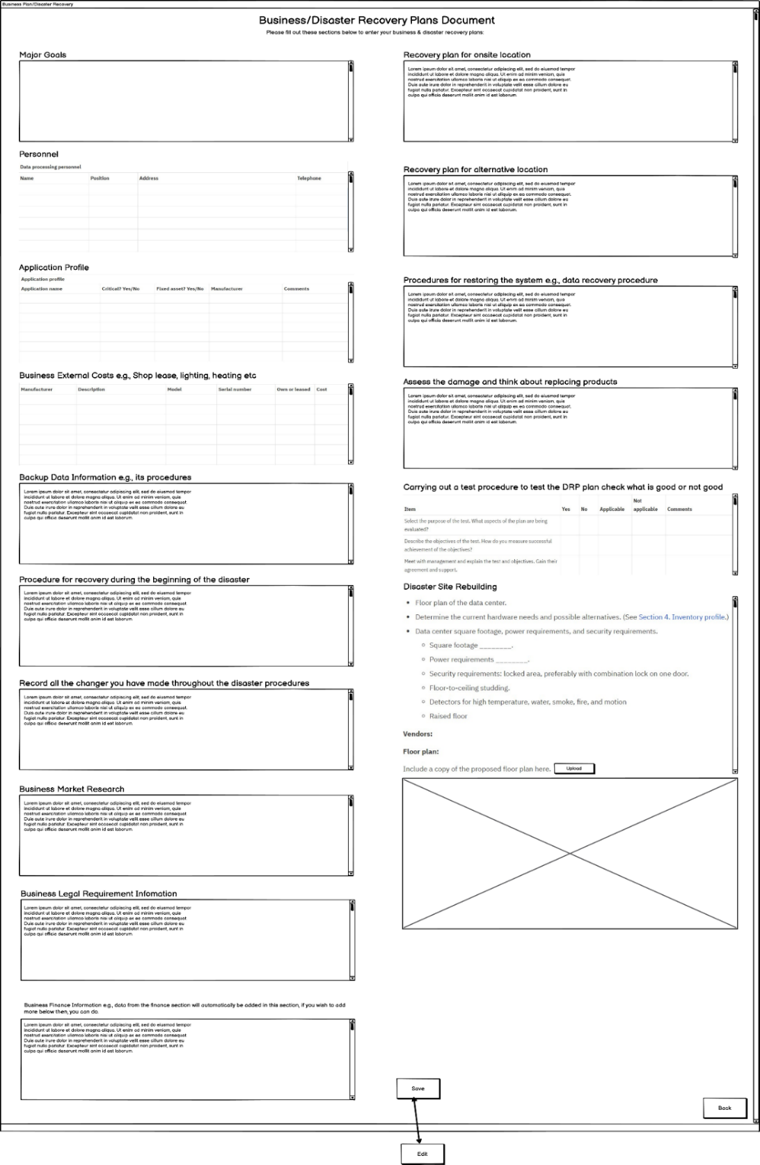

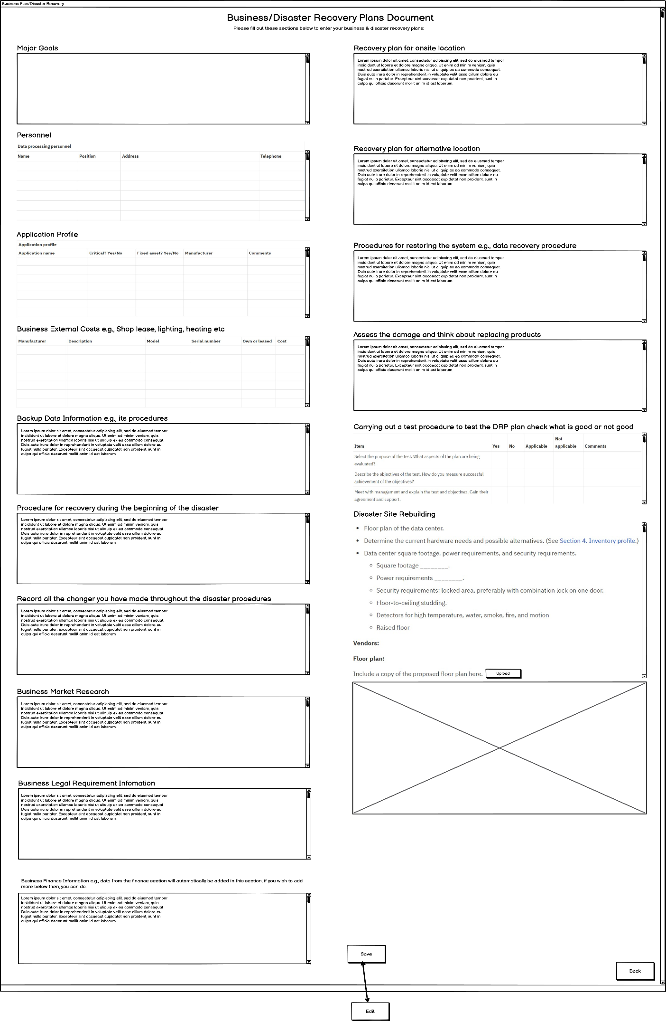

Continued

*Figure 11.20 – Business Disaster Recovery Plan Document Wireframe*

This is the section where the owners can make their DRP plans. Each plan has their own text area: where the users can type in their text, tables: where users can input the data into the rows, and an image upload button which allows the user to upload an 100x100 image from the file system onto the image view. The user can press the save button to save everything to the database and, it will disable all the text area, tables, and the image upload button therefore, the data doesn’t get edited accidently when viewing, it will also change the button name to *‘edit’*. The user can click back on edit button which will change the button name back to *‘save’* and enable all the components which will be editable. Each section has its own component with scroll bar therefore, if the user needs more space, and it becomes more easier to view data then, having lots of large text with big windows which would make it non-user-friendly.

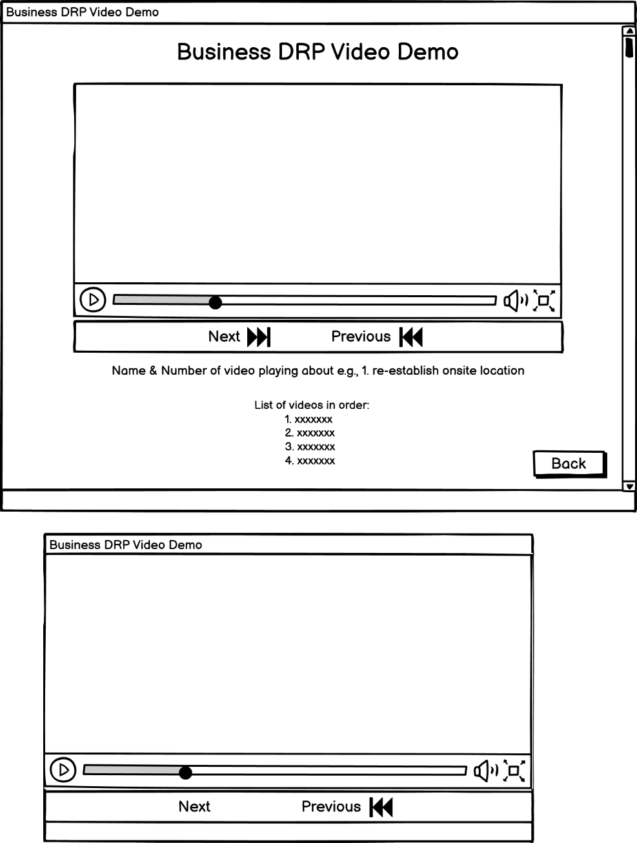

The users can view the video in a full screen mode if they struggle due to their visual impairment problems e.g., dyslexia as, the video contains a lot of text to read.

List of all the videos with their names.

Name of the video, to alert user which video is playing.

In this section the users can watch different videos regarding the DRP plans. There will be approximately 16 videos in the file system of the program. The videos will be played in order, the name of the video below is useful because if the user needs to skip to a particular video or even go back. The video will have all the necessary controls such as: play, pause, skip, and volume therefore, the user can comfortably watch the videos e.g., the users can pause if they want to read.

*Figure 11.21 – Business Disaster Recovery Plan Video Wireframe*

### **Finance**

All of this information will be loaded from the database therefore, when the database is updated then, the data in this section will be updated.

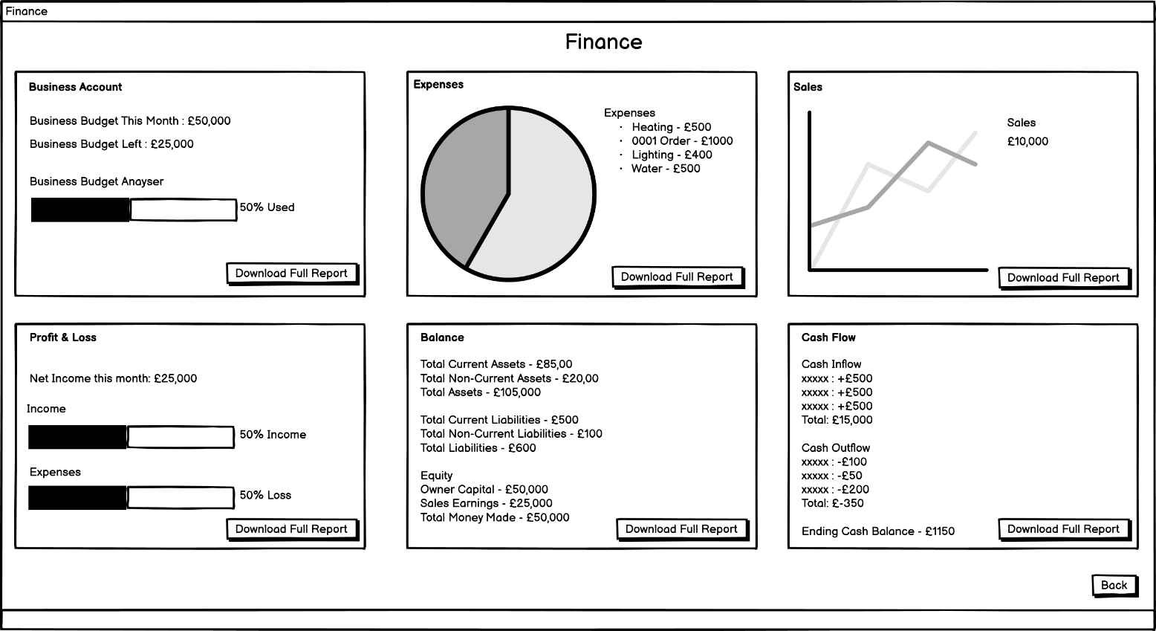

*Figure 11.22 – Business Finance Wireframe*

This section shows the financial status of the business. The business account: this will show the current budget and the business budget that is left and, using the loading bar it will show a percentage of how much budget is left over. Just by looking at the loading bar percentage the users can analyse what is the budget status of their business e.g, higher or lower. Profit & Loss: the loading bar shows the percentage of income made, and the loss loading bar shows how much of a loss was made and the net income is calculated automatically which is visible in the section. The expenses section will display a list of all the expenses and display them on the pie chart. The section for sales which are made using the line graph will show many sales the business has made. The graphs are developed using the JavaFX Graph API. The reason why loading bars and graphs have been chosen is because, the users can easily analyse e.g., just look at the graph and see which expense is the highest, rather then, reading long large reports with too much text which can make it difficult to understand as, this formats everything clearly. The user can click on the “download full report” button to open the selected report in the PDF viewer therefore, it can be seen in a larger content.

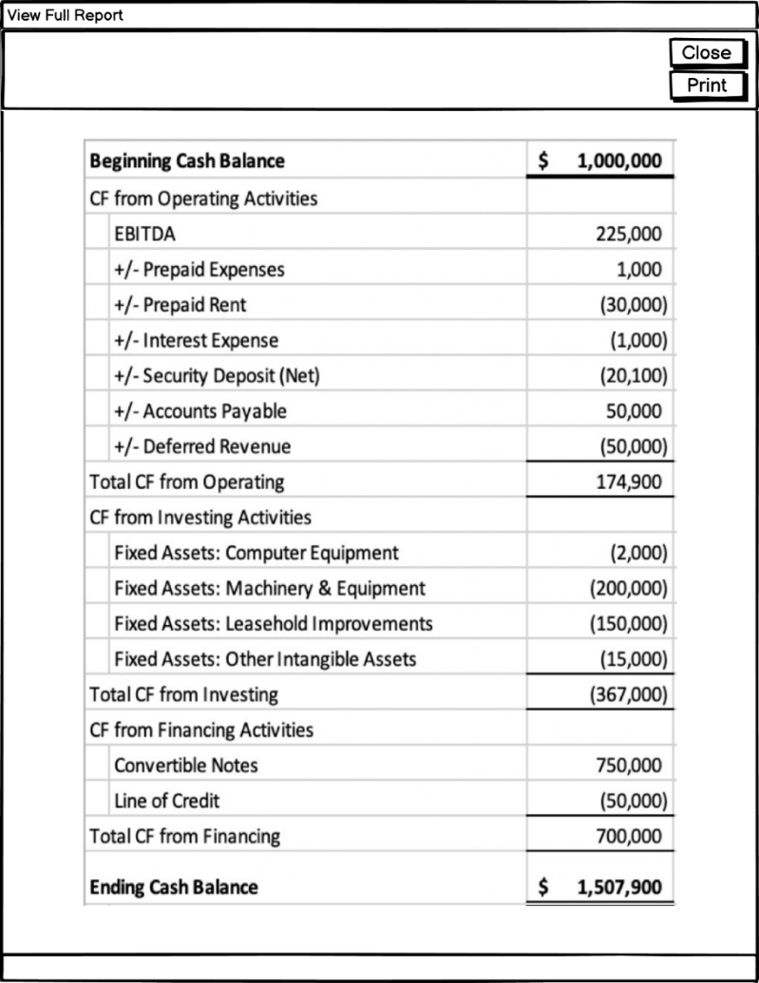

*Figure 11.23 – Business Finance Reports Wireframe*

In this section, when the user clicks on the “download full report” button then, the report will be downloaded which will be visible to users in the PDF viewer. This decision has been made; therefore, the users can view the reports in a large view which can be understood more comfortably. This also gives users the option to print the current opened PDF and, by clicking the print button the users can print a hard copy of the report. One example for the balance sheet has been shown but, it will work the same way for other finance sections.

### **Jobs**

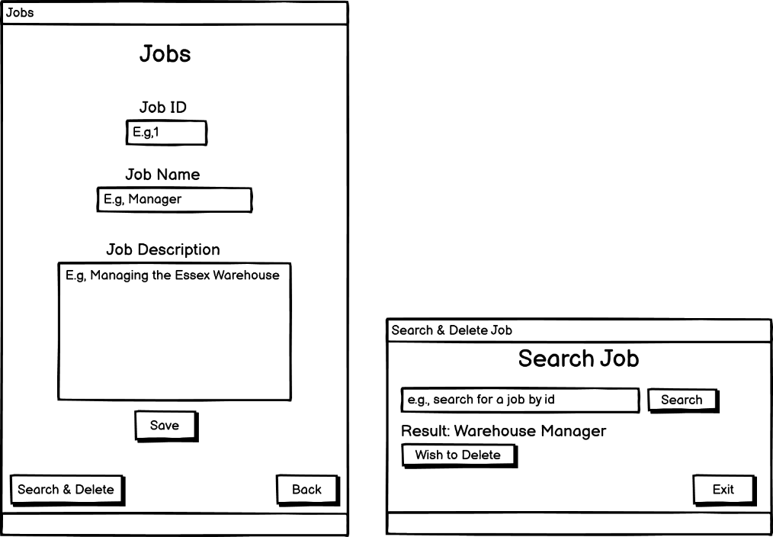

In organisations, there are many different job roles therefore, this section is used to make a job role within the company. It has three sections: job id, job name, and job description. The user can enter the data into these text inputs. The user can press the save button to add those details to the database.



The user can search and delete the job. The search works the same as figure 11.10 but, when the result is found the user can click on the “wish to delete” button to delete that job from the database.

*Figure 11.24 – Business Jobs Wireframe*

## **ERD for the Database**

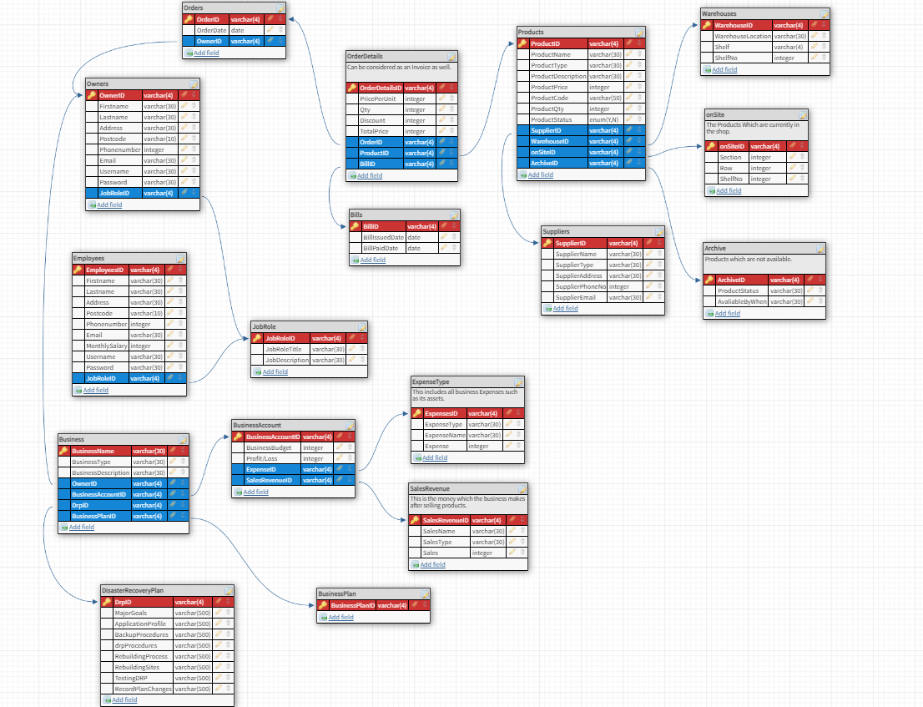

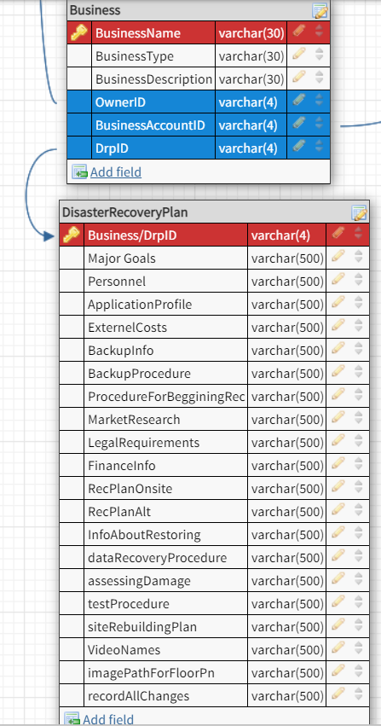

*Figure 11.25 – Entity Relationship Diagram*

The 3NF normalized database design with its primary and foreign key shows the logical design modal of how the data of the software system is stored. E.g., when the user signs up the data will be stored into this database. The database will be queried using the JDBC to manipulate data such as, selecting/searching, inserting, updating, and deleting the data into these tables shown in the design. In this diagram you can witness, a specific data can be identified from its table. The reason why this database has been developed is because, it can be used for accessing the data easily. This database design will be very effective for this software system. The data e.g., tables will be stored using MySQL and XAMPP: this will provide the modules for the apache and MySQL.

## **UML Case Diagram**

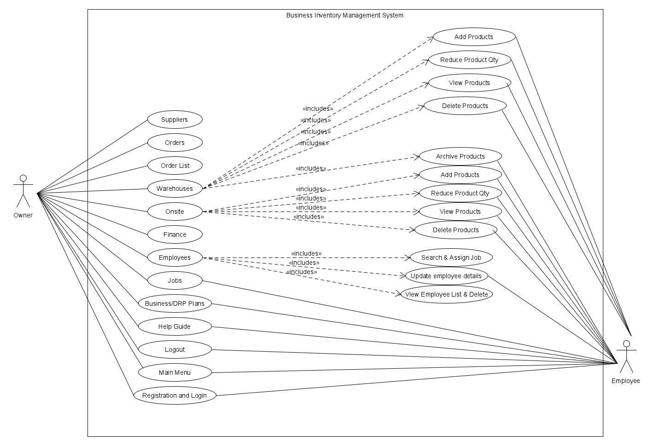

*Figure 12 – UML Case Diagram for Application access rights*

Figure 12 shows the security level of access such as which type of users are allowed to access which areas of the software system.

## **UML Sequence Diagram**

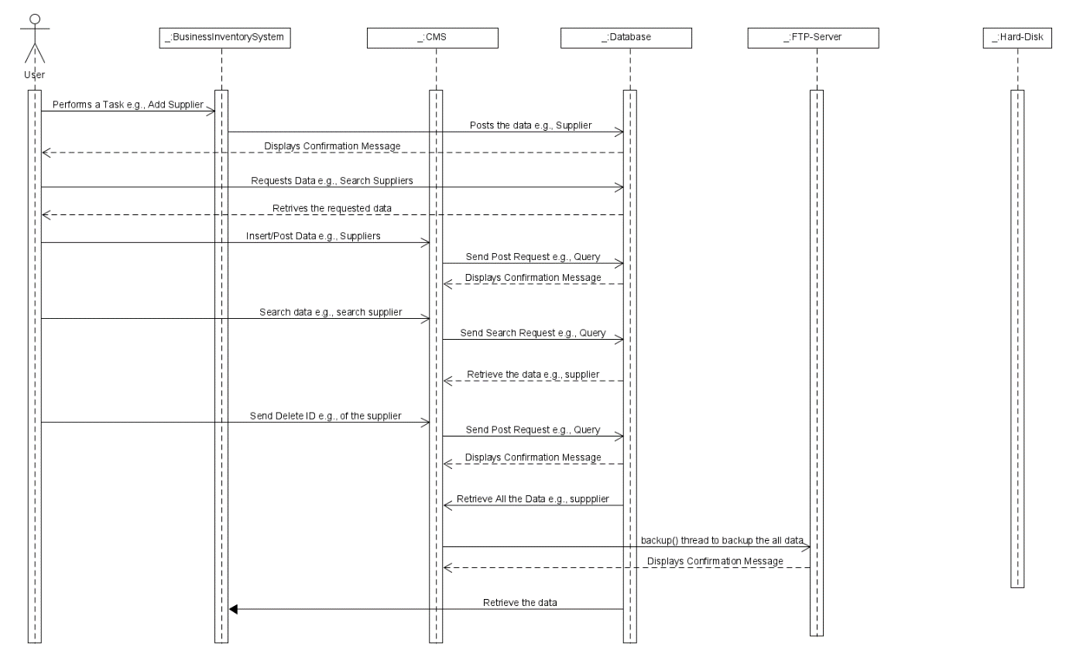

Figure 13 shows how the data flows within the application such as, when the users perform a task then, how does data get displayed onto the application, what requests it uses, how is data stored and retrieved, and how the data gets backed up. An example, relating to suppliers has been shown but, this will work for all the other functionalities as well.

*Figure 13 – UML Sequence Diagram to show the data access & Backup*

## **Navigation Design**

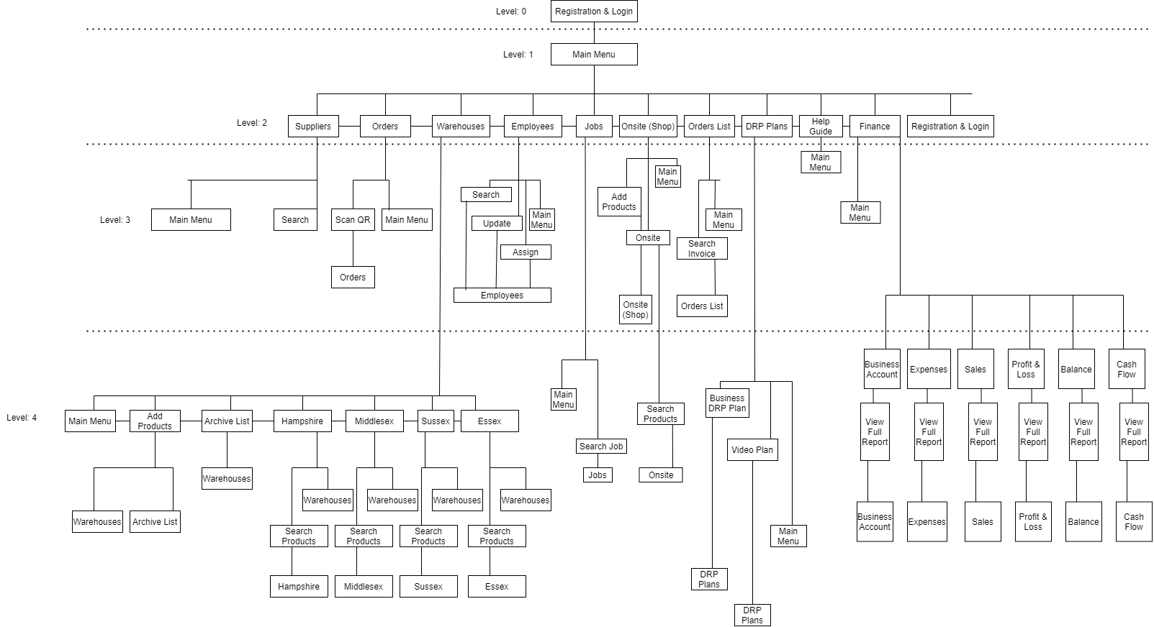

Annotation: 1

*Figure 14 – Software Application Navigation Design*

Figure 14 shows how the user can navigate through the business inventory system. Annotation 1 shows the names repeat, the reason for that is because, e.g., using the main menu the user can navigate to the suppliers and then, in the suppliers section there is a button for main menu which takes the user back, this is one example but, others work the same way.

## **Backup Design Architecture**

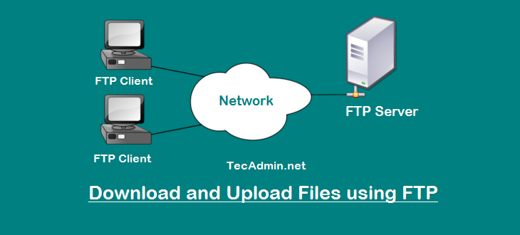

*Figure 15 – Backup Architecture Design using FTP-Server*

Figure 15 shows that the business owners can transfer their data from their own machine to the server. The server can be accessed from another machine to download data. This reduces the chances of data being lost or corrupted.

# ***Chapter 3: Implementation & Testing***

## **Implementation**

In this chapter the implementation of the software prototype will be covered. This is known to be the longest phase of the project. In the analysis and design chapter, the software prototype was designed which, is going to be used for implementing the software prototype. This chapter will also cover the different types of tools and technologies which were used for implementing the software. In the analysis and design chapter all the requirements have been specified therefore, the tools and technologies will be used to make these requirements work into practise to the best of its ability.

### **Tools & Technologies used in duration of the implementation**

The software prototype was developed on the HP envy machine using the NetBeans IDE with Java Programming language. NetBeans IDE and Java are known to have the best development environment for developing JavaFX applications as it provides the developer with all the necessary files (e.g., java packages, fxml files) to being the project, it’s very easy and user-friendly to use as the developer only has to click on buttons to build, compile, or run applications, or generating automatic code using data members which saves time of development and more importantly *“its integration is great with other tools” [13]*. This is the reason why Scene Builder was integrated with the NetBeans IDE.

Using the Scene Builder tool all the rich interactive GUIs with the initial design layouts were developed easily because, in scene builder the user only has to drag the **GUI design layouts and components** into the window scene view and then, all the GUI design layouts and components are getting stored into the .fxml file after that, .fxml file gets loaded into the Java class by the use of the Java FXML class loader. This tool reduces the development time as, the developer doesn’t have to spend a long time on the GUI development, which in reality takes a long time if its coded manually. it makes the programming code more concise because, there is no lengthy code for the GUI development in the Java classes.

There were small issues which caused hurdles such as, there were some GUI components which were not available e.g., Date Picker therefore, those had to be coded manually. Also, the height and width of the windows were never accurate therefore, the decision was made to manually set the height and width using the set methods and after that this issue was resolved.

On the next page, it can be witnessed how the integration is performed to develop the GUI.

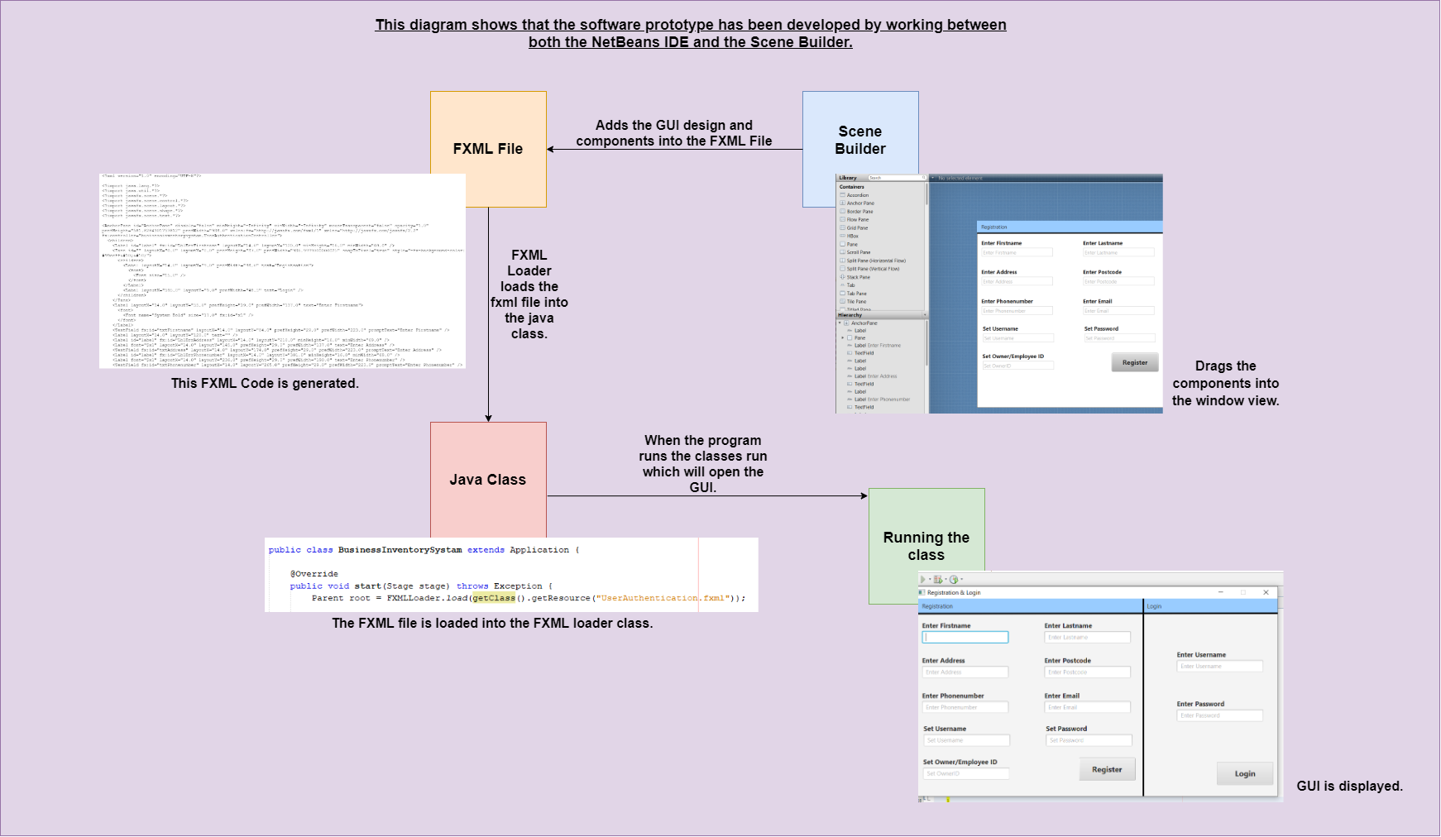

*Figure 16.1 - Integration between development software’s for developing rich GUIs*

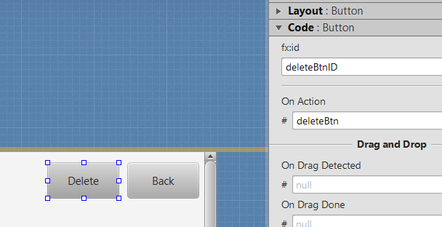

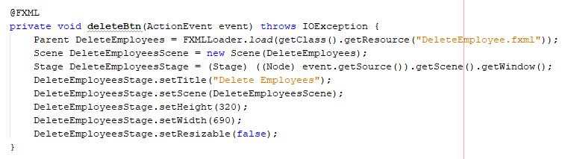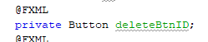

*Figure 16.2 – fc:id & on action*

In figure 16.2, an fx:id is set in the scene builder and then, it gets automatically generated into the code. The same for on actions and other types of events, such as input a name and then the event method automatically gets generated. This saves time writing lengthy code and makes the methods more accurate.

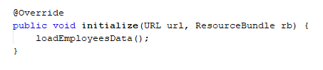

*Figure 16.3 – initialize method*

This method is automatically generated when each fxml, and java controller file is created, and anything inside this method will be executed when the selected class begins to run, this will be the first step. This method will be witnessed in the later sub-sections.

MySQL database was developed for storing and retrieving data to and from the application. The database design ERD which was designed in the design chapter in figure 12.5 was now developed using the Xampp and HeidiSQL software.

Xampp was used for running MySQL on the development machine. HeidiSQL was used for developing the database. Xampp was also used for developing a mysqldump which, makes a backup copy of the database and its current data.

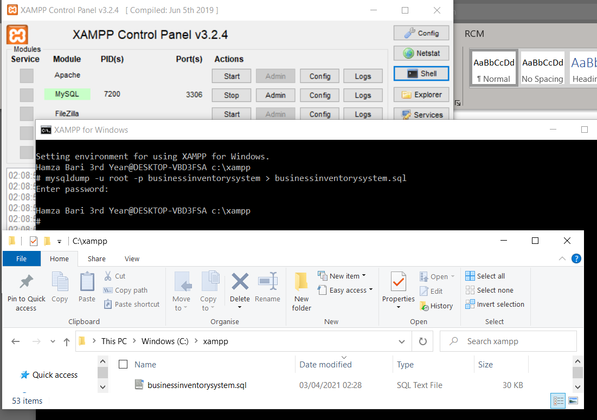

*Figure 16.4 – MySQL Dump Database Backup*

The reason why HeidiSQL was chosen is because its user-friendly as, the developer only has to use the GUI interface to develop the database for example, click on a button to add a table, row, or column.

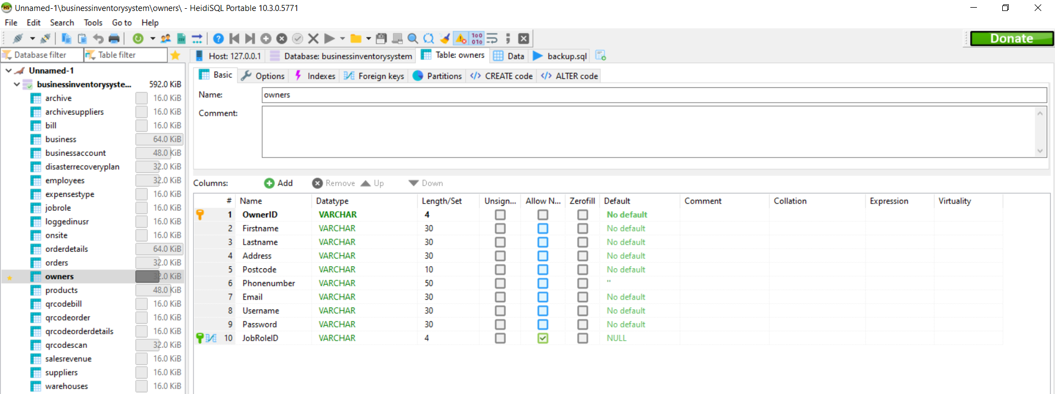

*Figure 16.5 – HeidiSQL Environment*

This saves time on developing the database manually using code, which also reduces less chances of making a mistake.

Developing the database was pretty simple but, there were many issues regarding the database such as it had many design errors, which were realised in the later stages when storing the data from the application to the database. Due to those design errors, it experienced difficulties which includes data not being added due to, foreign key not working, or stopping from adding the data, primary key giving duplicate exception errors, in short, it’s said that due to the design issues data couldn’t be captured the first time around. Therefore, during the implementation the developer had to revisit the areas of the database a lot of time and change those but, the only advantage the developer had in the whole senecio was that the changes were made quickly as, HeidiSQL is a simple tool to use. After, making the changes the data is being stored perfectly.

After, all the GUI, database, and all the beginning software architecture was developed then, it was the time to develop all the other main functionalities of the software prototype.

### ***Starting of the program***

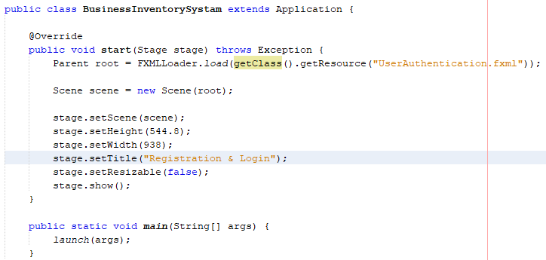

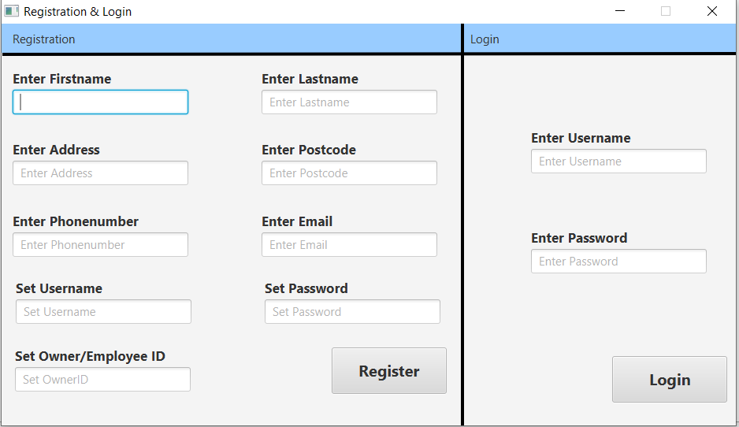

*Figure 16.5 – The Main Class loading* user authentication class

This is the main class containing the main start method. This main class is interacting with the user authentication class. Therefore, when the user clicks on the start button the user authentication class runs as, a result the user authentication window opens up first.

### ***Intuitive User Interface***

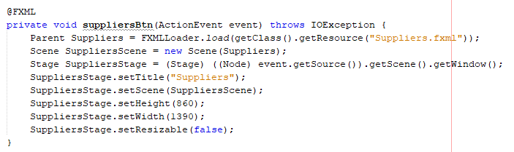





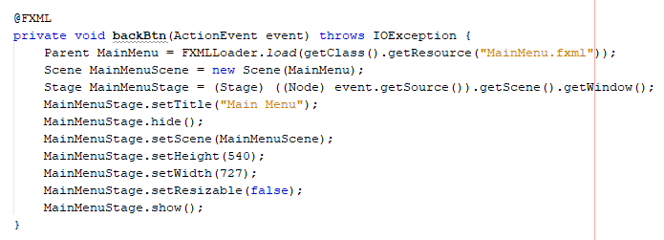

*Figure 16.6 – IUI Example*

In main menu class there is a button event method to navigate to different sections and, each classes have a method to navigate back to the main menu. If there are sub-sections in a section, they all have a button to navigate back the same way shown in figure 16.6. FXML Loader sets the class name of where to navigate.

### ***User Authentication***

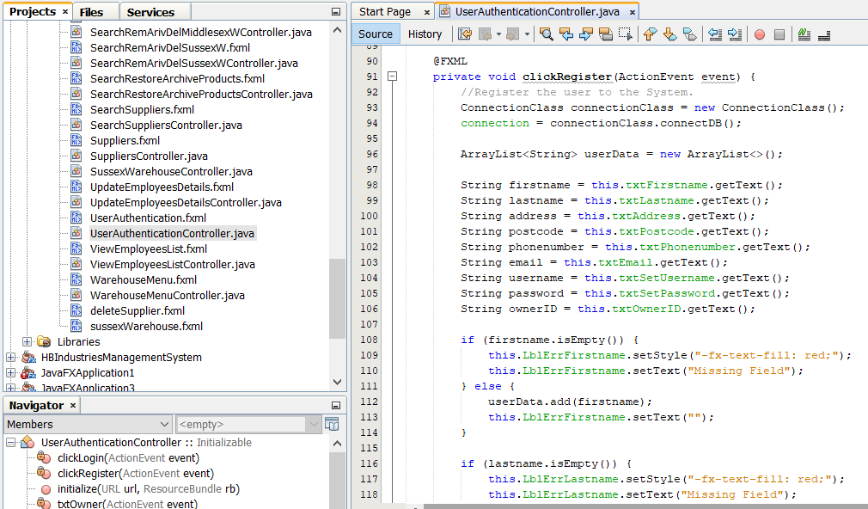





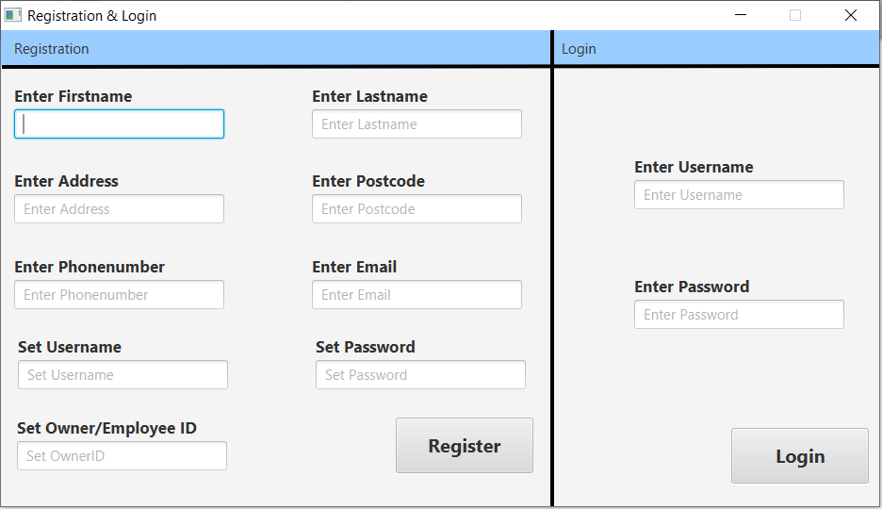

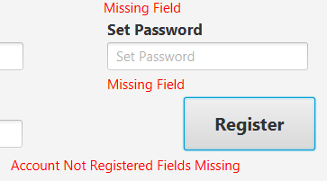 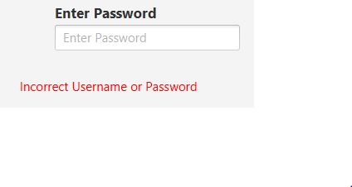 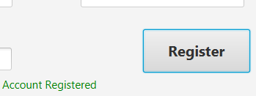

*Figure 16.7 – Screenshot of User Authentication Controller*

This class has two sections which are register and login for them owners and employees. In registration, it checks if the data inputted is correct and depending on the result it displays a message. In login, it checks if the username and password exist in the owners/employees table or not, depending on the result it displays a message, and navigates to the main menu controller if login successful. Error messages displayed in red, success message displayed in green.

### ***Main Menu***

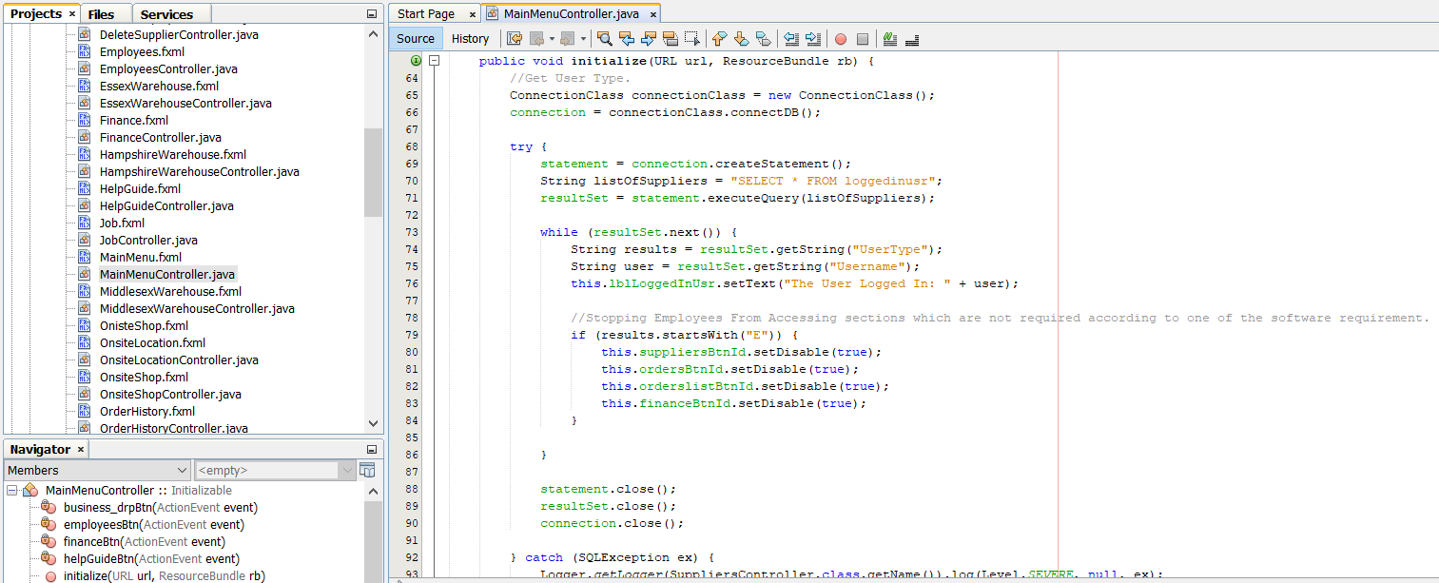

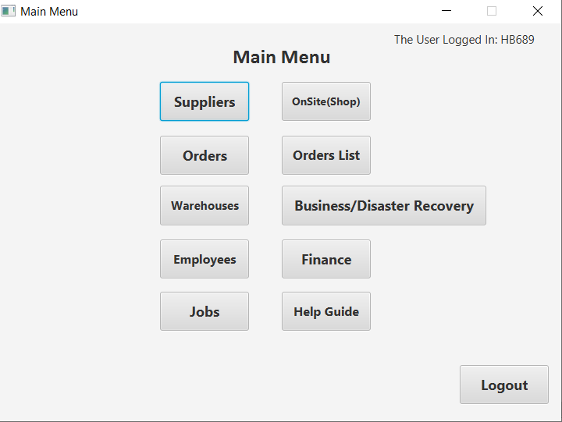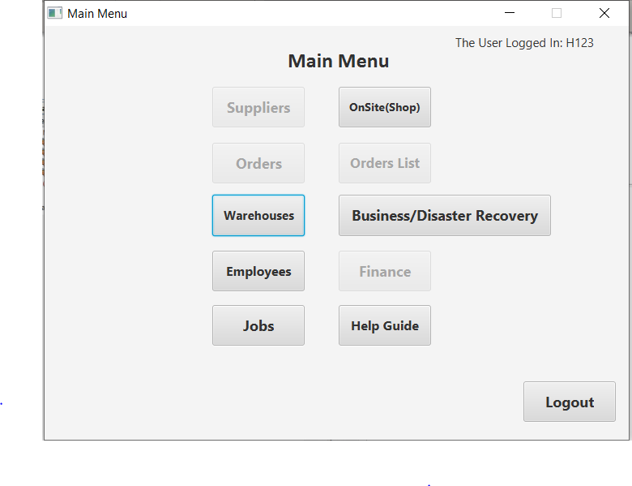

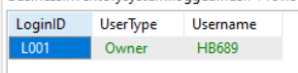

*Figure 16.8 – Screenshot of Main Menu Controller*

This class gets the data from logged in user table and then, its checking if the user type logged in begins with an “O” or an “E” as, the function is used for checking if it’s an owner or an employee. If owner then, all buttons are true but if employee then, some buttons are disabled. For more detail check: figure 12. An update query with same login id is performed every time a new user logs in or out and, it sets their username into the top-right label.

### ***Suppliers***

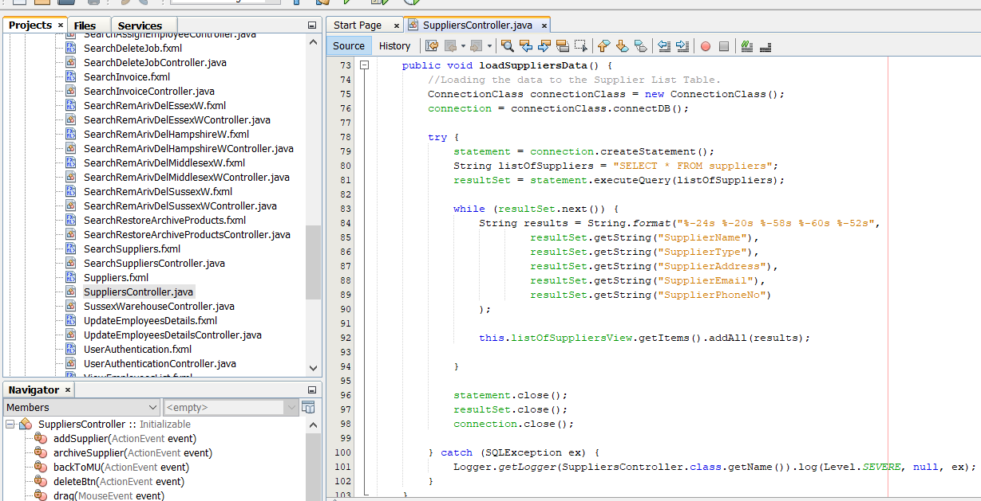

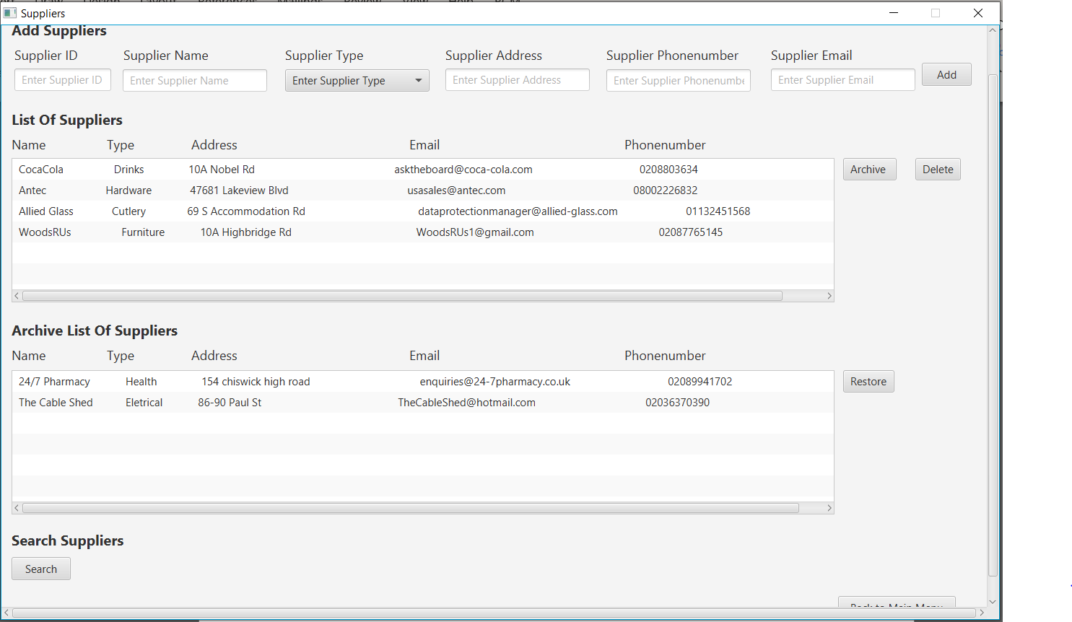

*Figure 16.9 – Screenshot of Suppliers Controller*

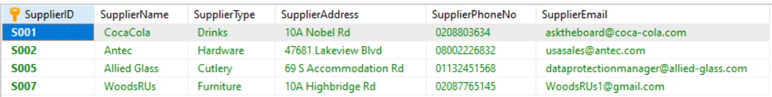

*Figure 16.9.1 – Screenshot of Suppliers Table*

Figure 16.9 shows the suppliers controller. The add suppliers section is where the user can add a supplier to the suppliers table. In the list of suppliers section all the suppliers are listed from the suppliers table (shown in figure 16.9.1) by using the select query.

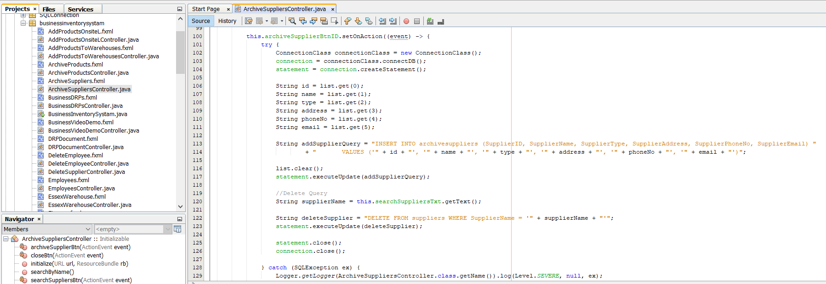

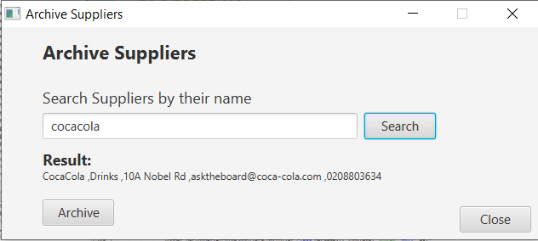

*Figure 16.10 – Screenshot of Archive Suppliers Controller*



*Figure 16.10.1 – Screenshot of Archive Suppliers Table*

In figure 16.9 a button can be viewed which says “Archive Suppliers” which navigates to archive supplier windows. By, clicking on the search button it will get the value from the text field and apply the search query therefore, if the query matches then, it sets the suppliers details into the result label. By clicking the archive button it would first perform a delete query by name to remove the supplier from the suppliers table and, then it would perform an insert query to insert all the suppliers details into the archive suppliers table shown in figure 16.10.1. In figure 16.9 in the archive suppliers list view it displays all the data which is in the archive suppliers table by using the select query.

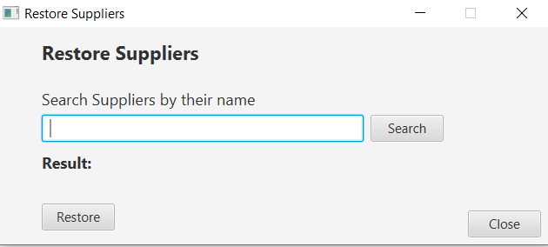

*Figure 16.11 – Screenshot of Restore Suppliers Controller*

The restore sections works exactly the same way as the archive suppliers but, does it the opposite way around deletes from archive suppliers table and adds the details into the suppliers table.

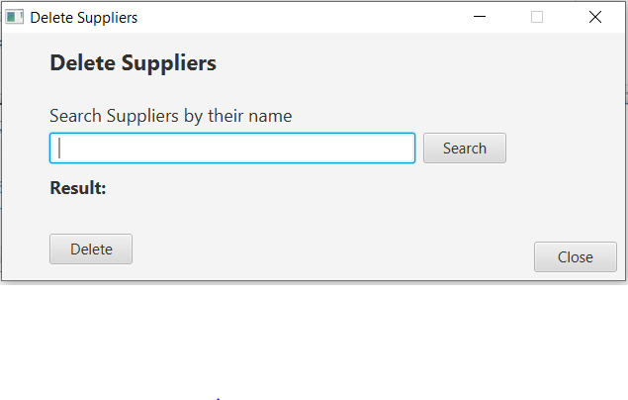

*Figure 16.12 – Screenshot of Delete Suppliers Controller*

The search works the same way as shown in figure 16.11 and 16.12 but, this time performs the delete query on the supplier name to remove the supplier from the suppliers table.

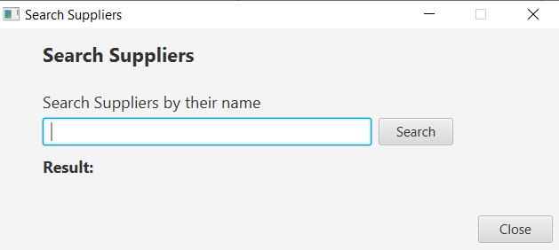

*Figure 16.13 – Screenshot of Search Suppliers Controller*

The search works the same way as shown in figure 16.11 and 16.12.

### ***Orders***

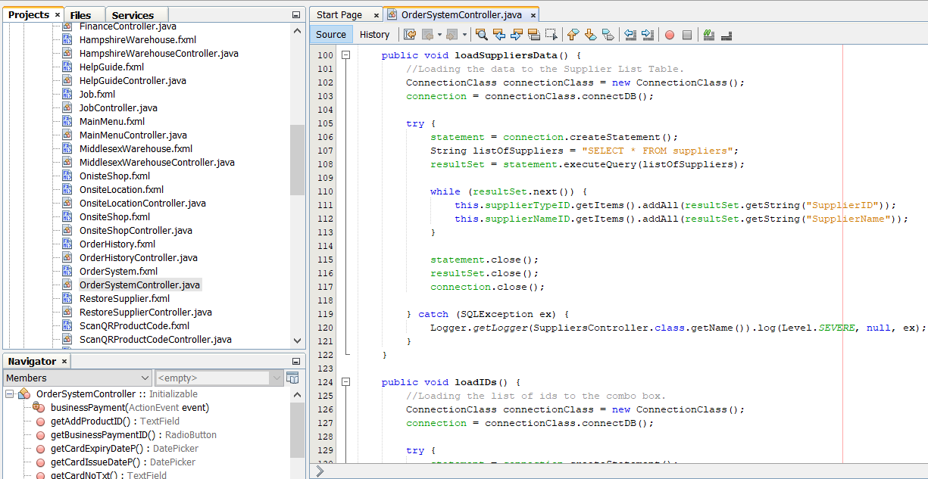

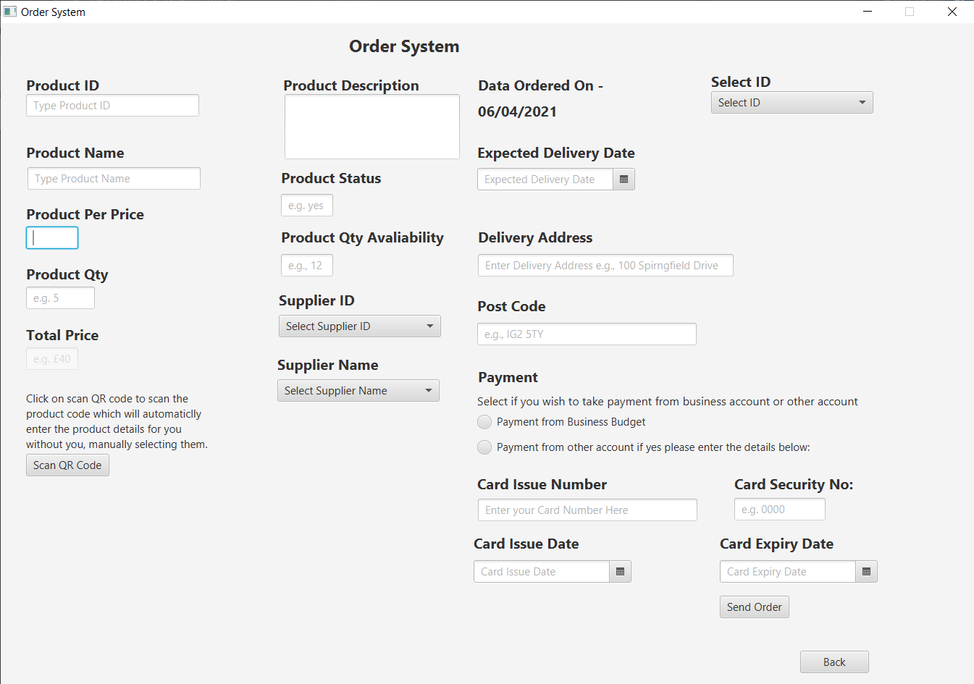

*Figure 16.14 – Screenshot of Order System Controller*

This class is used for owners ordering products from suppliers. This is where the owners would add all their ordering details of the product they want to order. After that, click the send order button to add all the products and order details into the database (shown in figure 16.15) using the insert query.

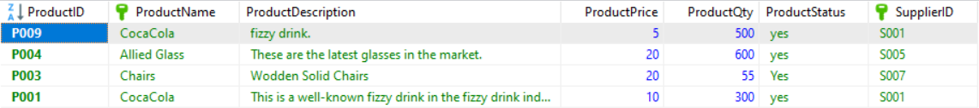

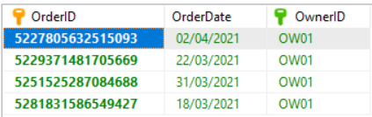

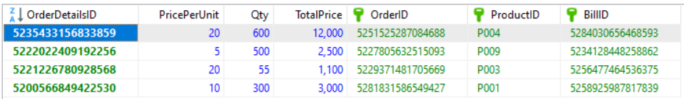

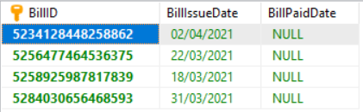

*Figure 16.14 – Data Storage of products, order, & order details*

Figure 16.14 shows all the products ordered are added into the products table, the order and order details for the products e.g., data and time are stored into the order and order details which uses foreign keys. A bill is also automatically generated which gets stored into the bill table.

The long-digits primary keys are automatically generated using math random class.

There are slight issues in this section of the software:

* The bill paid date is kept “NULL” because, there was no solution identified for this at the stage of implementation.
* Date picker wasn’t available with the scene builder but, a solution was identified:

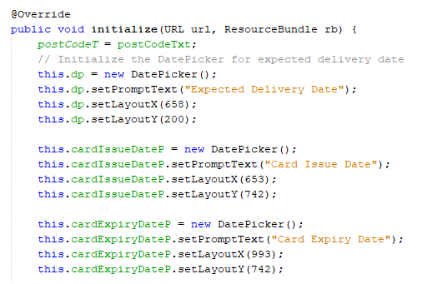

*Figure 16.14.1 – Solution for Date Picker*

Date-Picker is initialized and coded manually. It’s been added into the initialized method therefore, it automatically loads up when the order class runs.

### ***QR Code Scan***

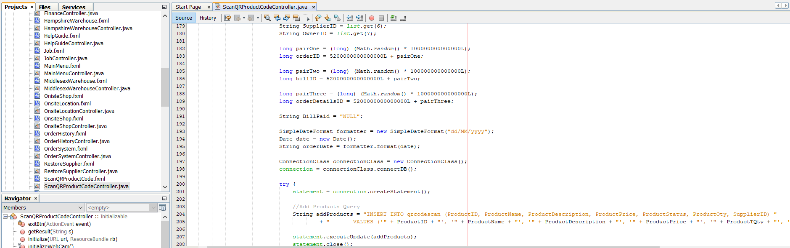

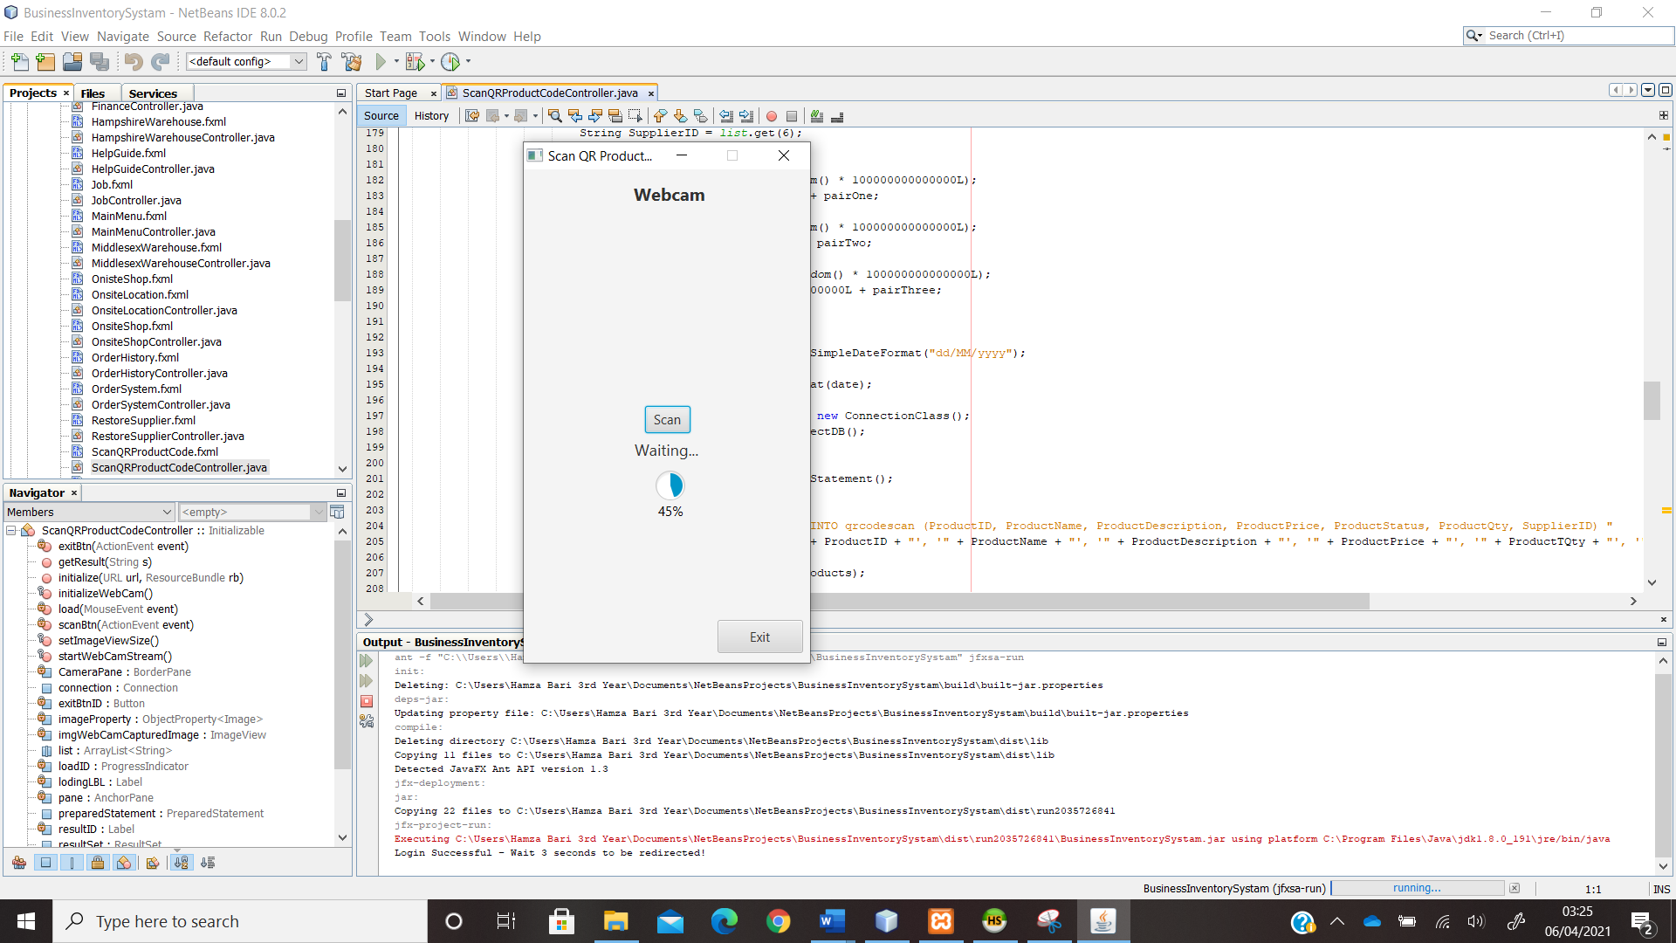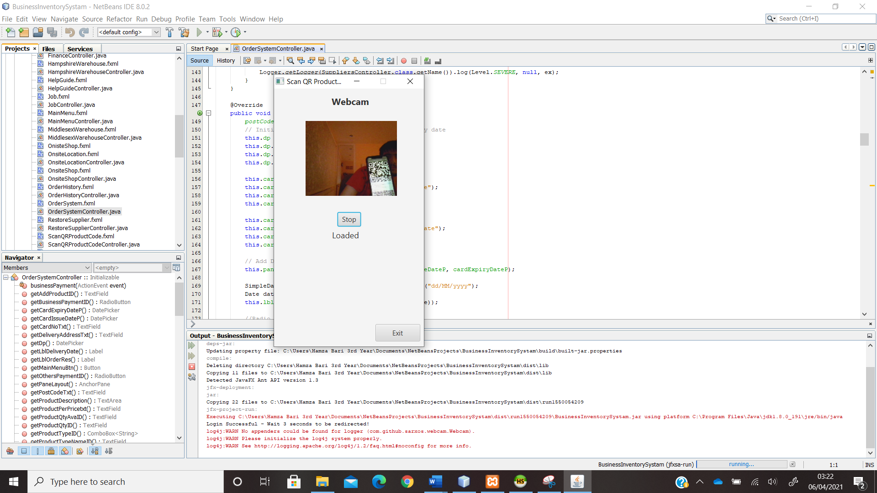

*Figure 16.15 – QR Code Scan Controller*

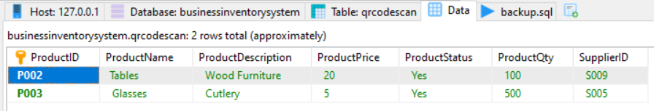

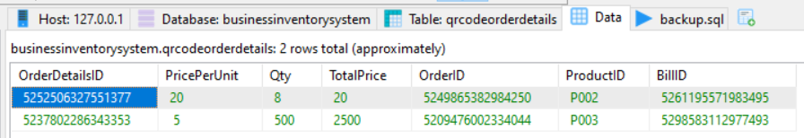

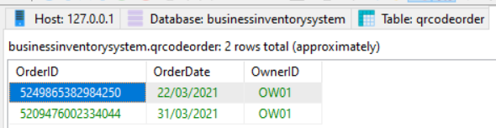

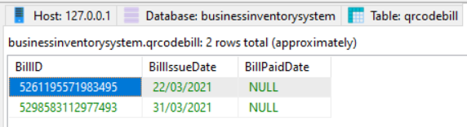

*Figure 16.16 – Data Storage of QR Code products, order, & order details*

This class has been used for scanning QR Codes. Figure 16.15 shows, by pressing the button scan it would start loading the webcam. When the webcam is loaded, then the user needs to show the QR code to the camera which will automatically scan the QR code and then, add all the products and orders details automatically into the QR code products, order, and order details table shown in figure 16.16. This is a key functionality of the software therefore; this functionality is explained in detail below:

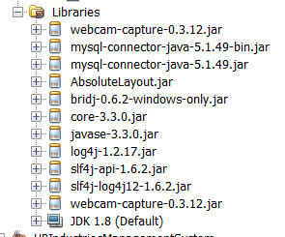

Figure 16.17 shows the webcam API and QR Google-Zxing API has been added into the project library.

*Figure 16.17 – API libraries*

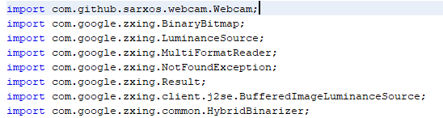

*Figure 16.17.1 – Import libraries*

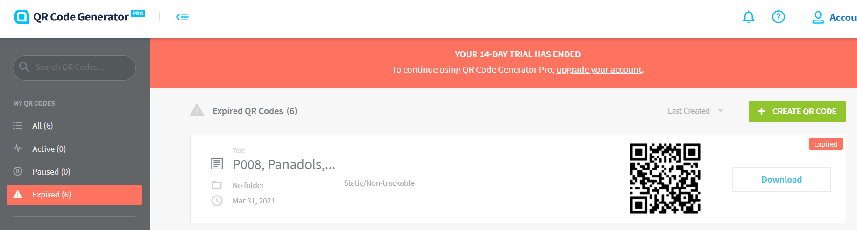

*Figure 16.17.2 – Developing QR Codes*

The QR codes were generated using an online website called QR Code generator: <https://app.qr-code-generator.com/>. In those QR code the text is set into them, meaning if they are scanned then, it would return back text. Therefore, the product details text has been set into them which is shown in figure 16.17.3.



*Figure 16.17.3 – QR Codes Set Text*

The required libraries have been imported.

Variables for webcam initialized.

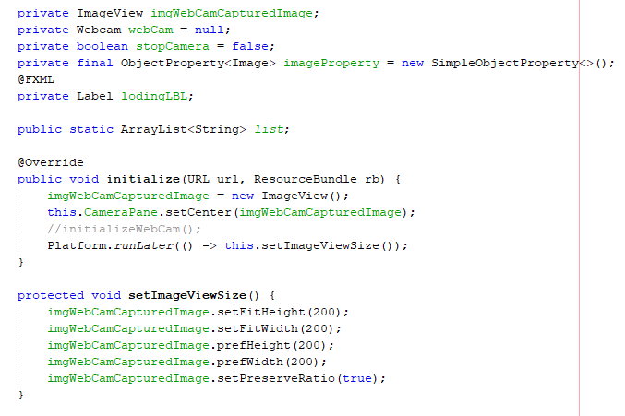

This is where the webcam is loaded automatically when the controller class starts running. In the method, it creates a new webcam view object and sets, the captured image into the webcam. Perform run later is used for displaying your webcam video.

This methods adjusts the image view of where the webcam will be placed.

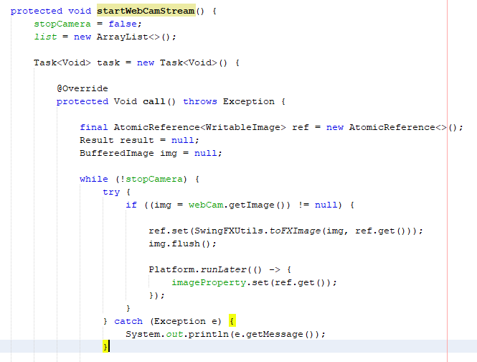

All executions happen step-by-step automatically in the Task object method once, the webcam starts streaming.

This is used for getting the image of the QR code.

The method start webcam stream is used for starting the webcam. The while loop is executing when the webcam is running. Therefore, it gets the image, and then using the writeable image reference, it gets the pixels and objects of that image scanned. Then, those pixels are set into the image property using the perform run later function.

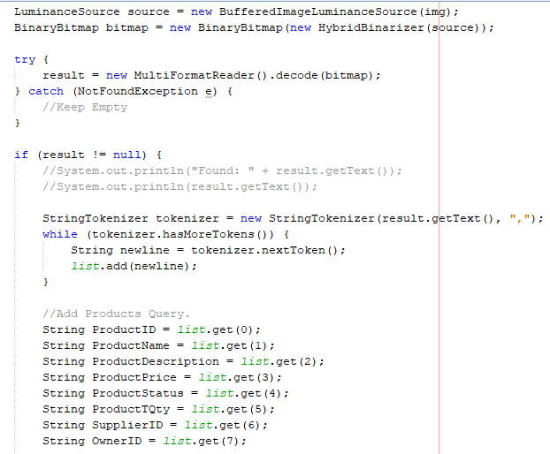

The image above is set to the luminance source because, this object will ensure that the reader doesn’t modify anything for example, if the image is tilted a bit while scan then, it should still scan. The binary bitmap will then, decode those pixels of the QR code image. The reason why Hybrid Binarizer is used with bitmap image is because, *“It is designed for high frequency images of barcodes with black data on white backgrounds. For this application, it does a much better job than a global black point with severe shadows and gradients.” [14]*.

After that, using the multi format reader it will decode the bitmap QR code image therefore, if the result if not null then, it will add all QR code text into the list data structure. The string tokenizer has been used to separate each word in the text by “,”.

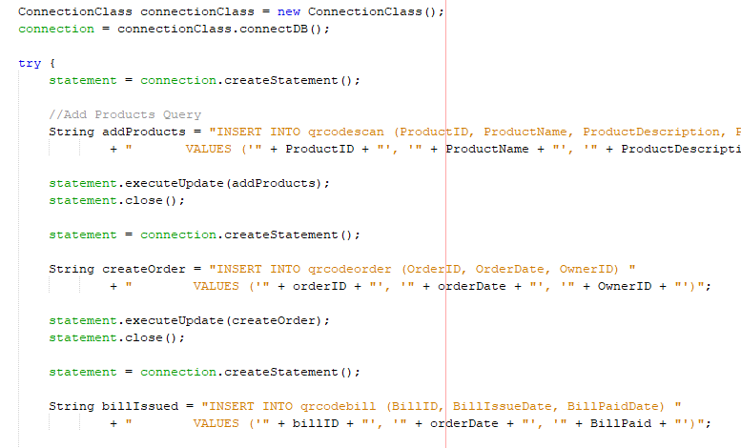

Once, its gets each word separated by “,” then, it adds that data into the tables using the insert queries.

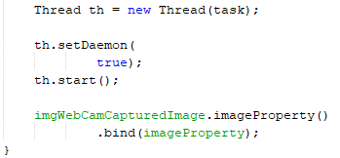

The thread is used to start the webcam task whenever the users press the scan button and the webcam starts streaming which basically, performing all executions in the task object method step-by-step which is mentioned earlier. Finally, it would set the image property of the QR code scanned into the webcam image view.

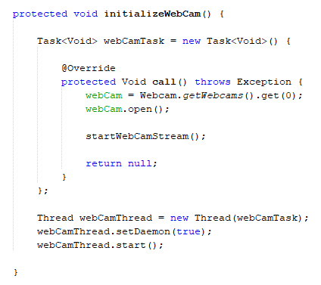

This is the initialize web camera method which creates another Task Object method. This time it gets the webcam from which is installed in your local machine e.g, OBS camera. Then, it opens that web camera and after that, it starts the web camera stream method to scan the QR code. A thread is set to the Task Object which starts every time the camera opens.

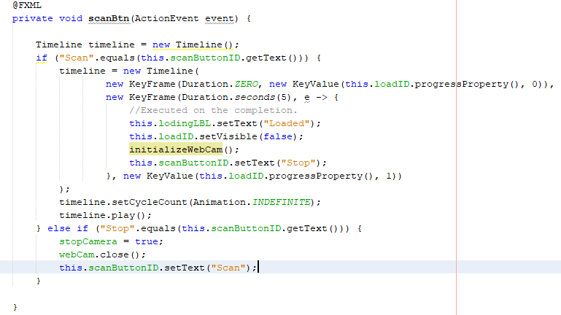

This initialized method is started when the scan button is pressed. A timeline is a timer which is used for setting the time for the code execution to begin. Its set to 5 seconds therefore, once the button is pressed then, it will take 5 seconds to complete the loading bar to 100% after that, it will begin the execution of the initialized webcam method.

*Figure 16.17.2 – Webcam Controller code*

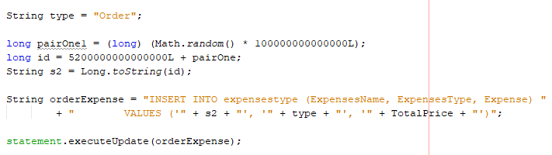

*Figure 16.17.3 – Expense query code*

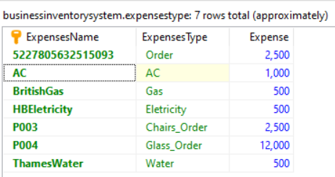

*Figure 16.17.4 – Expenses Table*

After each supplier orders, an expense is automatically generated through this expenses query shown in figure 16.17.3. This is included for both order system and QR code order system. Figure 16.17.4 shows the expense name of what product the order was for, and what type of order it was, and expense shows how much the order cost the organisation.

### ***Onsite***

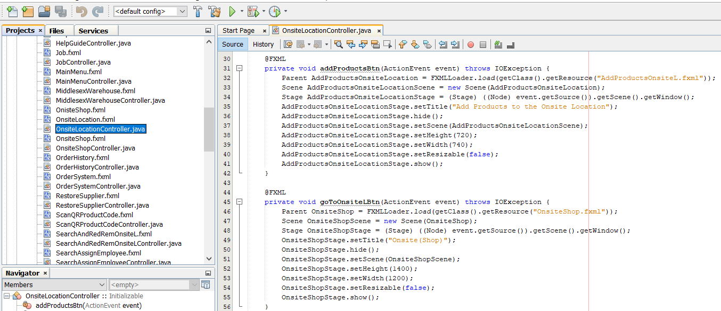

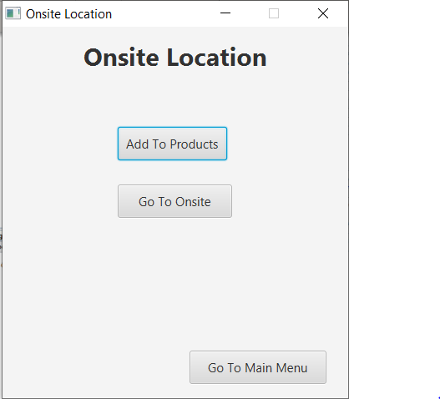

*Figure 16.18 – Onsite Menu Controller code*

This class creates a menu for the onsite location.

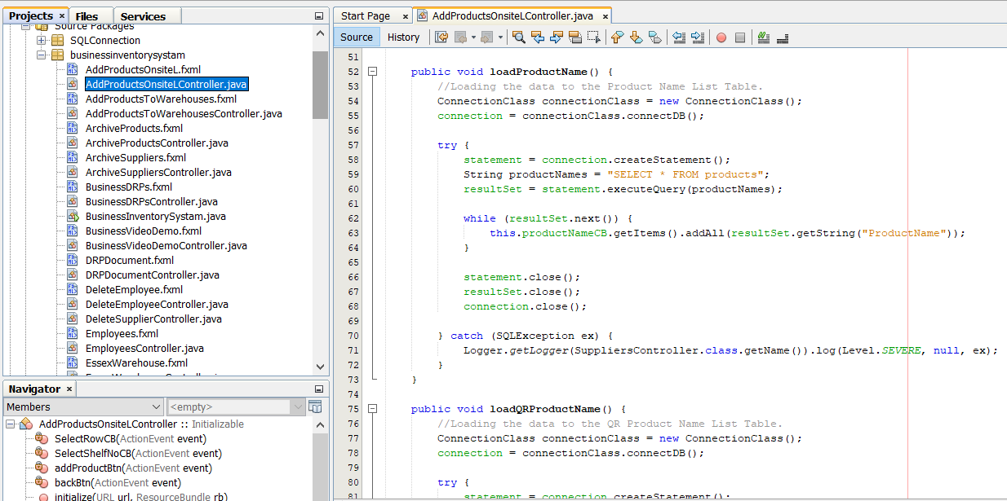

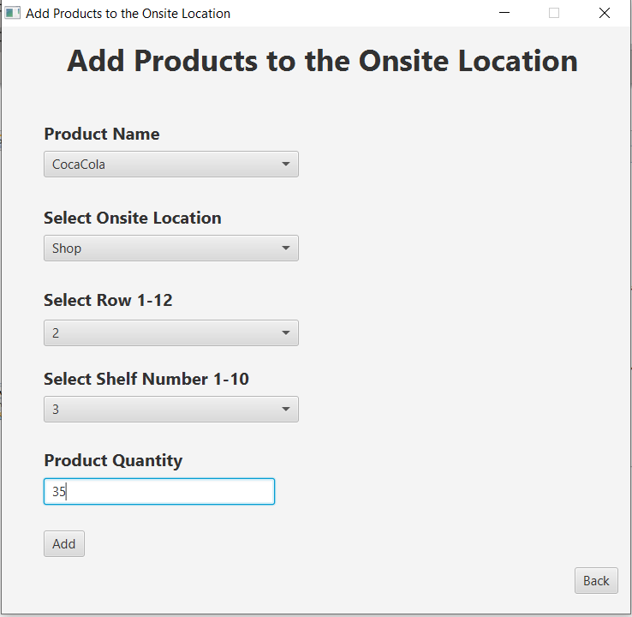

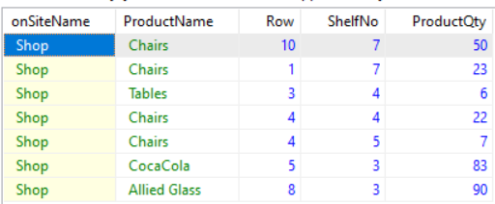

*Figure 16.19 – Add Products to Onsite Controller code*

This class is used for adding the products into the onsite (shop) table. The product names have been loaded from the products table and have been added to the product name combo box option.

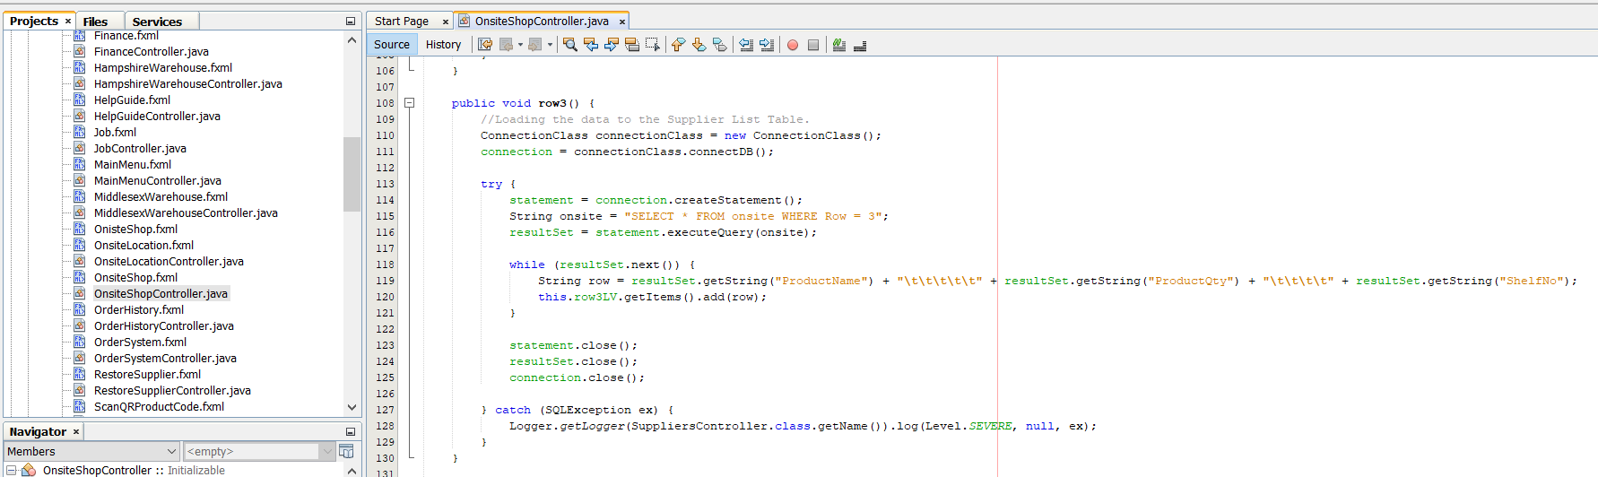

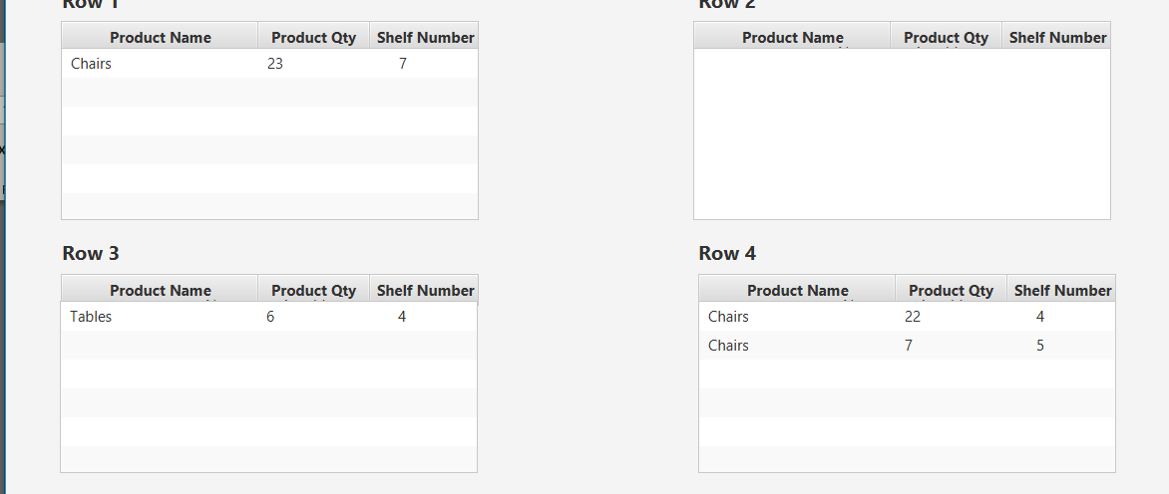

*Figure 16.20 – Onsite Controller*



*Figure 16.20.1 – Onsite Row Code Example*

Figure 16.20.1 shows one example of row-number 3. The way the method works is the following: the select method has been applied on row-number 3 which means it will get all the data where the row number is 3. After that, it will add the results into the row 3 list view. There are about 12 rows in the onsite and each onsite has its own method and list view component to display the data.

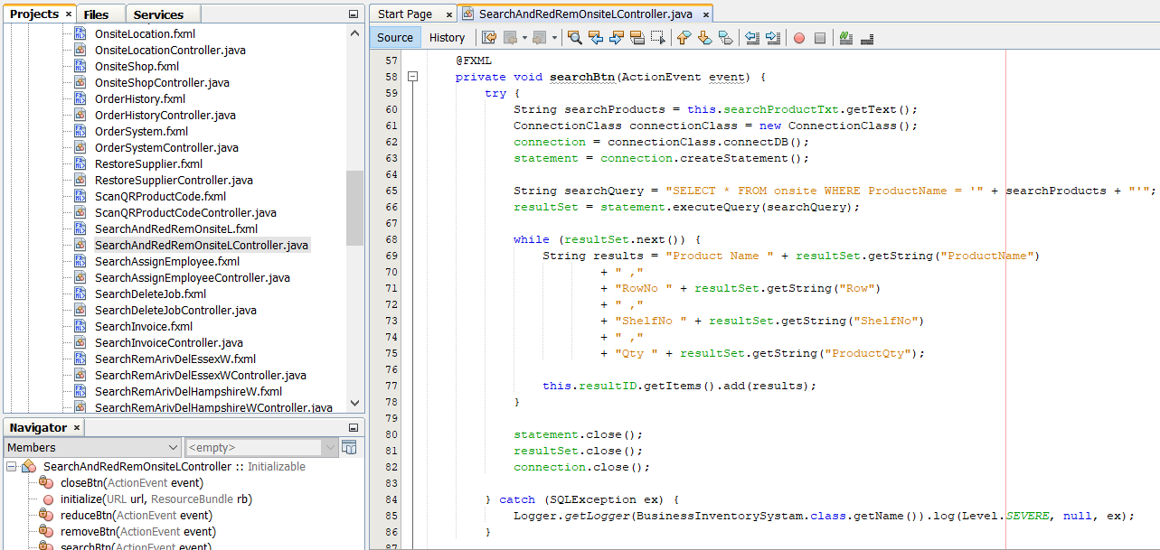

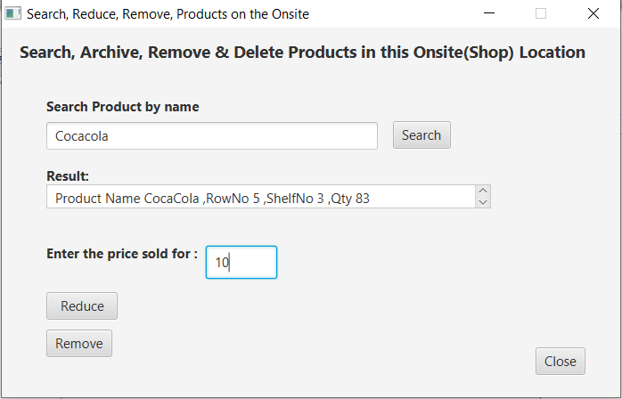

*Figure 16.20.2 – Onsite Search, Archive, & Delete Controller*

The search and delete for this controller work the same way shown in figure 16.10 for searching and 16.12 for deleting/removing. The extra feature in this controller is that, in the textbox the user can enter the price to sell the product and then, press the reduce button which will reduce the product quantity down by one in the onsite table and the onsite rows. In addition to that, it will create a sales revenue because, each time setting the price and then, reducing the product means that the product has been sold which automatically generates revenue therefore, it adds that to the sales revenue table which can be witnessed in figure 16.20.3.

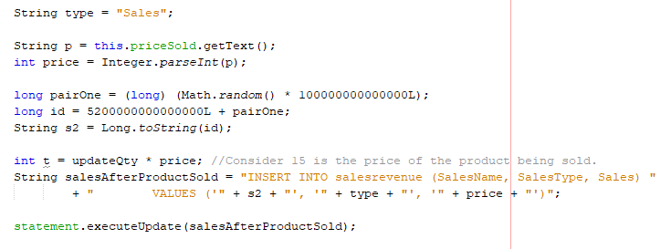

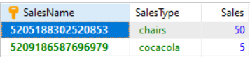

*Figure 16.20.3 – Sales Revenue*

### ***Orders History***

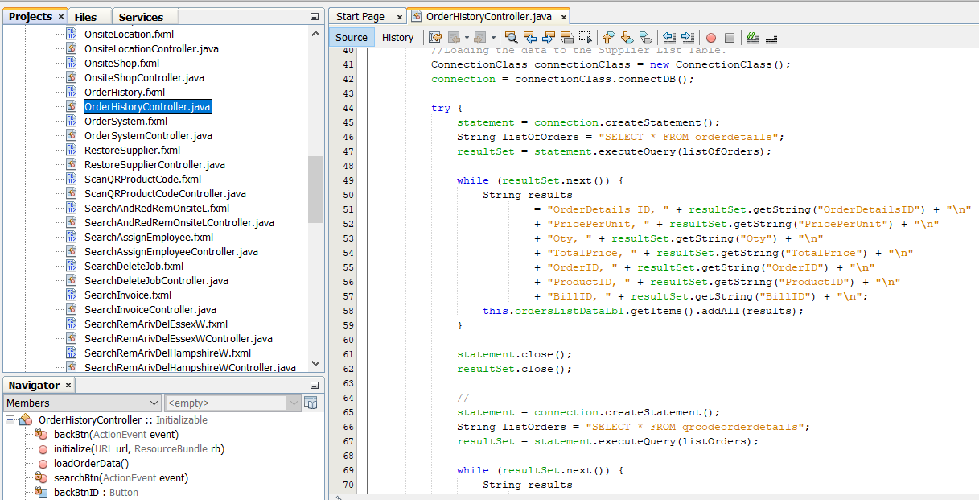

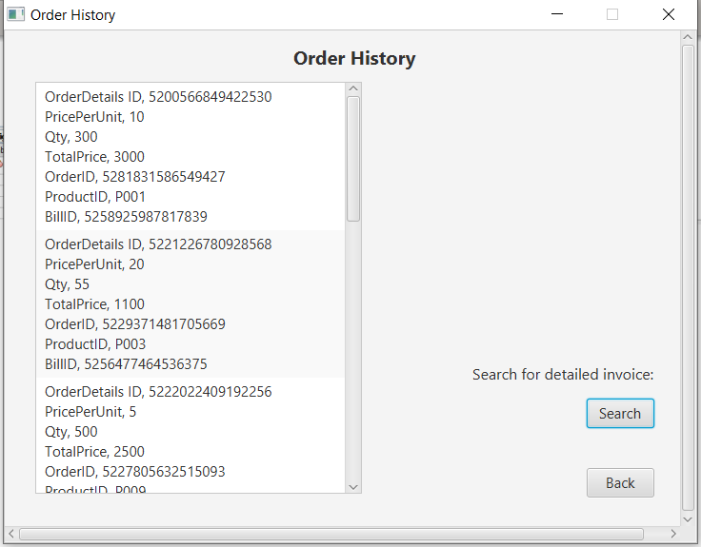

*Figure 16.21 – Order History Controllers*

In this controller the select query has been used on the order details of the products which have been added manually and, through the QR codes after that, they are added into the list view.

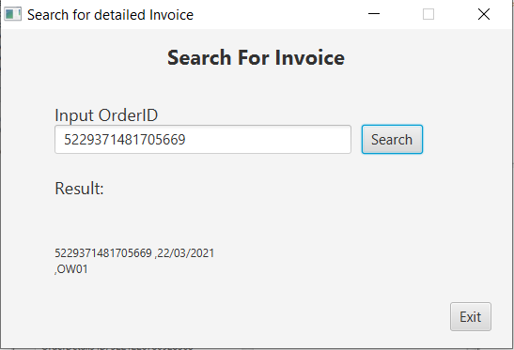

*Figure 16.21 – Search Order Invoice Controllers*

The search is applied on the order and QR code order table and it works the same way as shown in figure 16.10.

### ***Warehouses***

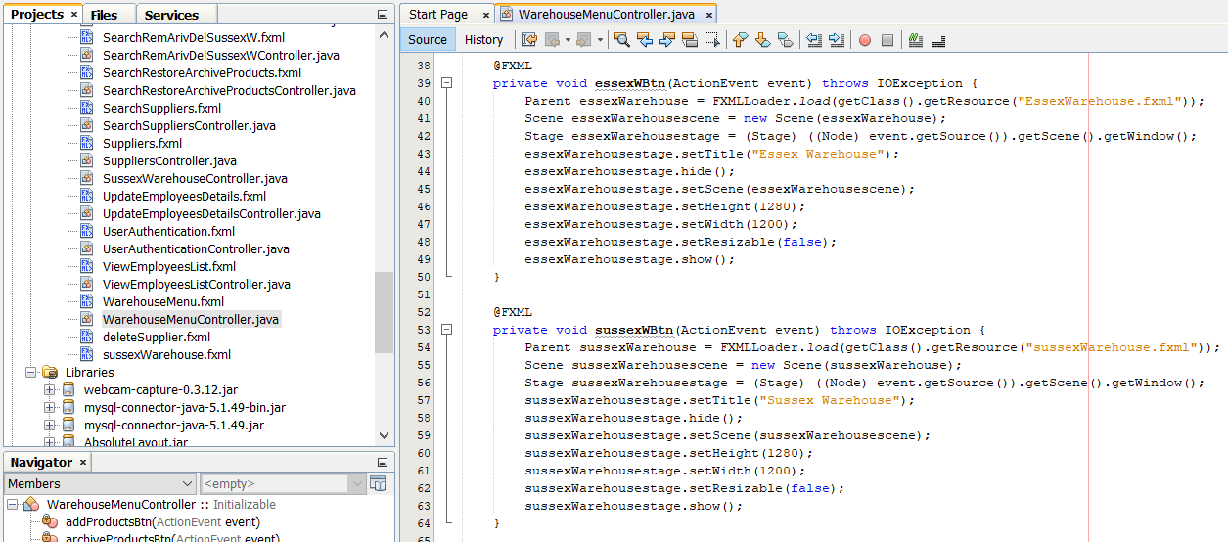

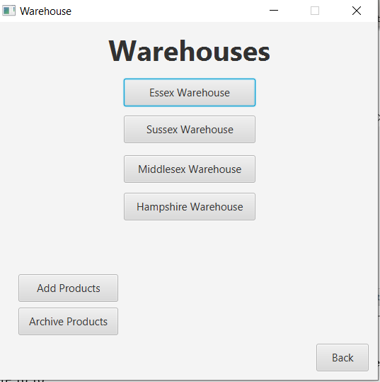

*Figure 16.22 – Warehouse Menu Controllers*

Figure 16.22 works the same way as figure 16.18.

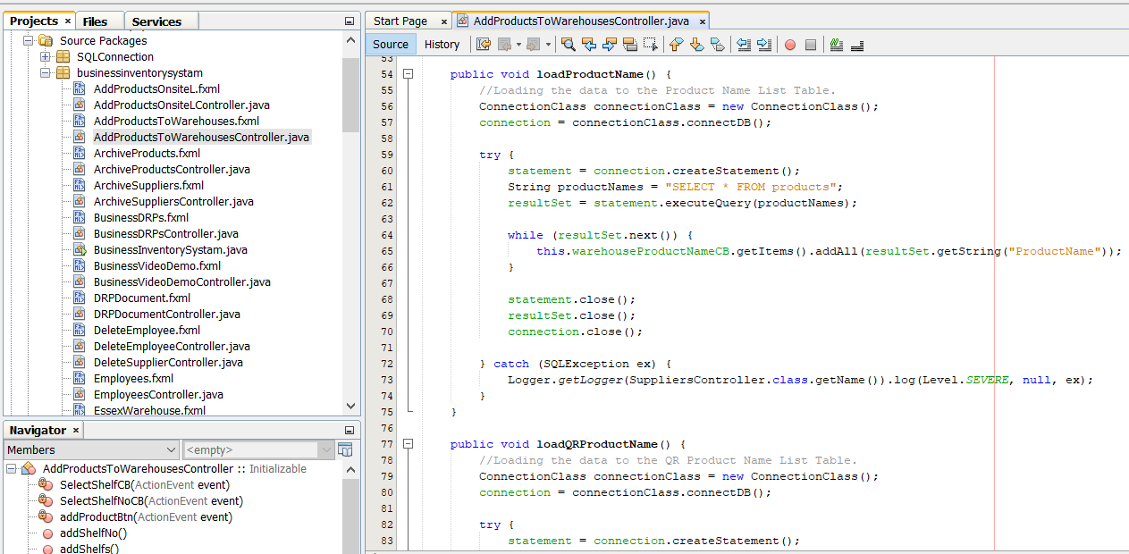

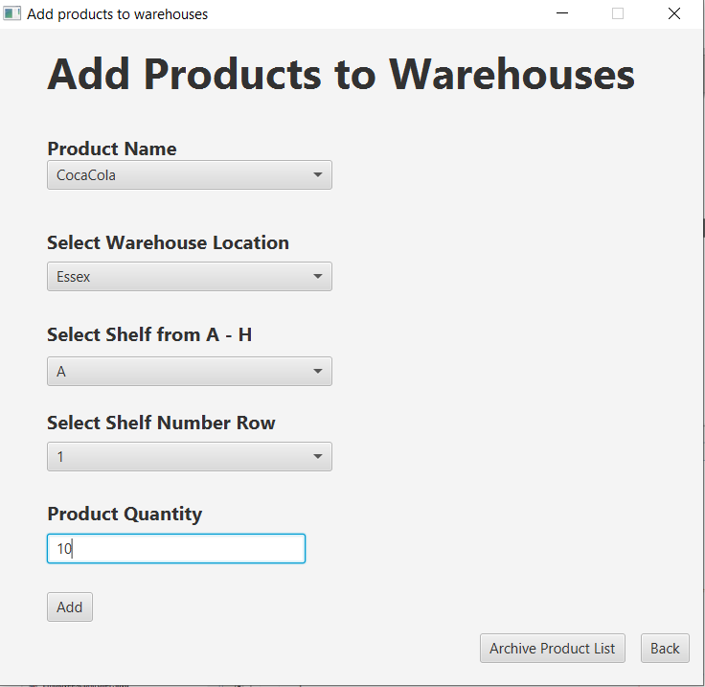

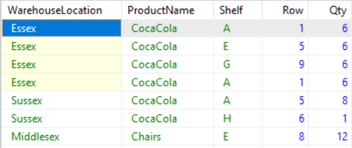

*Figure 16.23 – Add Products to Warehouse Controllers*

Figure 16.23 works exactly the same way as figure 16.19. This time it adds data to the warehouses table.

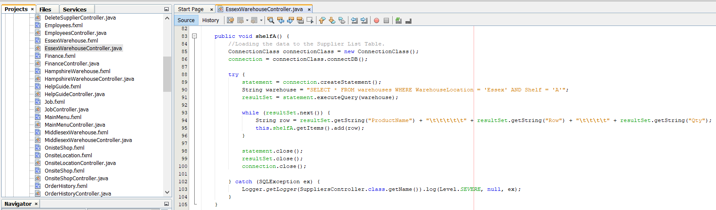

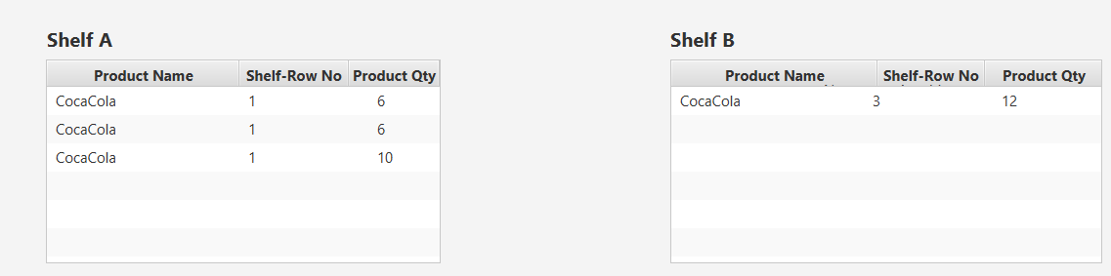

*Figure 16.24 – Products Warehouse Controllers*

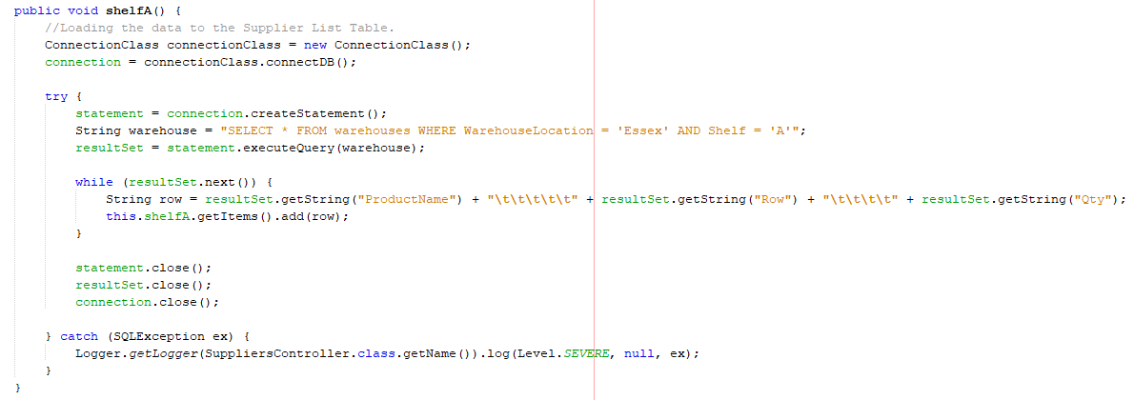

*Figure 16.25 – Products warehouse code*

Figure 16.24 shows the Essex warehouse controller with all the products in the shelf. There are about A-H shelfs in the warehouse, and each shelfs have products inside them. Each shelf has its own method and a shelf list view. The select query checks where the location is, and then it checks the Shelf letter, and based on that it gets the results from the warehouse table and then, those results are added into the Shelfs list view, which are displayed in figure 16.24. Figure 16.25 shows an example of Shelf A only, otherwise for all the other shelves it’s the same method but, the query uses a different letter.

Apart from Essex warehouse there are three other warehouses called: **Sussex, Middlesex, and Hampshire**. They also have warehouses and shelfs A-H. The other warehouses work exactly the same as the Essex warehouse shown in figure 16.24 and 16.25.

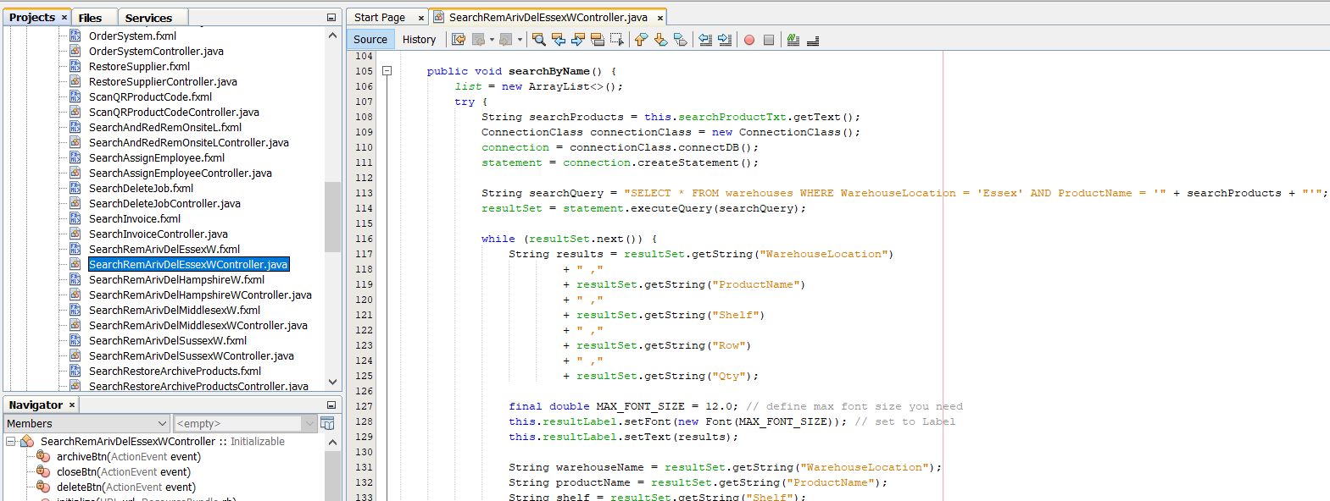

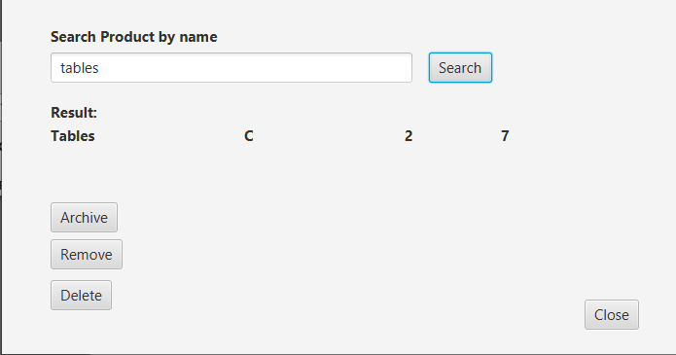

*Figure 16.26 – Search Product in the warehouse by their names*

Figure 16.26 works the same way for search and archive as shown in figure 16.10. Search and remove works the same way as figure 16.20.2. Search and delete works the same as figure 16.12.

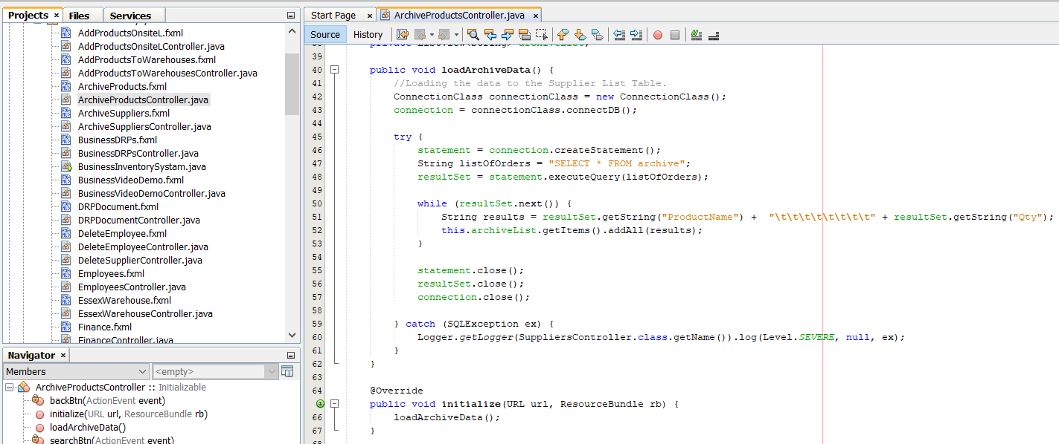

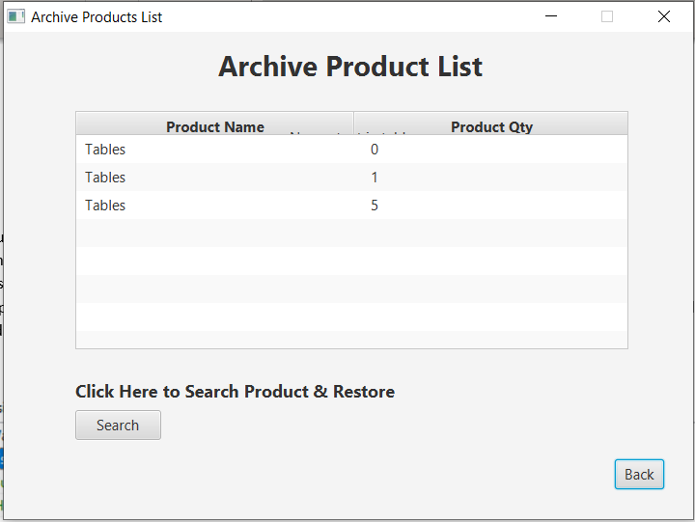

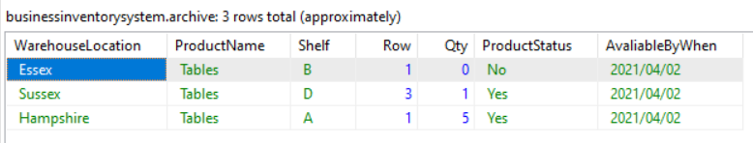

*Figure 16.27 – Archive products in warehouses*

Figure 16.27 shows the archive products list. Whenever a product is unavailable, then the user archives the product. Any products archived from any warehouse will be added to the archive products table. The archives products data will be loaded into the list view which is seen above.

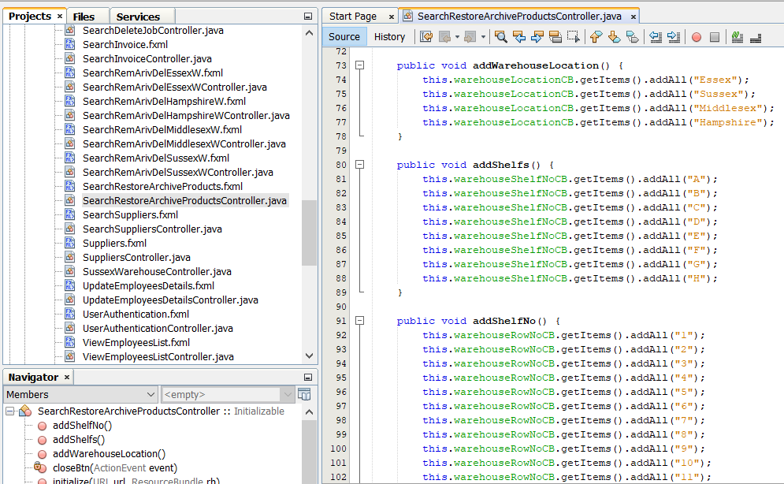

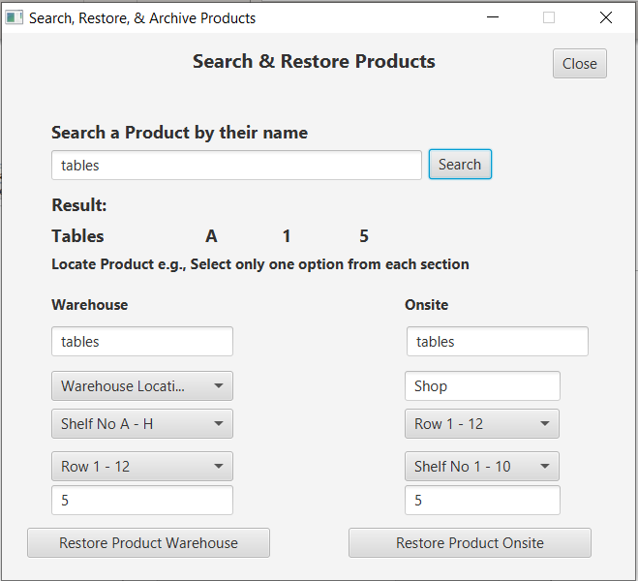

Selection options for both sections are the same as figure 16.23 for warehouses and, figure 16.19 for onsite.

*Figure 16.27 – Search & Restore products in warehouses*

The search for figure 16.27 works the same as figure 16.10, though the process for restoring products is quite different. When the search button is pressed and the result comes down then, the product name and quantity data from the result is automatically loaded into the warehouse and onsite sections text fields. In both cases, the user has to decide whether they want to restore the product into the warehouse or onsite therefore, depending on the user choice e.g., warehouse, the user would have to click restore button which would delete the product data from the archives table and add it to the warehouse or onsite table depending on the choice.

The archives section is available from figure 16.23 and 16.27.

### ***Employees***

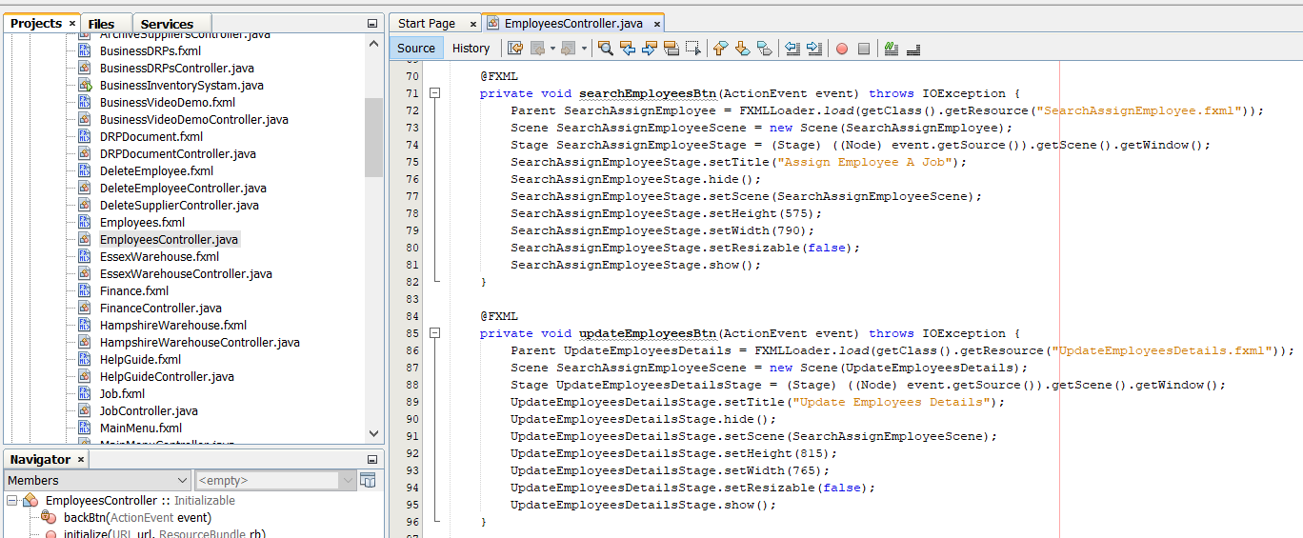

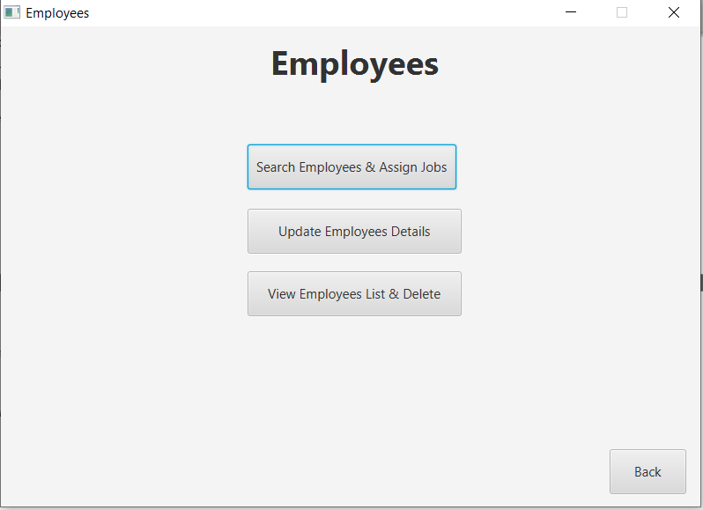

*Figure 16.28 – Employees Menu Controller*

This works the same as figure 16.18.

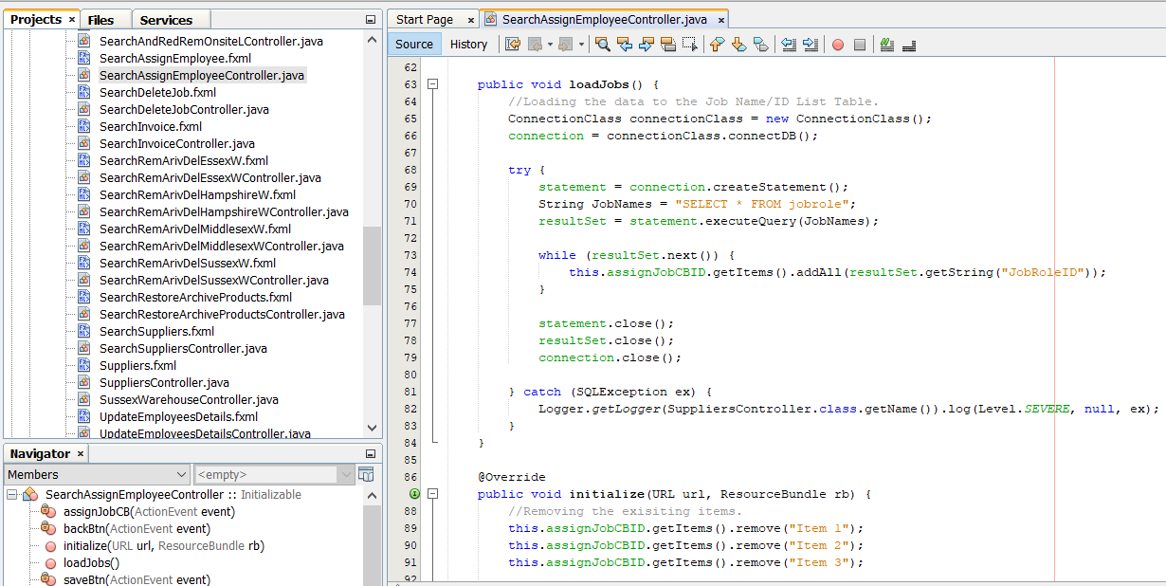

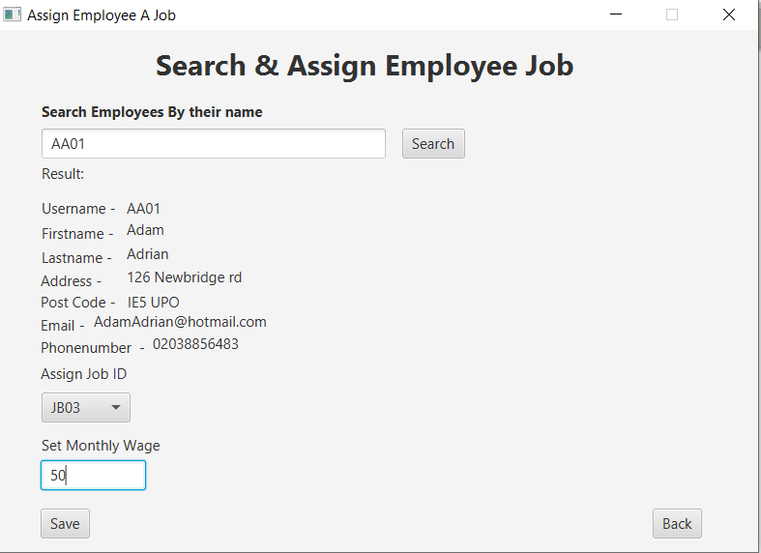

*Figure 16.29 – Search & Assign Controller*

Before Assigned.



After Assigned.

*Figure 16.29.1 – Employees Table*

In figure 16.29 the user must, input an employee id in the text field and then, the search button should execute the search from employee id query which displays all results next to the labels shown in figure 16.19. When a new employee signs up, then his monthly salary and job role is kept null. When the employee is searched then, a job is assigned to them using the combo box and their wage is inputted into the text field after that, by clicking the save button it performs the update query to change from null to newly updated data.

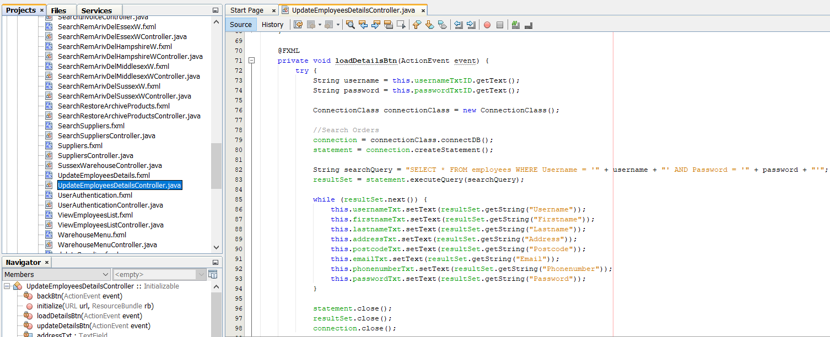

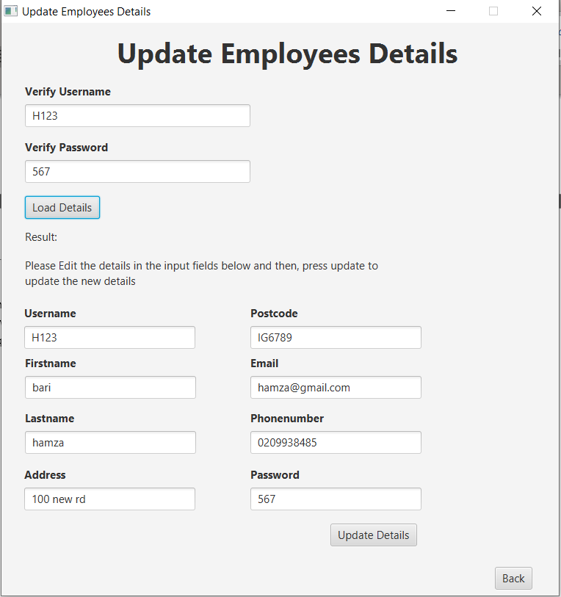

*Figure 16.30 – Update Employees*



*Figure 16.30.1 – Login Query*

Figure 16.30 contains a login feature for all employees to change their details. The employee would input their username and password and press load details button. After that, it gets the username and password from the input by the get method and, then it performs a SELECT AND query shown in figure 16.30.1 therefore, if both username and password exist then, it would load all the employees details into the results text fields below. After that, employees can change their data in the text fields and click the upload button which, will perform the update query as a result, the employee details will be updated in the employee table. There is a slight issue here which I’ll mention below:

* All details are not updated once therefore, the user must edit one text field, then click the upload details button to update and then, to change another detail the user has to repeat the same process as, it won’t do it all at once.

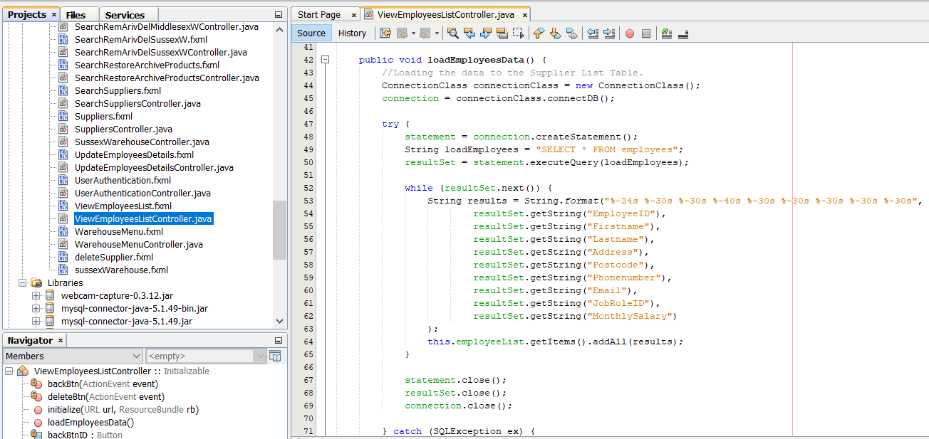

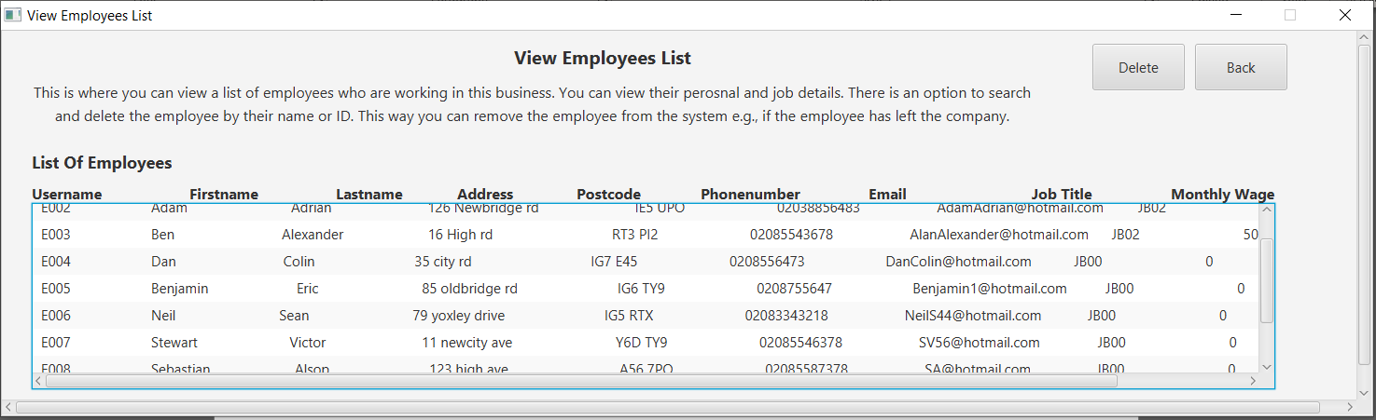

*Figure 16.31 – View & List Employees Controller*

All employees in the employees table are added into the list view by executing the SELECT * FROM Employees query. The owners can view all the employees who are working in the organisation.

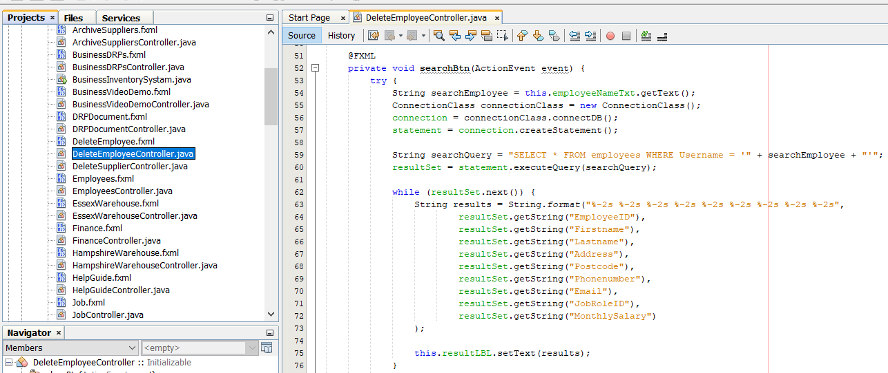

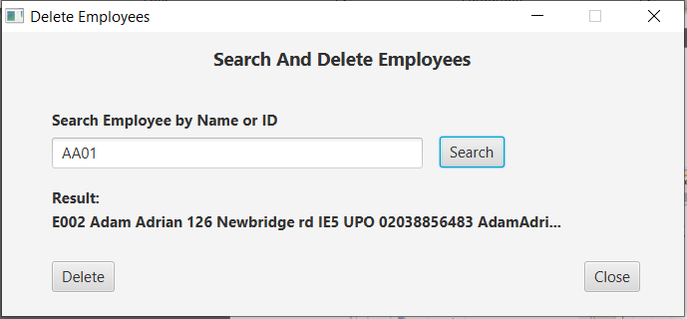

*Figure 16.32 – Delete Employees Controller*

Figure 16.32 works exactly the same way as figure 16.12.

### ***Jobs***

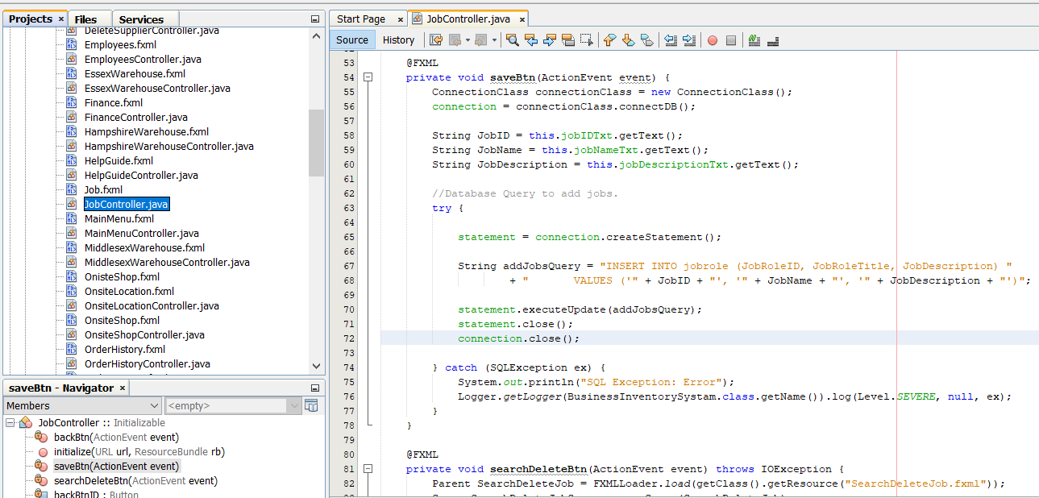

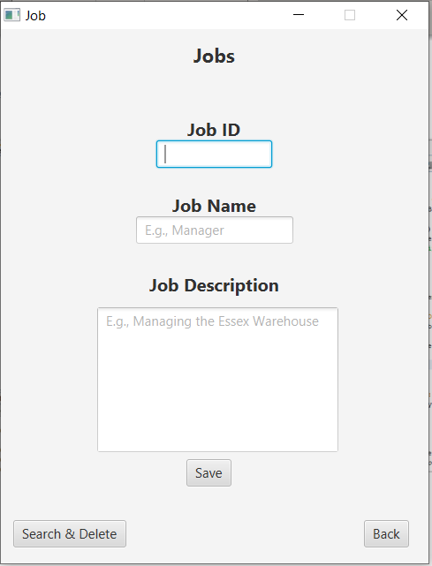

*Figure 16.33 – Add Job Roles Controller*

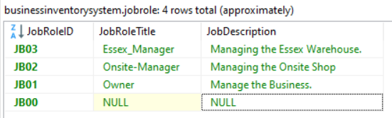

*Figure 16.33.1 – Job Roles Table*

Figure 16.33 is where the owners can add new job roles to their organisation using the text fields to input the job id and name, text area for typing the job description as, that usually requires longer text. After that, clicking the button save will insert the job role into the job table.

Note that “JB00” means NULL. When an employee newly registers then, their job role is NULL basically “JB00” before they are assigned an actual job role.

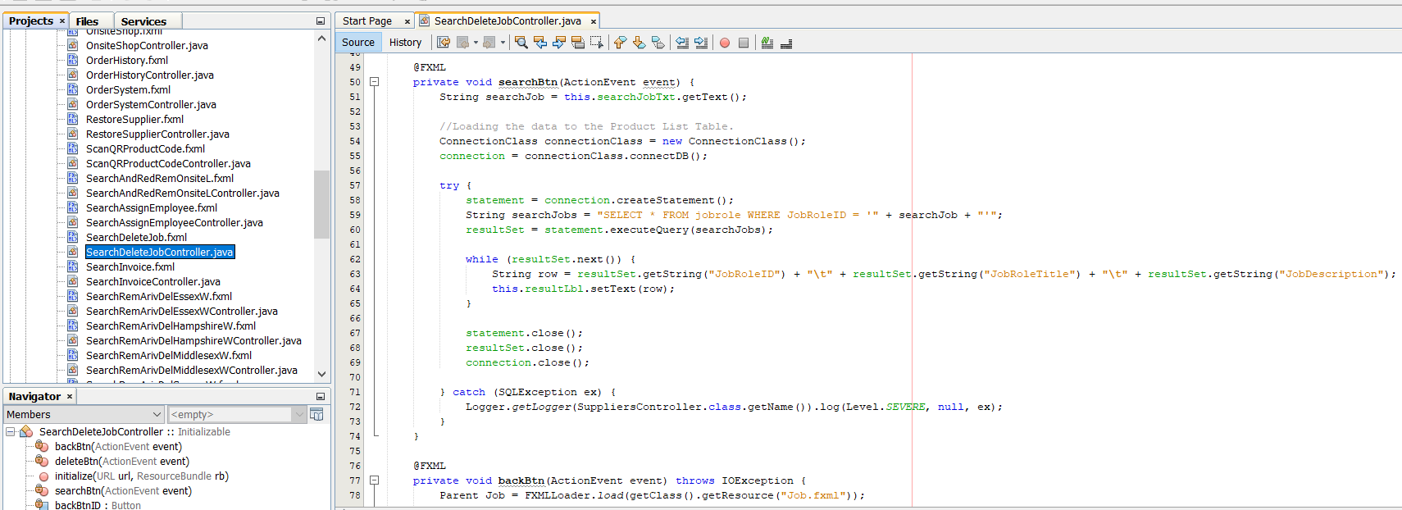

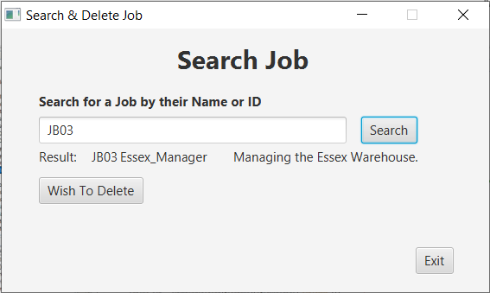

*Figure 16.33.2 – Search Job Roles Table*

Figure 16.33.2 works exactly the same way as figure 16.12.

### ***Help Guide***

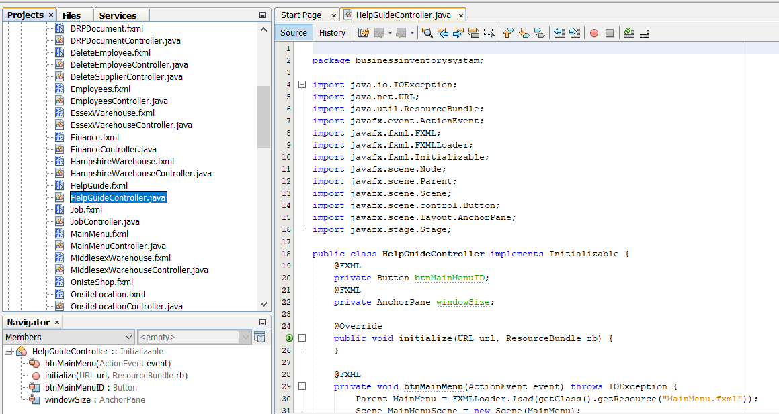

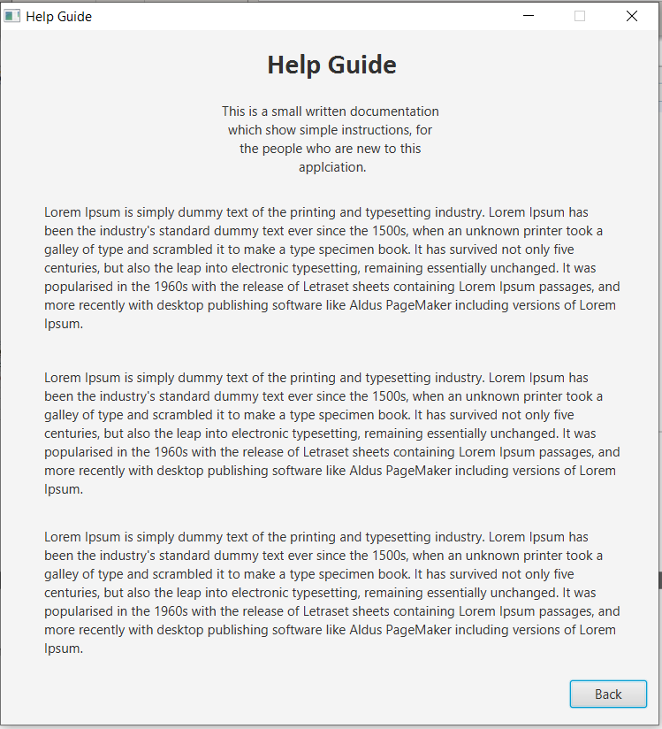

*Figure 16.34 – Help Guide Controller*

This class controller provides users documentation on how to use the software prototype. The text has been inputted into the text labels.

### ***Disaster Recovery***

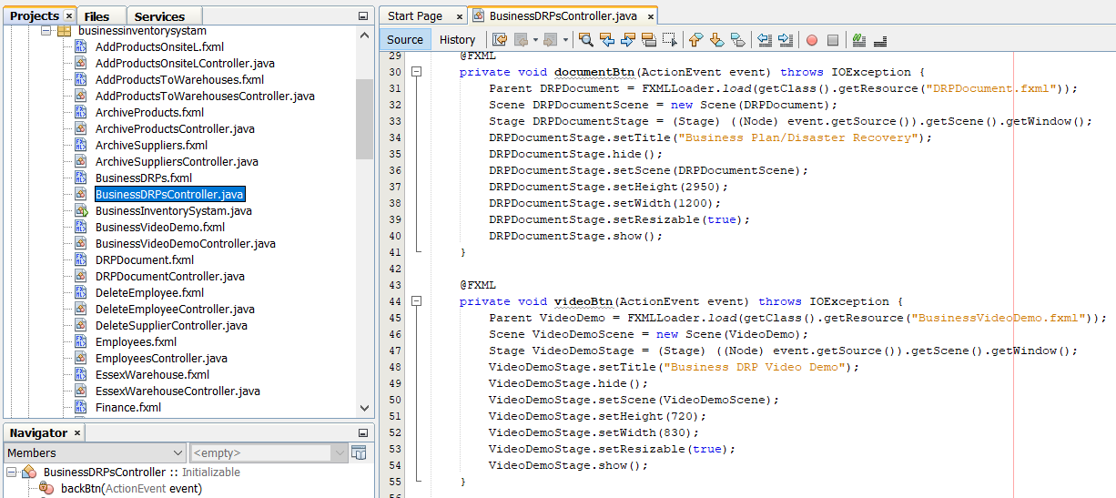

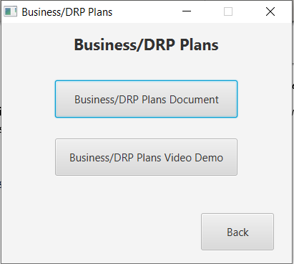

*Figure 16.35 – DRP Menu Controller*

Figure 16.35 works the same as figure 16.18.

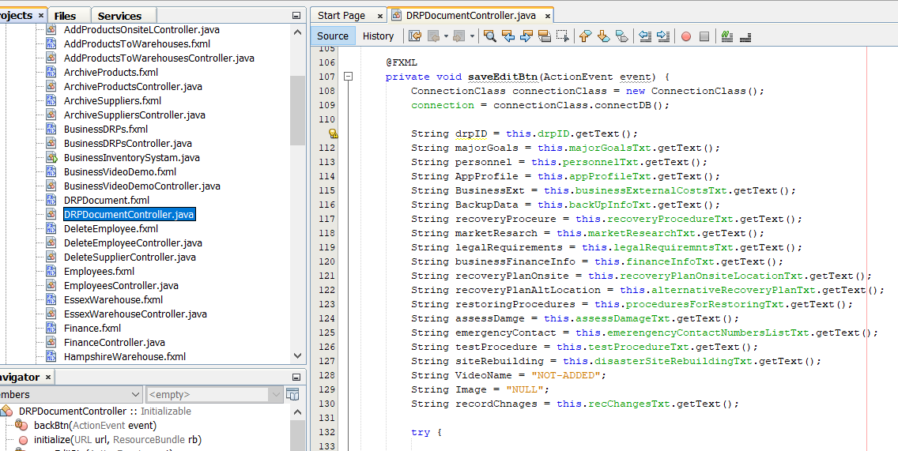

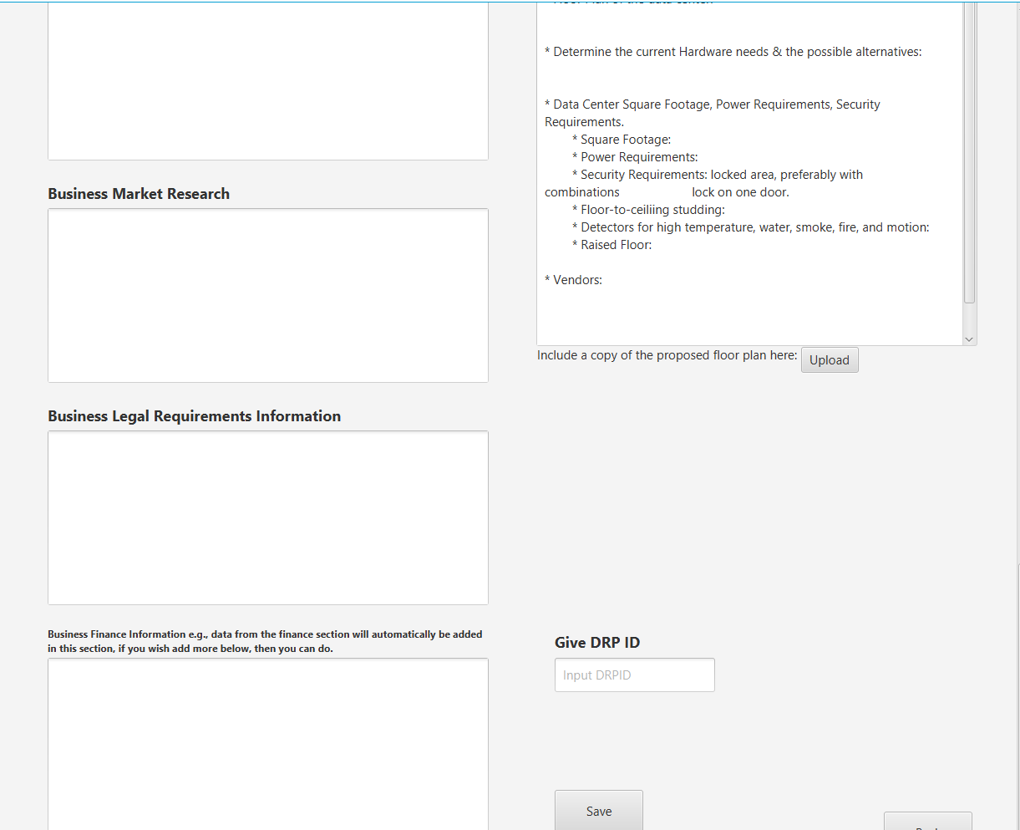

*Figure 16.36 – DRP Document Controller*

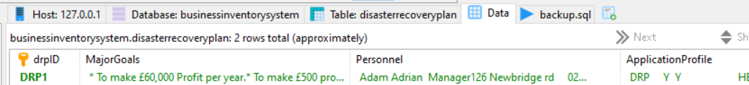

*Figure 16.36.1 – DRP Table*

Figure 16.36 gets all the data from the text inputs using the get method, when clicking save button. After getting the texts, the data gets stored into the disaster recovery plan table shown in figure 16.36.1.

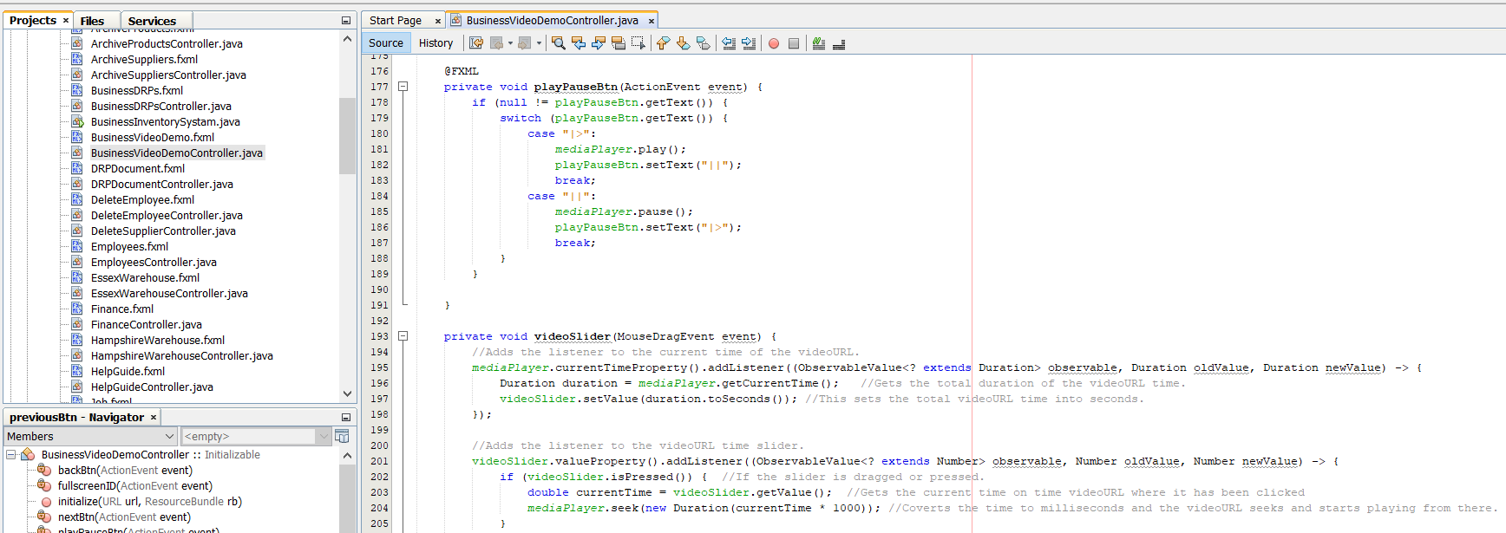

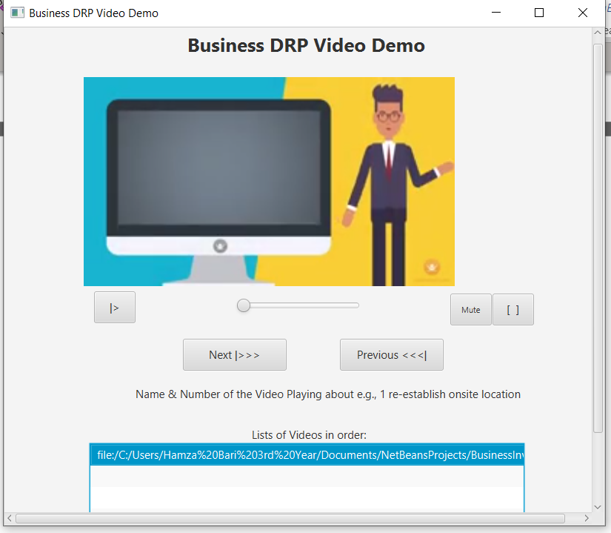

*Figure 16.37 – DRP Videos Controller*

Figure 16.37 shows the video playing in the media view which could be witnessed in the red box. The file class gets the video location, then the file is loaded into the media class, then the media created gets inputted into the media view class which loads the video automatically when the video controller is loaded. Below, media view is all the necessary video controls such as, play and pause, skip to next video, go back to previous video, mute sound, or make the video full screen in this case the media view will use the full video controller space. The current video playing file path gets added to the videos list using set list view method.

### ***Finance***

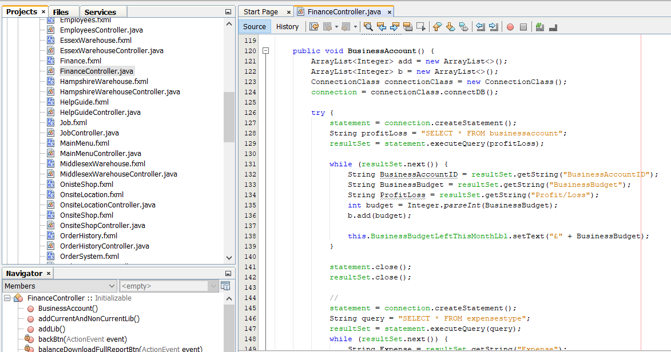

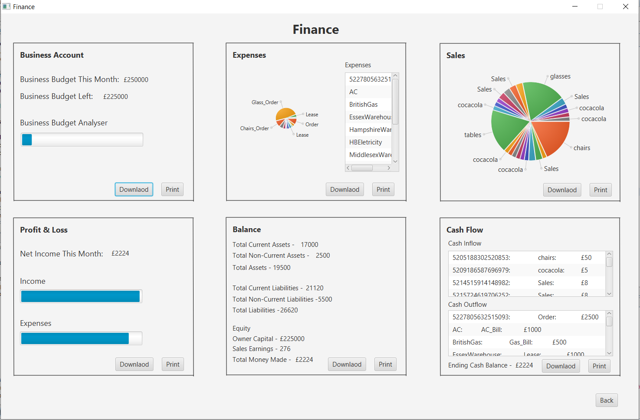

*Figure 16.38 – Finance Controller*

Figure 16.38 shows the finance controller which, is known to be one of the main functionality of this software prototype therefore, each section is explained in detail below:



*Figure 16.38.1 – Business Account Section*

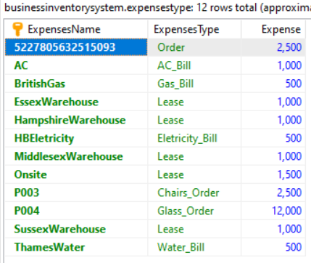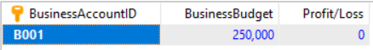

*Figure 16.38.3 – Business Account Table*

*Figure 16.38.2 – Expenses Table*

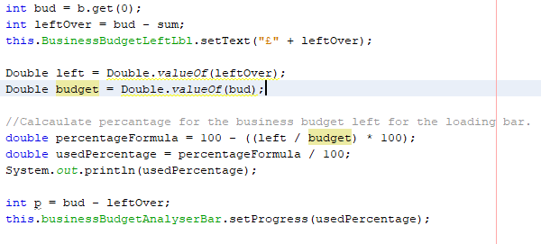

Original budget.

Left over budget.

*Figure 16.38.4 – Business Budget Left Formula*

Figure 16.38.4 shows the formula which is used to calculate the percentage of the budget used. All expenses from figure 16.38.2 are added together which gives the total sum, then the business budget from figure 16.38.3 is taken, after that both values are subtracted which gives the left over budget value. Therefore, to work out the percentage a formula has been implemented which can be witnessed in the red label. Once, the percentage is worked out, then the percentage variable is passed into the loading bar set progress function which, sets the position of the loading bar showing how much percentage of the budget has been used which can be seen in figure 16.38.1 blue label.



*Figure 16.38.5 – Business Account Section*

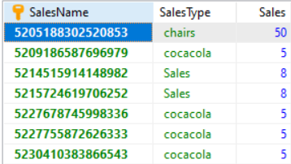

*Figure 16.38.6 – Sales Revenue Table*

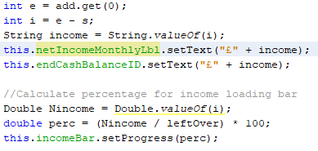

*Figure 16.38.7 – Percentage of Income from left over budget formula*

Figure 16.38.5 shows the net income made, percentage of income from left over budget on the income loading bar and, percentage of expenses used on the loss loading bar. The income is calculated by adding all the sales from sales revenue table shown in figure 16.38.6, then using the formula shown in figure 16.38.7 grey label is how the percentage is calculated. That percentage value is set into the income loading bar using set progress function. You can witness that in figure 16.38.5 green label.

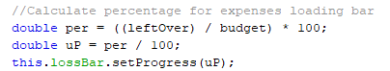

*Figure 16.38.8 – Percentage of expenses from budget formula*

Figure 16.38.8 shows the formula in the orange label. The formula is used for calculating the percentage of expenses used from the business budget. Once, the percentage is worked out, then using the set progress function the percentage is set into the loading bar which can be witnessed in figure 16.38.5 yellow label.

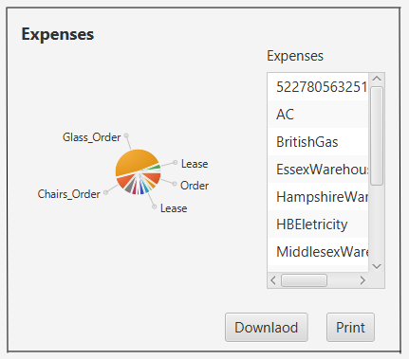

*Figure 16.38.9 – Expenses pie chart*

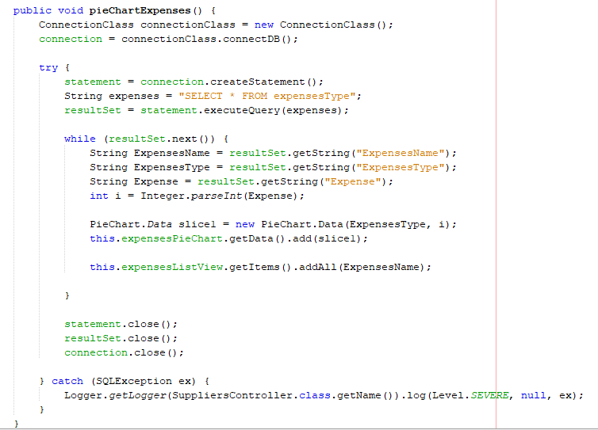

*Figure 16.38.10 – Expenses pie chart method*

Figure 16.38.9 shows the expenses being used which are displayed on the pie chart with labels. In figure 16.38.10 black label you can witness the following: all data is loaded from the expenses table, then a pie chart data slice is initialized which takes two parameters the expenses type and the numerical expense value after that, the data slice is added to the pie chart using the get data method. In figure 16.38.9 blue label, the pie chart shows the expense type labelled with its type of name and, according to the expense numerical value the bars are set on the pie chart, in terms of one slice is bigger than the other which all depends on the amount of expense.

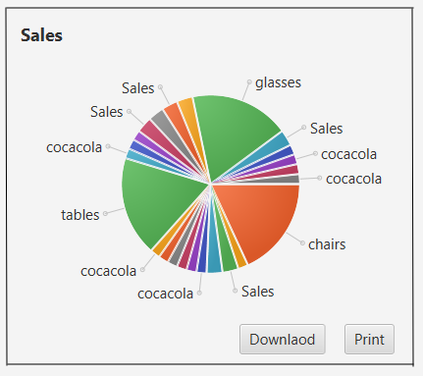

*Figure 16.38.11 – Sales pie chart method*

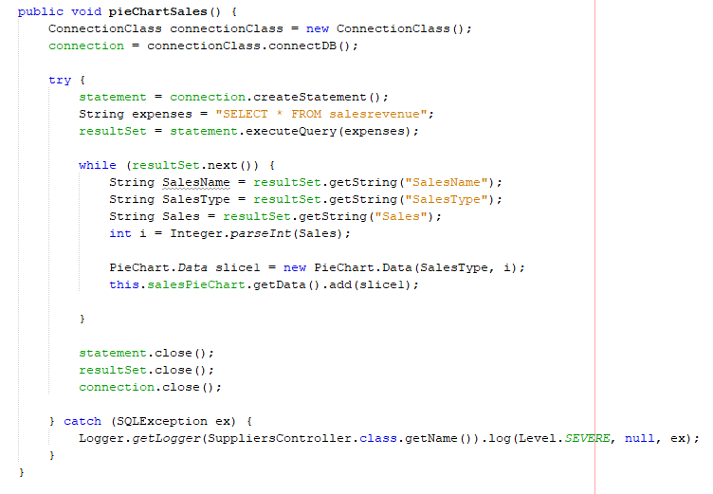

*Figure 16.38.12 – Sales pie chart method*

Figure 16.38.11 and 16.38.12 work exactly the same as figure 16.38.9 and figure 16.38.10.

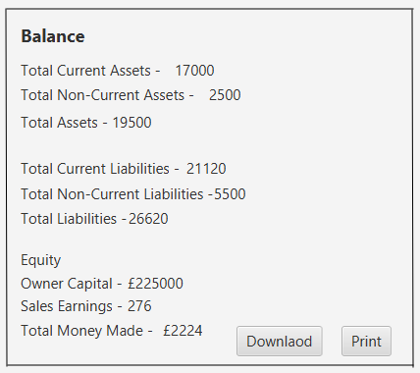

*Figure 16.38.13 – Balance Sheet*

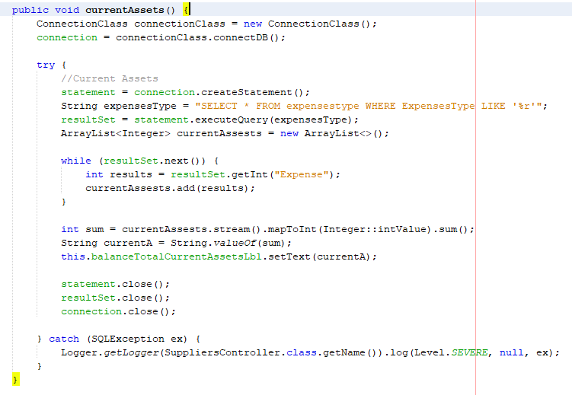

*Figure 16.38.14 – Balance Sheet Current Assets method*

Figure 16.38.14 gets all the order type expenses from the expenses table. The query has a “like %r” because, it only returns the expense type which end with the letter ‘r’ and in this case its only order which ends with ‘r’. After that, using the current assets stream shown in the orange label shown will sum up all expenses, which gives us a current assets total which is then set to the current assets label.

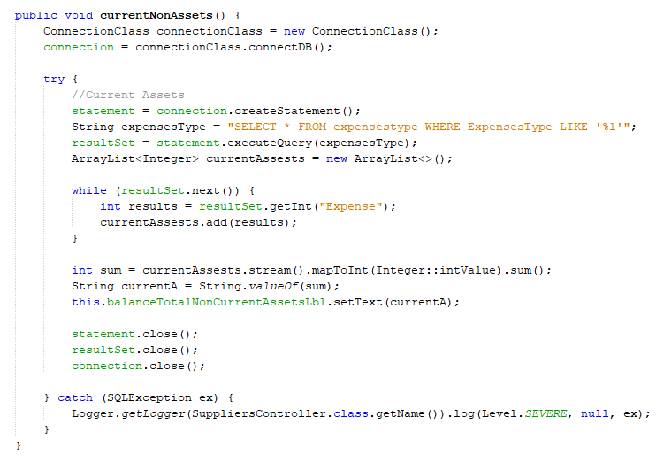

*Figure 16.38.15 – Balance Sheet Non-Current Assets method*

Figure 16.28.15 gets all expenses type beginning with the letter ‘l’ which is lease. After that, the following approach is exactly the same as shown in 16.28.14.

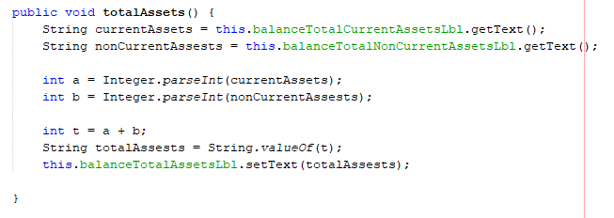

*Figure 16.38.16 – Total Assets method*

The total of current and non-current assets is added together. The result is set into the total assets label.

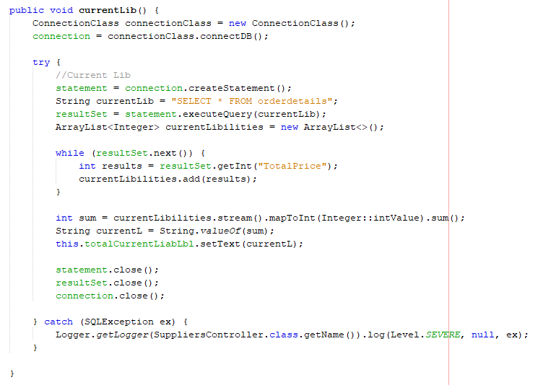

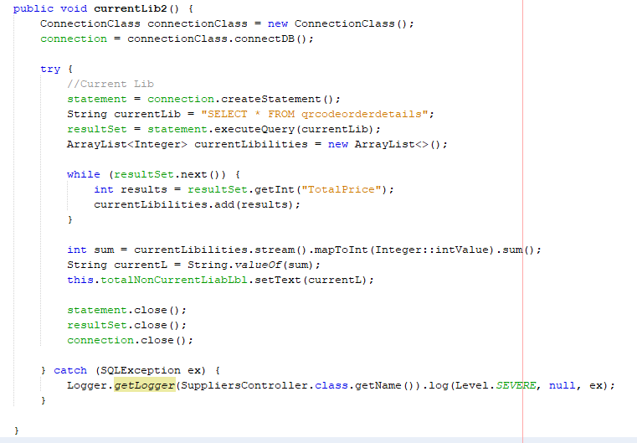

*Figure 16.38.17 – Balance Sheet Current Liabilities method*

This works exactly the same as figure 16.38.14. The only difference is that it gets data from the order details and QR order details.

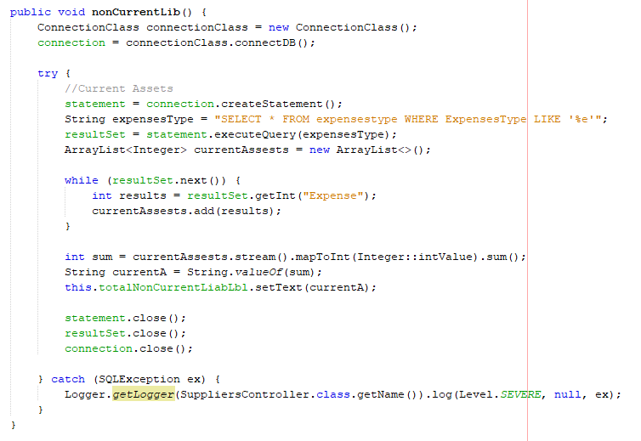

*Figure 16.38.18 – Balance Sheet Non-Current Liabilities method*

This works exactly the same as figure 16.38.15.

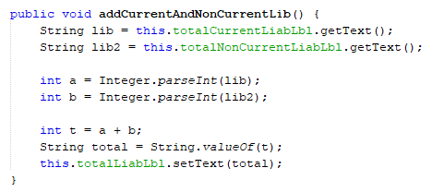

*Figure 16.38.19 – Total Liabilities method*

This works exactly the same as figure 16.38.16.

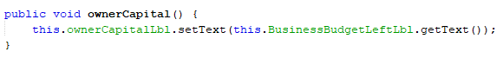

*Figure 16.38.20 – Owners Capital method*

This is set to the owner capital label.

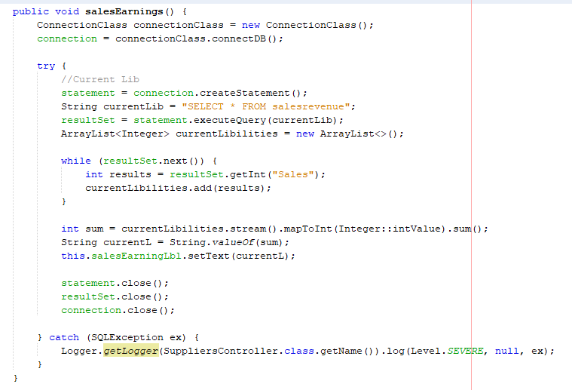

*Figure 16.38.21 – Sales Earning method*

This works exactly the same as figure 16.38.15.

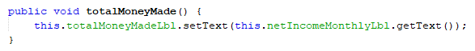

This works exactly the same as figure 16.38.20.

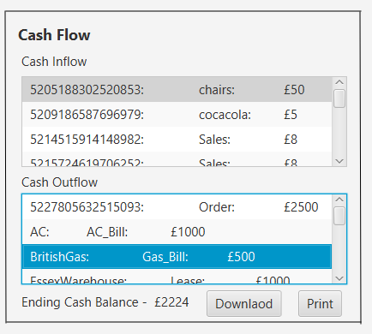

*Figure 16.38.22 – Cash Flow*

The value of the ending cash balance is the same as the net income therefore, it’s the same.

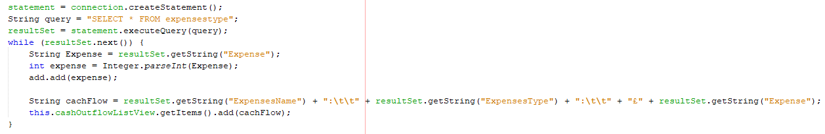

*Figure 16.38.23 – Cash Inflow*

Data from expenses table is loaded into Inflow list view.

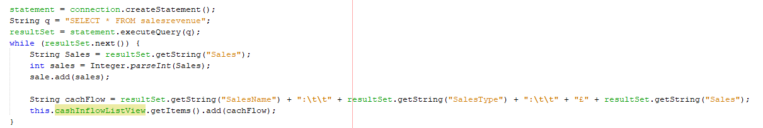

*Figure 16.38.24 – Cash Outflow*

Data from sales table is loaded into outflow list view.

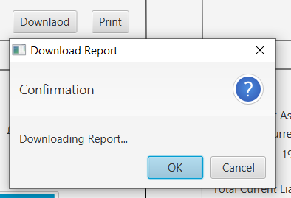

*Figure 16.38.25 – Download*

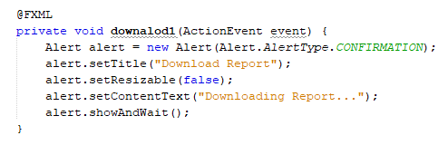

*Figure 16.38.26 – Download Method*

Figure 16.38.25 opens an alert box when clicking the download button. This is used to alert users that its ready to download. In Figure 16.38.26 it creates a new alert objects which then, sets the information details.

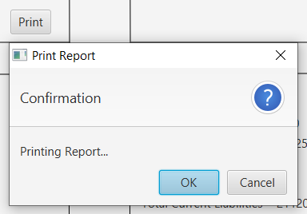

*Figure 16.38.27 – Print*

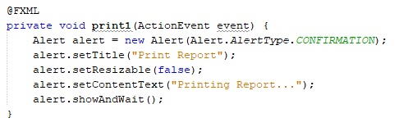

*Figure 16.38.28 – Print Method*

Figure 16.38.27 and 16.38.28 works the same as 16.38.25 and 16.38.26, the only difference is that its connecting to the printer.

### ***Backup Application***

This backup application was developed to back up the database file into the FTP-Server. The FTP-Server has been configured on the HP envy machine therefore, the FTP-Server is enabled. Once, the FTP-Server is available then, its accessible from the web browser by using the link with the machines IP address which can be witnessed in figure 16.29.

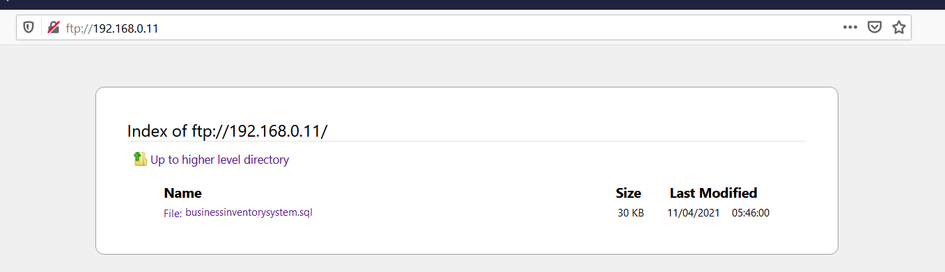

*Figure 16.29 – FTP-Server running on the web browser*

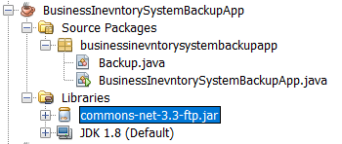

*Figure 16.29.1 – FTP-Server-API*

Figure 16.29.1 shows the FTP-Server development API has been added to the application library.



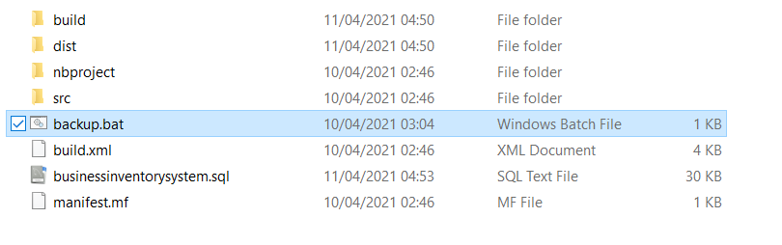

*Figure 16.29.2 – Backup-Bat-File*

Figure 16.29.2 shows the Bat file which automatically develops an mysqldump when the file executes.

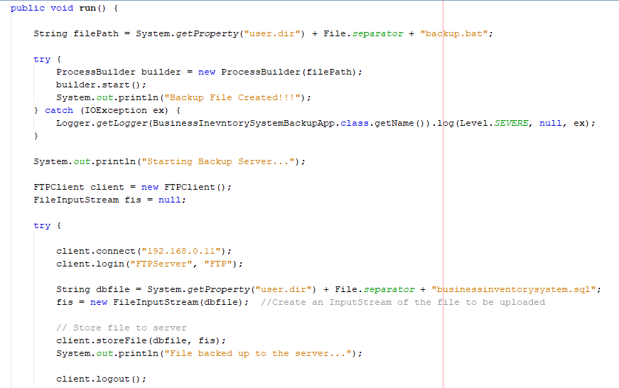

*Figure 16.29.3 – Run-Method*

Figure 16.29.3 blue label shows the file path of the bat file is inserted into the object of the process builder class which, executes the file automatically through the application when, the builder.start() method runs.

Figure 16.29.3 green label shows the FTP-Client object has been developed. The connect method is used for connecting to the machine and, login method takes the FTP username and password as two parameters to login and access the FTP account. The database file gets stored into the FTP-Server account by using the store file method.

Figure 16.29.3 shows a method to get the latest mysqldump file and store it to the FTP-Server.

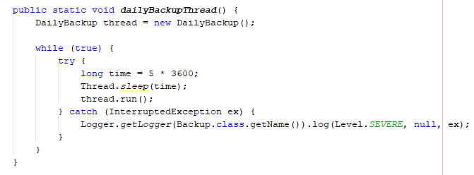

*Figure 16.29.4 – Daily-Backup Thread*

Figure 16.29.4 shows a daily backup method. Within the method a thread is initialized. The time is initialized to the total number of seconds in a day, and that number gets passed to the thread sleep method therefore, it runs the thread according to the number given. Once, the time is up, then the run method shown in figure 16.29.3 executes. This way the database is backed up daily. Once, the thread has completed running, the file gets stored to the FTP-Server shown in figure 16.29.

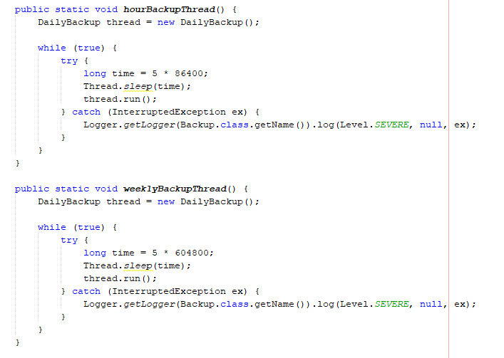

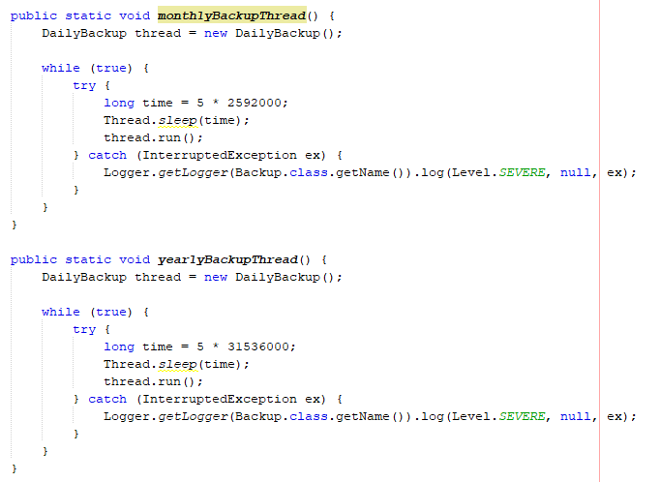

*Figure 16.29.5 – Other-Backup-Threads*

All threads shown in figure 16.29.5 work the same as figure 16.29.4. The only difference is the seconds given to the sleep method.

## **Testing**

After the development of the software prototype, it was now the time to test it. The testing was also in process during the development because, the first type of testing was **live testing** as, each time a functionality was developed, then by the execution of the code it could be witnessed how that functionality works, just after the development. The software testing took place on the HP Envy machine and the NetBeans IDE during the development and unit testing. Unit testing was performed using the Junit API, which was inserted into the project library as, it can be witnessed in Appendix 4 Figure 17.1 blue label. Unit testing was helpful in finding out the expected result values from the software, which included the following: getting accurate data onto the application from the database, the sophisticated mathematical formulas expected results and checking if the formula is correct, and data from text inputs being stored to the database. This helped in finding out errors which were related to the code and mainly data/specific value being expected from the software.

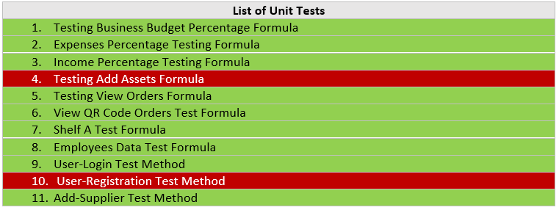

*Figure 17 – List of unit tests*

Above, in figure 17 is a table where it can witness all unit tests which were carried out. The tests highlighted in green are the ones which have passed for the first time, the tests highlighted in red are the ones which have failed first time around. Out of 11 only 9 unit tests managed to pass for the first time whereas, there were 2 tests which have failed and those were the following: test assets formula, and the user registration method. After revisiting those tests, a solution was identified therefore, those 2 test had managed to pass for the second time. In the appendix 4 figure 17.4.9 and 17.4.21 it can be witnessed how the errors were solved. In addition to that appendix 4 also shows, looking into the detail of each test such as what class it was part of, the test functions in the code, and an explanation on how those test functions work and execute tests and, if the test fails then, an explanation of why the test failed and how the correction was made to pass the test.

The acceptance testing was also carried out as, a beta version of the software prototype, which was released for testing and it was given to 50% of people out of university and, 50% of people in university. With the beta application a questionnaire was also given out to all those users who were testing it. The results of the questionnaire will support in giving the positive and any negative feedback regarding the application and, this is extremely useful because, it recommends improvements which could be considered when updating the software version 1 to version 1.2. In appendix 5 the questionnaire and results can be witnessed. Acceptance testing turned out to be very useful because it supported in detecting different types of bugs such as related to performance as, users are using different machines, if something specific isn’t working which was missed out in the unit or system testing etc. The results also suggested improvements from various different perceptions. The acceptance testing took place after all the software requirements were implemented. The results will suggest the improvements for the upcoming version.

When all of the requirements from figure 11 had been developed then, the system testing had been carried out for testing the software prototype. The software prototype was being tested constantly to look out for any bugs or errors which may have occurred during the implementation process. There were many types of errors which occurred during the implementation such as exceptions causing the software to break but, those types of errors were pretty straightforward which were fixed quite quickly. Throughout and after the implementation all features and requirements are tested efficiently. The software prototype source code was examined extensively for making sure the code written for the project was at its highest standard and, this was the stage where static testing was applied. During the implementation, the requirements were revisited quite frequently such as looking at the requirement before implementing each functionality the reason being, to make sure the project was moving on the right track.

Appendix 3 Figure 18 shows the test plan which tests all the requirements from figure 11. It shows which requirements managed to pass and which ones failed. The row will be highlight green if the requirement has passed, or it will highlight red if the requirement has failed. The test plan is used for verifying the requirements making sure the software prototype meets the required specification. The functionality of the software prototype was very important hence why the test plan has been carried out.

Out of 42 there were 7 requirements which have failed to meet. Out of 7 there were 5 requirements that weren’t considered that important compared to the other requirements since those were more related to further development in the project. The other 2 failed requirements were: update employee details, and disaster-recovery documentation. Those 2 requirements need to be revisited; perhaps more time and further testing needs to be carried out on those to spot the actual errors and make it work. Currently this is the first stage of the software development therefore, in the first stage the software will not be released for any commercial use therefore, it’s not important that all requirements meet in the first stage. In general all the major requirements have successfully been met. The timing constraint was perhaps an issue in this project which led to 7 requirements failing.

Another Important type of testing is the performance testing. This software prototype will be used by a variety of different small business owners on different machines. Every machine has its own memory and processing power. In performance testing it can be seen how much CPU power and memory does the software prototype use. In order to make the software prototype reliable and robust, the performance issues would matter a lot which needs to be taken into consideration.

Task manager and performance manager software’s are included within the machines. Both of these are used for testing the performance of the software prototype.

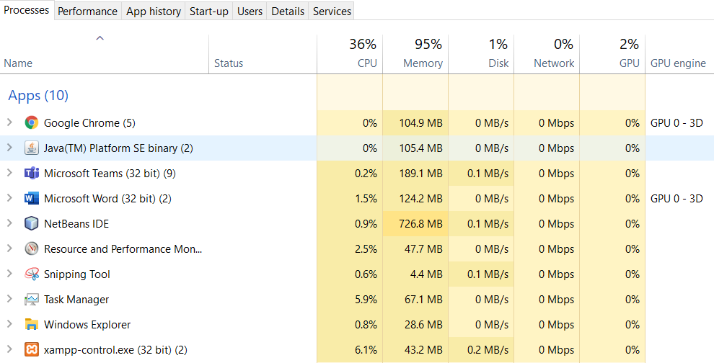

*Figure 19 – Task Manager showing usage of CPU & Memory*

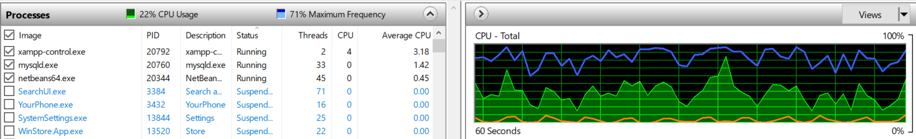

*Figure 19.1 – CPU Usage*

Testing the CPU performance of the software prototype is very important as, users have different machines which will have its own processing power depending on the CPU brand, model, and version for example, many users use machines which have old versions of CPUs. This means there could be a difference in the processing power if you compare a brand new machine to an older version machine. Another important factor to consider is that testing software prototype in this current HP envy machine environment is not going to be a final number for the processing power because, that depends on what machine the user is going to be using with all the different systems of that machine. This environment only gives us a very rough idea. The CPU testing shows the total software prototype workload which is the reason why it’s important to recognise. Figure 19.1 is showing the CPU usage used in the black label and, a graph log – the orange spike labelled in yellow shows the CPU power being used. This test was carried out for approximately 5-10 minutes. It can be witnessed that the software prototype running uses less processing usage. The orange spike will relatively go higher depending on certain tasks which the software is performing for example scanning QR codes using camera, playing videos, connecting to database, executing database queries, and searching and loading data. When these tasks weren’t performed then, it reduces the orange spike back down towards decreasing again. In general the impact of the CPU processing power will certainly depend on device/machine the software prototype is loaded on. Its highly recommended to business owners that they use a modern machine which has the latest processor, which will be more powerful and reliable, this way the software prototype will run flawlessly and it will be compatible with the latest technologies used in the software.

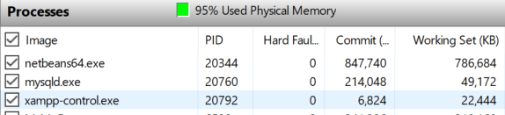

*Figure 19.2 – Memory Usage*

Figure 19.2 shows the memory usage of the software prototype in terms of the server running the database, the database itself, and the application running. Memory is an important part of performance testing since the machines have a certain limit of memory. It can be witnessed from figure 19 and figure 19.2 that the software relatively uses less memory but, it has to be considered that the memory testing took place on the HP envy machine which has different memory management compared to other machines. This machine only gives a rough idea of how much memory the software is using. It has been seen that memory will slightly increase when more data is added to the database which leads to increasing the database file memory and that’s creates an impact on the whole memory. Therefore, its recommended that business owners use a machine where the hard disk has a capacity of 120+ GB and, only use the machine for managing their business using this application. This way the application will load up quicker and run faster.

In this project the testing phase was completed before the software prototype was released for evaluation. In the testing phase, all the requirements from figure 11 were tested. The testing was done by performing each requirement on the software e.g., registering user and, then seeing how it would work in a real life scenario when a user is using the application. This was detailed monitoring and observation of the software prototype.

## **Issues related to testing**

One of the issues related to testing were experienced in the unit testing process. The unit tests had to be developed into a separate test package because, it doesn’t use the get methods from the JavaFX components in the test classes e.g., get data from the username text field in the test class. This is why a separate method is developed in the main classes which only uses string to check if the data passed to the function is equal by using assert equals in the test function. The same implies with the financial mathematical formulas since, it doesn’t get the value by using the get method from the application as a result, the values calculated in the formulas are hardcoded. This will only test financial mathematical formula methods and see if its meeting the right expected values. The testing of just the mathematical formulas were important because, 75% of the finance section depends upon those formulas.

In this project the tests were carried out from lower level integration testing, and system testing. The errors which occurred during the implementation were solved at that current time. The unit testing was performed after all the requirements were implemented. Even looking at appendix 4 it can be witnessed that there were bugs which managed to be identified and fixed. Even after fixing bugs it’s not guaranteed that the software prototype is free of bugs. When carrying out the test plan which can be seen in figure 11, that many bugs and errors were identified, which caused the requirement to fail.

# ***Chapter 4: Evaluation***

This software prototype has a large number of requirements which is stated in figure 11. Those requirements must be met for making this a successful software development project. In the table below the results can witnessed after the completed development stage.

In the table below, it can be witnessed that these requirements were the project goals which were set at the beginning of the project in the design stage, and almost 80% of the requirements were met. The overall result of the project was satisfied. The software prototype meets a majority of its requirements against the design specification as a result, the business inventory system is a now a completed JavaFX Desktop application.

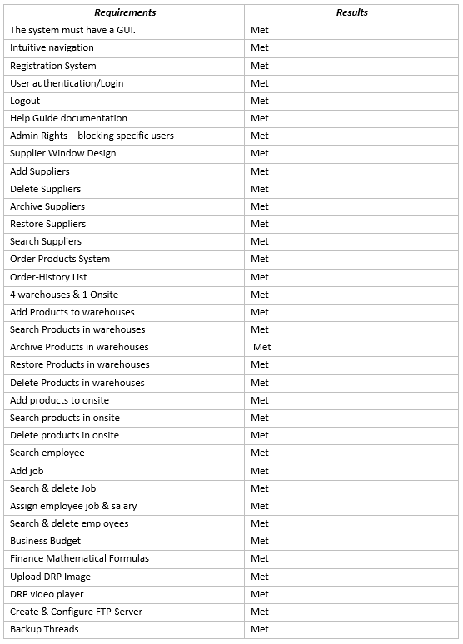

When the project was proposed a Gantt chart was developed for estimating the time of completion such as how long it would take to complete the project. The Gantt chart can be witnessed in figure 22, which can be used as a comparison to see how long it actually took to complete this project by analysing the Gantt chart and the logbook-record shown in figure 23, to see how long it took for the project to be completed by, as this way it could be identified if it took less time, or it took more time than expected. After the analysis, it was identified that the implementation took one extra week as, in total there were 24 weeks for this project and 10 weeks for the implementation but, the implementation took 11 weeks which delayed the project by a week therefore, the time estimated was close but not met. This shows the project was more challenging, then expected.

*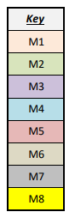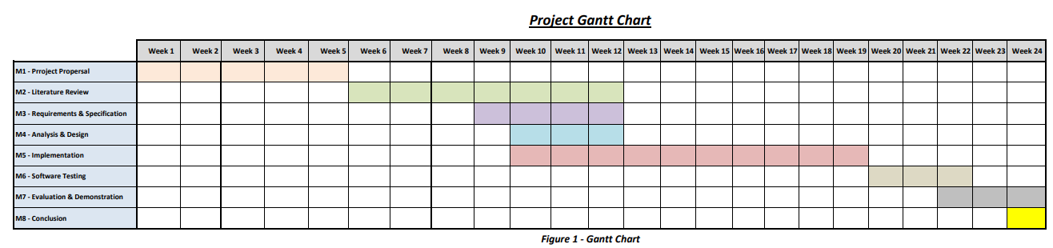Figure 22 – Gantt Chart*

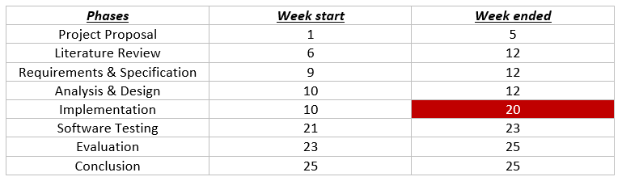

*Figure 23 - Phases Completion Logbook*

The red box highlighted shows where the delay has occurred.

## **Evaluating Project**

Once, the software prototype was fully implemented and tested, now was the time for evaluating the desktop application. In the testing stage it was identified that, the software was implemented very well in terms of its functionality and software performance on the desktop. This was a very large software in terms of its design which contains a lot of different type of areas therefore, in the first version 80% of the main functionality was working and, in addition to that despite it being a large software the usage of CPU and memory was lower on a variety of machines with different operating systems, this was identified in the user testing results shown in appendix 5, apart from one user, there were no complaints regarding the performance.

The functionality of the software prototype was compared and contrasted with the existing applications which have been mentioned in the literature review for example, in figure 6 it can be seen that QuickBooks software finance functionality is very similar to the finance controller in figure 16.38, also in figure 4 it can be seen the Info Cloud scanning products is very similar to the QR code scanner in figure 16.15. It’s understood that this is only the first version of development and it suddenly won’t meet the functionality of the industrial software’s e.g, QuickBooks by a 100%, but still if the functionality slightly matches and works similarly then, the software development is efficient and on the right track from this current implemented first version, then soon it will be on the right track to meet industrial standards like QuickBooks and Info Cloud.

The business inventory system was developed with a lot of experience in front-end JavaFX desktop applications. Experience matters as, this is the reason why the software prototype was developed productively with very less inconsistencies.

The software prototype is lacking a lot of features and functions, plus the requirements which were not met due time constraints. All these would be considered for improvements in future developments.

The business inventories software prototype has provided a significant understanding into JavaFX desktop applications, and the different types of barriers which are related to the development of JavaFX desktop applications, and the solutions to these barriers have also been provided.

## **Evaluating Requirements**

Evaluating the requirements is an important part of the evaluation. The requirements in chapter 3 figure 11 have to be checked to see if they are completed. All the major project requirements have been implemented. When the users use the software prototype, then they’ll be able to perform all the major features and functions which have been stated in the important requirements which are highlighted in light-red. There are some requirements which were not so important therefore, they were highlighted in light-blue and kept for further developments or if extra time was left during the implementation therefore, due to the time constraints those requirements haven’t been implemented. There were only a few non-important requirements which were met, for example the disaster recovery video section is working. The different types of the system components were checked very carefully using the testing techniques, and the results were satisfying, and there was no issue found, which would crash the system from working. The GUI implemented was a big success in this project as, there was a lot of positive feedback received from acceptance testing shown regarding usability. The labels and buttons have a great visibility and, it’s easy to navigate within the application as, the application is intuitive. Extensive comments have been added into the code for the important functionality, and the code is formatted very well in terms of indentation and, all this effort has been put to keep the code clear and easier to understand. The main goals of the software prototype have been met and, its working alright.

## **User Evaluation**

The evaluation from users is the one of the most important part in this project because, this is where its discovered if the project was excellent, satisfactory, just ok, not useful, meaning the software prototype is worthless and time wasting. Appendix 5 shows the questionnaire and results, the questionnaires were handed out to 50% students and 50% of people for evaluating the software. In the questionnaire there were many questions asked related to the software such as positive and negative feedback, major functionalities, and performances which went quite well overall. When the users filled in the questionnaire, they used the software without any guidance from the developer. The users were able to use the application quite easily understanding what they need to be doing. From the results in Appendix 5, it can be witnessed that the users found it quite easy to use the application. A majority of users gave positive feedback regarding the looks and feeling of the software, as the software was organised and designed very well. The users were able to navigate easily across the different forms using buttons. The guidance provided in the application was very useful as, the text on GUI components were easily read and the instructions were clear to users such as what they need to do e.g., how to add products to the warehouse. 66.7% of users thought the application was just ok, 33.3% of users thought the application was satisfactory and, these were the results received from the questionnaire. The QR code scanning was a very useful functionality found by users as, the users were able to purchase an order with a 2 second scan, compared to filling out the whole form, which is time consuming. The users also though the application was related to the subject given in the literature review therefore, it’s on the right track to be used by the small businesses.

## **Evaluating Implementation Process**

The development process of the software was developed using the software development life cycle method which was the most appropriate way to develop software’s which can be seen in figure 23.

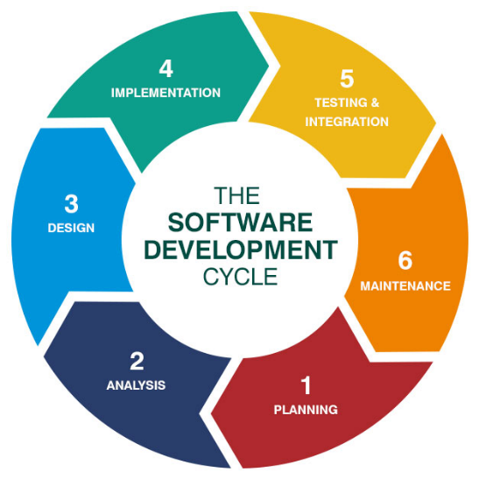

*Figure 24 – Software development approach*

The planning phase was completed on time according to the Gantt chart shown in figure 22. Analysis and design phases were done during the same period, and both phases were completed according to the plan, these two were the phases where the design specification and software architectural diagrams were analysed according to the design decisions made and then developed. The longest phase was the implementation where most issues such as errors and bugs had occurred. It took longer to implement, than expected, which can be witnessed comparing figure 22 and figure 23. This is the reason why it caused a short delay in moving to the next testing phase. The time was very short and more time was needed for implementing the project. The testing phase was completed on time as expected to the plan, in the testing phase the testing approaches were used for testing the software application and find any further bugs or errors. The next phase is the maintenance phase which in written in chapter 6 showing the further developments needed. In figure 24, the software development approach turned out to be an effective choice for developing the software, as it kept all phases organised which extremely encouraged the developer to keep working and solve problems while going along. This way the developer has learnt how to develop software’s with the right planning approach and this has been added to the developer experience list in the area of software development, which is known to be very valuable for future software development projects.

# ***Chapter 5: Conclusion***

The software prototype developed overall was satisfactory. The key success of this software was by completing all major requirements. Many challenges came across during development but, was a useful process. The software prototype learning process was very detailed and using a variety of technologies which made things very sophisticated but, at the end it all contributed towards learning new experience and improving.

This project has provided a great amount of experience in developing larger projects related to software development in a duration of 25 weeks. To complete the project and making it work on the time planned was very critical. Many challenges came across which had to be overwhelmed to get to the stage of completion. These challenges included learning how to use webcam API with java, learning how to configure FTP-Server, and use FTP API, all these things were entirely new for the developer. There were several other personal limitations which resulted in developer taking short beaks from the project, especially during implementation stage, as this was difficult because it puts the developer off having to revise everything after a gap of 1-4 days. NetBeans-JavaFX is a very beneficial platform for developing desktop applications and giving users many advantages, such as using Scene Builder and FXML to concise time. The project is meeting a majority of all major requirements but, there is a lot of space for improvements for updating in future.

## **Project Overview Summary**

Eight milestones had been identified for this project at the very beginning, which can be witnessed in figure 22 Gantt chart. First milestone was working on the project proposal to plan the project such as, what the project is about, time management, and the tools and technologies used. Second milestone was researching existing applications in the subject and evaluating them, which was carried out in the literature review. Third milestone was writing the requirements specification based on the research on existing software’s from the literature review. Many user requirements were decided after reviewing the existing software’s and seeing what types of important functionality is required by a software related to business inventories and disaster recovery. The requirements specification was used as a guide on how to develop the software relating to the topic. In the fourth milestone the software was designed using GUI wireframes, UML diagrams, and ERD diagrams and these were analysed justifying why they would be useful for the implementation stage. The requirements specification and design chapters are developed in detail so the developer keeps on reinforcing these during the implementation phase making sure the functionality is implemented properly. The fifth milestone known as the implementation is where all the project source code was written, and the functionalities were developed. After completing the implementation, the software was tested using the different testing techniques in the sixth milestone, and the seventh milestone evaluates the project results, and finally the further developments are decided in the eighth milestone.

The main goal of this project was to develop a desktop application for *‘A Modern Business Inventory and Management System for Small Businesses to manage and avoid potential disasters’*. This application helps small businesses to manage their large inventories in store and warehouses, suppliers, orders, products, employees, finance, business plans, jobs, invoices, and finally an automatic backup system of the database to the FTP-Server keeping business data secured. The project is successful as the main objectives have been completed. The implementation of this application has shown the areas of strengths as well as the areas of weaknesses where improvements are required. Some solutions have been provided in the areas of weaknesses, which is supporting to solve these issues, which had occurred during the implementation and testing.

In general, this has been a satisfactory project which fulfils the majority of requirements.

## **Recommended Improvements for future developments**

In any software development project there are always areas for making amendments or improvements. In this project there were some requirements which weren’t met because of the time constraints. Whatever could be implemented at this point was implemented. This is the reason why several improvements can be done within the application. Before releasing the next updated version, more features can be added to improve this software prototype. Below, there are areas of improvements based on the requirements which have failed because, something that’s not really accurate enough, and some latest features that can be added:

* There were issues with the database as, it did not meet the ERD diagram shown in figure 11.25. This caused problems while adding the data to the database as, a lot of changes were needed to be made to the database during the implementation. Therefore, the database design requires improvements using further normalisation to protect the data integrity.
* A content management system hasn’t been created for this project despite it being in the non-important requirements. A CMS will be useful for business owners to manage their data in detail for example, if the data doesn’t get added to the database, then owners can track that using the CMS whereas, currently they won’t know till it’s too late.
* According to the latest research users prefer using a mobile app more than using desktop applications since, mobile phones are something which users have on them all the time compared to a laptop or PC. Therefore, using the existing design, requirements, database, and backup-system, a JavaFX Android and IOS version of the applications will also be developed which, will come more into use, which leads to better business performance.
* In the help guide more features can be provided such as, a help chat functionality. After reading the guide, if users still don’t understand it, then using the chat the users can ask for guidance by communicating with an expert. The chat would work like Facebook messenger.
* Develop a user authentication system for the users to login to the FTP-Server via the Java application. The reason for that is because, the login details are hardcoded which can be a risk if the computer gets hacked or stolen as, a result all business data will be leaked. Therefore, by having a login system using the scanner class the login details will remain anonymous meaning, the hacker won’t be able to find that out.
* In the finance section make the reports downloadable and printable. This is useful as, finance relates a lot to banks therefore, hard copies can be given to banks and electronic copies downloaded can be emailed if needed.
* Develop a playlist in the DRP videos section. Adding videos to playlist using file upload. Then, automatically play the playlist in order. Currently, the video paths are hardcoded into the project folder.

## **Final Opinion**

After working on this project for almost 183 days it was finally the end. As, the project has been completed to the satisfactory level, now is the time to think about the achievements gained. The project work was completed thoroughly allowing the developers to show their existing skills as well as, learning new skills, and experiences with an increased level of confidence. After completing this project, the developer feels confident to face more sophisticated challenges in future related to software development.

# ***Appendix***

## **Appendix 3 – Test Plan**

**Please refer to figure 11 to view the requirement number. As, the test descriptions are shortly described in the description column.**

|  |  |  |  |
| --- | --- | --- | --- |
| *Requirement No.* | *Description* | *Expected Results* | *Actual Results* |
|  | The system must have a GUI. | The software must have a GUI. | The software has a GUI. |
|  | Intuitive navigation | The user should be able to navigate forward and backward. | The user can navigate forward and backward. |
|  | Registration System | Get data from text inputs and store into the owners or employees table. | Data is retrieved from text inputs and then stored into the owners or employees table. |
|  | User authentication/Login | Data should be validated from the owners or employees table and then, it should allow the user to login if details are valid, if not, then display error message. | Data is validated from owners and employees table and, then it allows the user to login if data is valid otherwise it displays an error message. |
|  | Logout | By clicking logout, the software should navigate to user authentication. | When clicking logout, the software navigates to the user authentication. |
|  | Help Guide documentation | The documentation data should be displayed on the help guide window. | The documentation data is displayed on the help guide window. |
|  | Admin Rights – blocking specific users | The Suppliers, Orders, Order-List, Finance, Set-Employee salary should be hidden from employees. | The Suppliers, Orders, Order-List, Finance, Set-Employee salary are hidden from employees. |
|  | Supplier Window Design | Supplier window should show 4 sections add, list, archive, and search supplier horizontally . | Supplier window shows 4 sections add, list, archive, and search supplier horizontally underneath each other. |
|  | Add Suppliers | By clicking add the data from text input should be stored into the suppliers table using insert query. | By clicking add the data from text input is stored into the suppliers table using insert query. |
|  | Delete Suppliers | Delete query should delete the supplier from the suppliers table. | Delete query deletes the supplier from the suppliers table. |
|  | Archive Suppliers | Delete query should delete supplier from supplier table and, insert that deleted data into the archive suppliers table using the insert query. | Delete query deletes supplier from supplier table and, insert that deleted data into the archive suppliers table using the insert query. |
|  | Restore Suppliers | Delete query should delete supplier from archive supplier table and, insert that deleted data into the suppliers table using the insert query. | Delete query deletes supplier from archive supplier table and, insert that deleted data into the suppliers table using the insert query. |
|  | Search Suppliers | Get supplier id or name from the text field and apply the select query to get result. | Supplier id and name is retrieved from the text field. After that, the select query returns the result. |
|  | Order Products System | Retrieve data from the GUI components e.g., combo box, inputs and, then send data to the orders tables using insert query. | Data is retrieved from the GUI components e.g., combo box, inputs and, then the data is sent to the orders tables using insert query. |
|  | Order-History List | The data should be retrieved using the select query and then displayed on the order-history window. | The data is retrieved using the select query and then its displayed on the order-history window. |
|  | 4 warehouses & 1 Onsite | Different windows should be displayed for each warehouse and onsite. | Different windows are displayed for each warehouse and onsite. |
|  | Add Products to warehouses | The data should be retrieved from the input text and combo boxes and, then data is added into the warehouse table. After that, data should be displayed into the warehouse window using select query. | Data is retrieved from the input text and combo boxes and, then data is added into the warehouse table. After that, data is displayed into the warehouse window using select query. |
|  | Search Products in warehouses | Use the text input to get the data and apply the select query to get the result. | Data is retrieved from the text input and when the select query is applied it returns back the result. |
|  | Archive Products in warehouses | Remove data from warehouse window and then add that data to archive warehouse window. | The data is removed from warehouse window and its displayed into archive warehouse window. |
|  | Restore Products in warehouses | Remove data from the archive warehouse window list and display that data on the warehouse window. | The data is removed from the archive warehouse window and its displayed into warehouse window. |
|  | Delete Products in warehouses | The product selected from the name or id should be removed from the warehouse window. | The product selected from the name or id is removed from the warehouse window. |
|  | Add products to onsite | The data should be retrieved from the input text and combo boxes and, then data is added into the onsite table. After that, data should be displayed into the onsite location window using select query. | Data is retrieved from the input text and combo boxes and, then data is added into the onsite location table. After that, data is displayed into the onsite location window using select query. |
|  | Search products in onsite | Use the text input to get the data and apply the select query to get the result. | Data is retrieved from the text input and when the select query is applied, it returns back the result. |
|  | Delete products in onsite | The product selected from the name or id should be removed from the onsite location window. | The product selected from the name or id is removed from the onsite location window. |
|  | Search employee | Get the employee name from text input and apply search query to display the result on the window. | After searching the employee name in the input text field, it displays the employees details in the window. |
|  | Add job | The insert query function should add job to the job table. | The insert query function adds job to the job table. |
|  | Search & delete Job | The search by job name should display the job details and, then the delete button should remove that job from the system. | The search by job name displays the job details and, then the delete button removes that job from the system. |
|  | Assign employee job & salary | All employee details are loaded by their name and, then in the combo box set the job id and in the text input set salary. Then, click the assign button to perform the update query. | The employee id and salary are set after clicking the assign button. |
|  | Update employees details | User should login to display all their details into the text inputs. After that, the user should be able to edit their details in the text inputs and update it. | When user logins all details are displayed in text inputs but, when editing the data in the text inputs and updating, then only the first text input edited will be updated not, all the text inputs edited. |
|  | Search & delete employees | The search by employee name should display the employee details and, then the delete button should remove that employee from the employee list. | The search by employee name displays the employee details and, then the delete button removes that employee from the employee list. |
|  | Business Budget | The business budget formula should calculate a percentage which is assigned to the loading bar. | The loading bar displays a value as, the formula has calculated the percentage and assigned it. |
|  | Finance Mathematical Formulas | The functional mathematical functions should calculate different financial values such as expenses and revenue and, display those onto figures onto the pie charts and labels. | The finance data is calculated from the functional mathematical functions and can be seen in the pie charts and labels which can be used for analysing organisation financial status. |
|  | Download and printing | The reports should download to the local disk and print. | The reports cannot be download to the local disk and cannot be printed. |
|  | Disaster recovery documentation | Add data to documentation and press save to disable the text boxes and save data to the DRP table. | Data is saved to the DRP table but, it doesn’t disable the text boxes and, there is no method to update the DRP. |
|  | Upload DRP Image | The image should be uploaded to the documentation. | The image is displayed on the documentation after being uploaded. |
|  | DRP video player | Show a video player on the GUI. | Video player can be seen. |
|  | Importing videos | Import a video from file system and play it. | Video cannot be imported from the file system instead the path is hardcoded when the video plays. |
|  | DRP application text-based TUI | Switch statement allows navigation back and forward. | No switch statement implemented. |
|  | CMS | View, add, update, and delete data. | Not implemented. |
|  | Create & Configure FTP-Server | Use FTP-Client object login method to login to the FTP-Server, use store method to backup mysqldump file, after that use logout method to logout. | Using FTP-Client object methods the user can login, the mysqldump file gets backed up, and after that the user logs out. |
|  | Backup Threads | The backup method should run on the time it’s been set. After that, the method should execute which should backup the mysqldump file. | The backup method runs on the time set. After the backup method is successfully ran, which backs up the mysqldump file. |
|  | Use regular expression to secure FTP username & password | Secure the password using regular expression. | Password not secured. |

*Figure 18 – Requirements Test Plan*

## **Appendix 4 - Unit Testing**

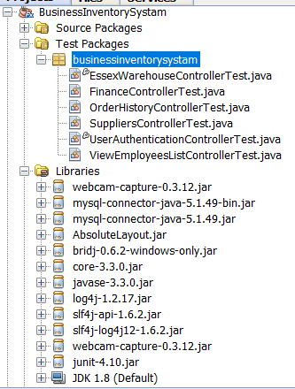

*Figure 17.1 – Junit testing environment setup*

A separate Test packages folder has been created where all the test classes are located. Inside the test classes are the test functions.

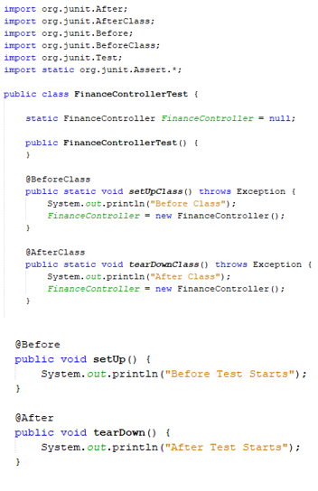

*Figure 17.2 Setup in before the test functions.*

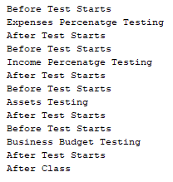

*Figure 17.3 Testing Class Console.*

Every test class for this project created has a before class and after class setup methods, which is also shown in figure 17.2. The before methods will be executed before the test begins, and the after methods will executed after the tests have been executed. It can witness all the tests which have ran in figure 17.3 orange figure.

### **Finance Controller Test Class.**

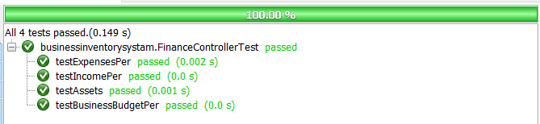

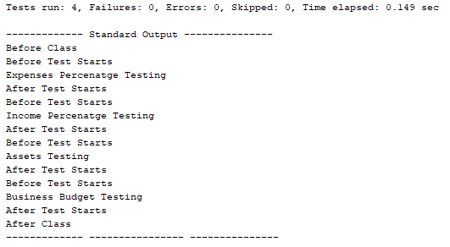

*Figure 17.4 - Finance Controller Test Results*

Figure 17.4 shows that all unit tests for the finance class have been passed.

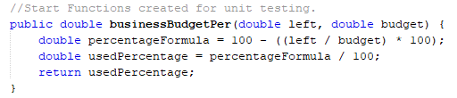

*Figure 17.4.1 - Business Budget Percentage Formula*

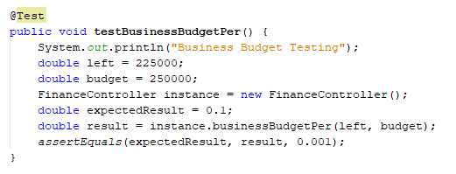

*Figure 17.4.2 - Testing Business Budget Percentage Formula*

Figure 17.4.2 is a method testing the expected result of the formula. An instance of the main finance controller class has been created. The function from figure 17.4.1 is called from the instance, and both values from the blue label have been passed into the parameters of the function. That function returns back with a result. An expected result has already been identified in the orange label. Using the asserts Equal the expected result is compared with the result from the formula, to see if they are equal or not. If they are, then the test will pass but, if not then, the test fails. Therefore, from figure 17.4 it can be seen the test has passed.

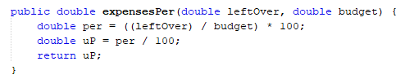

*Figure 17.4.3 – Expenses Percentage Formula*

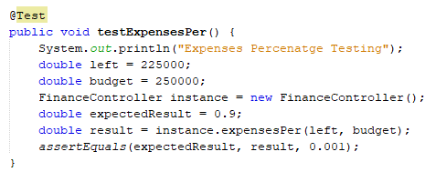

*Figure 17.4.4 – Expenses Percentage Testing Formula*

The testing function is the same as figure 17.4.2. This test also passes as it can be witnessed in figure 17.4.

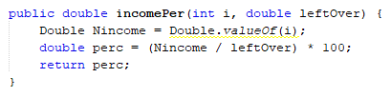

*Figure 17.4.5 – Income Percentage Formula*

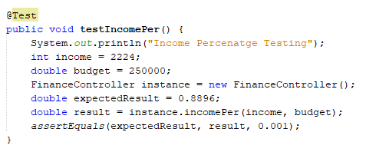

*Figure 17.4.6 – Income Percentage Testing Formula*

The testing function is the same as figure 17.4.2. This test also passes as it can be witnessed in figure 17.4.

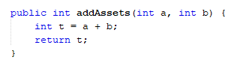

*Figure 17.4.7 – Add Assets Formula*

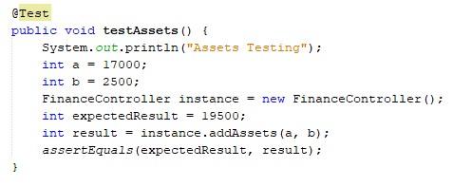

*Figure 17.4.8 – Testing Add Assets Formula*

The testing function is the same as figure 17.4.2. This test also passes as it can be witnessed in figure 17.4.

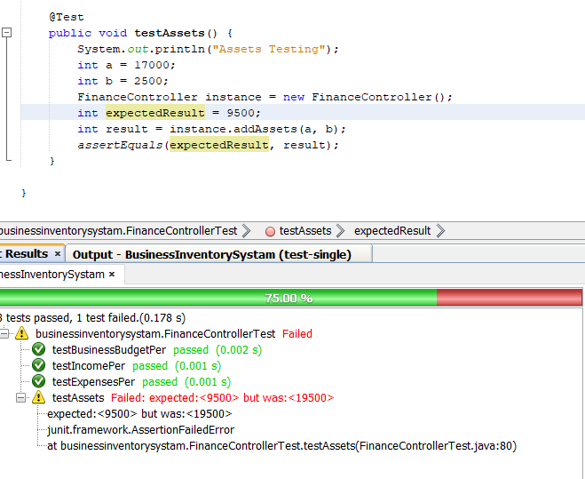

*Figure 17.4.9 – Solving Errors*

From figure 17.4.9 it can be witnessed that if there are any errors with the expected result such as values not matching then, it will show which test has failed. The error found on this project was the assets function where instead of a plus, the minus operator was used therefore, when the function was tested it didn’t meet the expected value therefore, the formula was revisited and the mistake was found therefore, it was corrected and retested after that, the test passed.

### **Order-History Controller Test Class.**

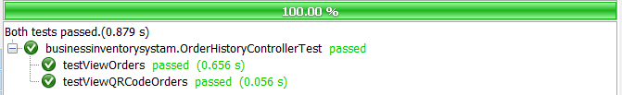



*Figure 17.10 - Order-History Controller Test Results*

Figure 17.10 shows that all unit tests for the finance class have been passed.

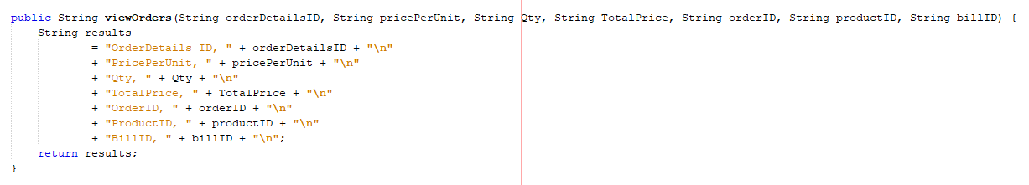

*Figure 17.4.11 – View Orders Formula*

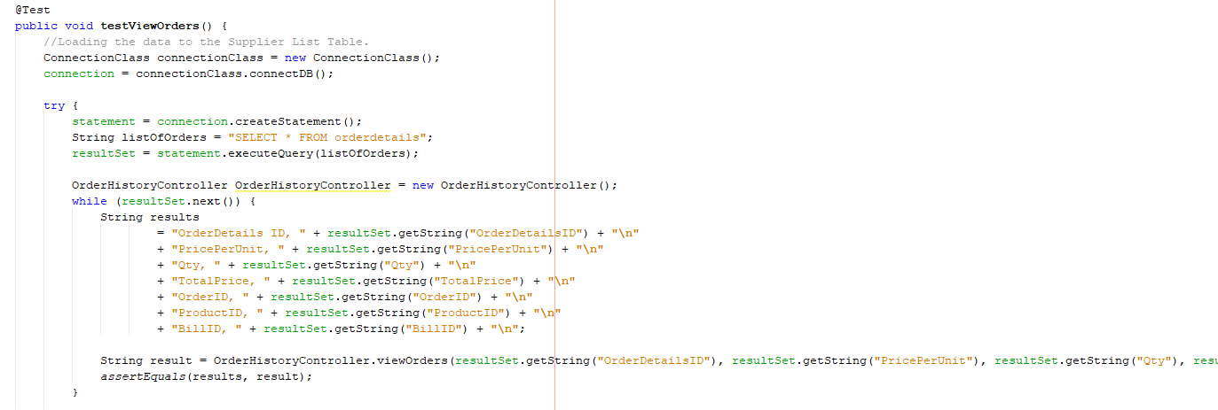

*Figure 17.4.12 – Testing View Orders Formula*

Figure 17.4.12 test function has been used for testing the order invoice data that’s being retrieved from the database onto the application. This function gets the data from the order history table using the SQL query after that, it uses the view orders function to retrieve the same data from the query. After that, the assert equals tests both data results to see if they match or not. After that, the test passes as it can be witnessed in figure 17.4.10.

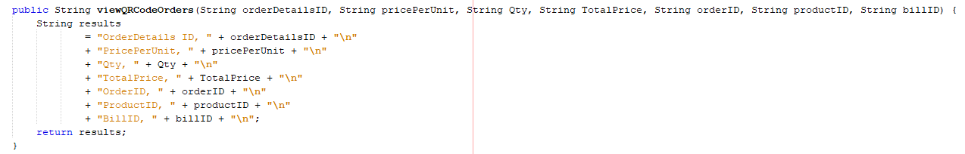

*Figure 17.4.13 – View QR Code Orders Formula*

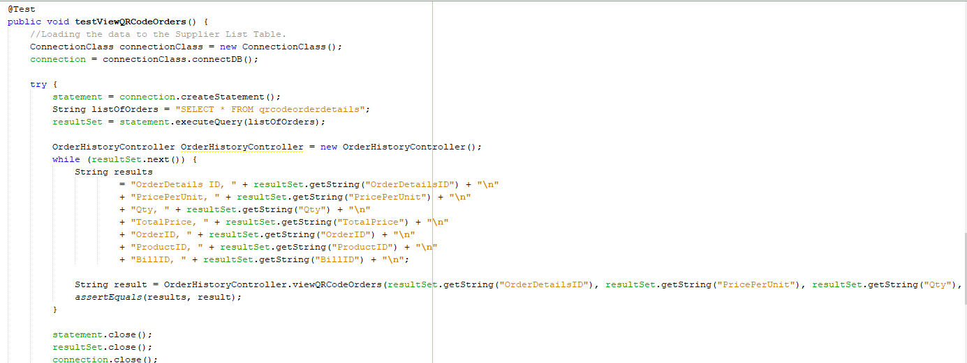

*Figure 17.4.14 – View QR Code Orders Test Formula*

The testing function uses the same approach as figure 17.4.13. This test also passes as it can be witnessed in figure 17.4.10.

### **Essex-Warehouse Controller Test Class.**

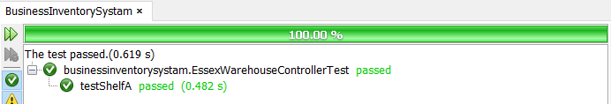



*Figure 17.4.15 – Essex-Warehouse Test Results*

Figure 17.4.15 shows that all unit tests for the finance class have been passed.

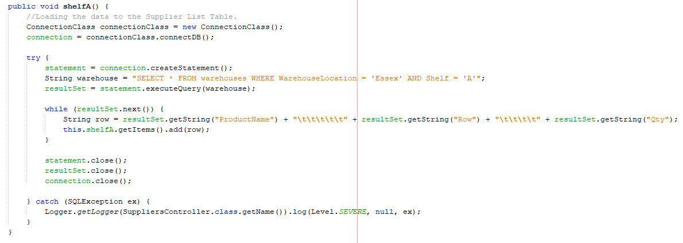

*Figure 17.4.16 – Shelf A Formula*

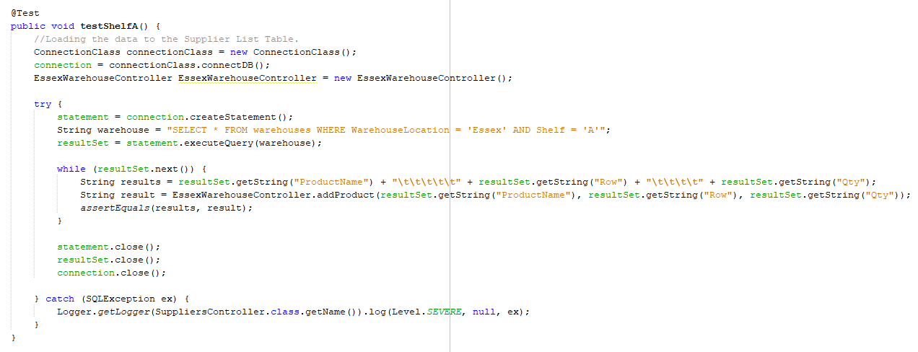

*Figure 17.4.17 – Shelf A Test Formula*

This test function is checking to see if the data coming from the query is from the Essex warehouse and shelf A. This test also passes as it can be witnessed in figure 17.4.15.

### **View-Employees Controller Test Class.**

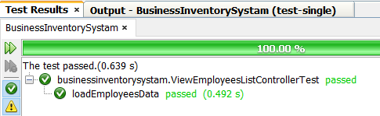



*Figure 17.4.18 – View-Employees Test Results.*

Figure 17.4.18 shows that all unit tests for the finance class have been passed.

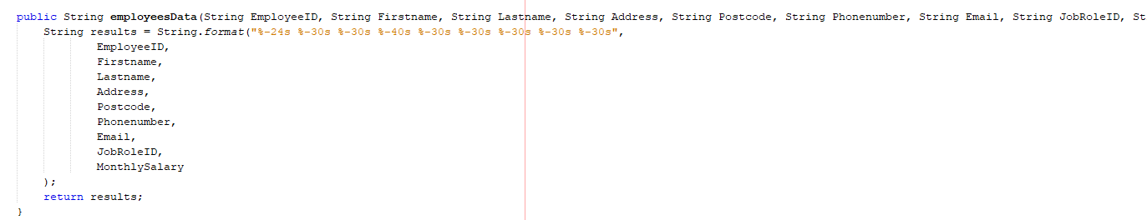

*Figure 17.4.19 – Employees Data Formula*

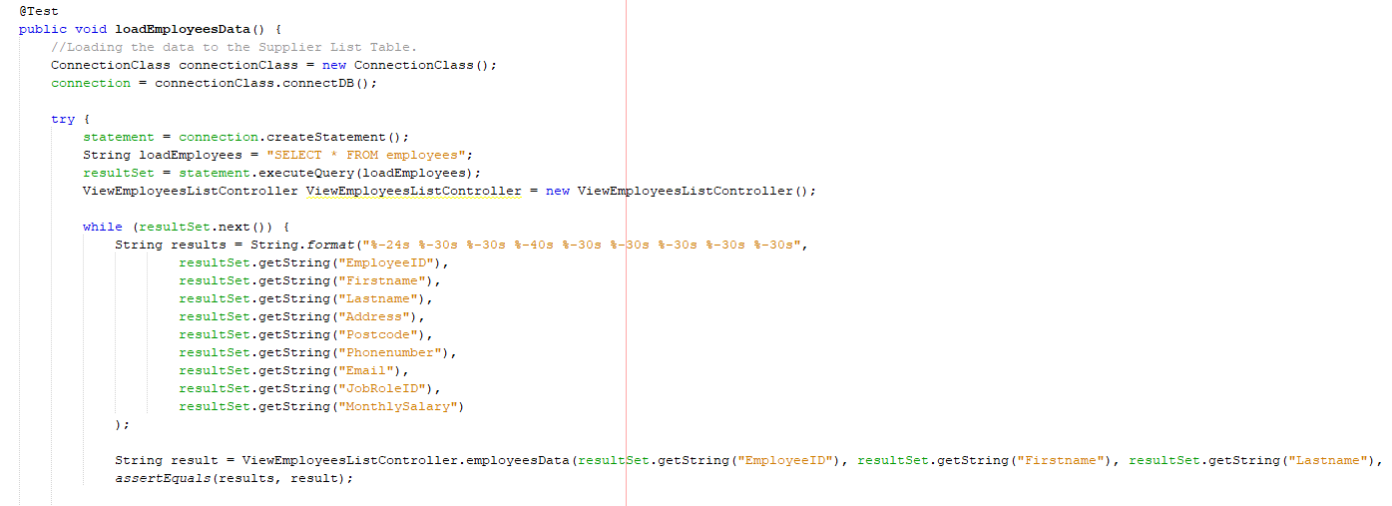

*Figure 17.4.20 – Employees Data Test Formula*

The testing function uses the same approach as figure 17.4.13. This test also passes as it can be witnessed in figure 17.4.18.

### **User-Authentication Controller Test Class.**

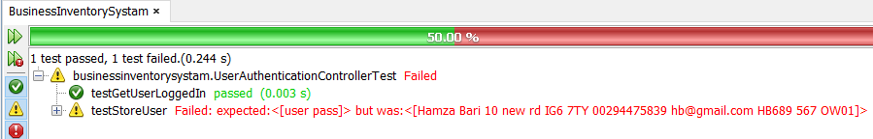



*Figure 17.4.21 – User-Authentication Test Results.*

Figure 17.4.18 shows that all unit tests for the finance class have been passed.

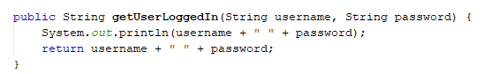

*Figure 17.4.22 – User-Login Method*

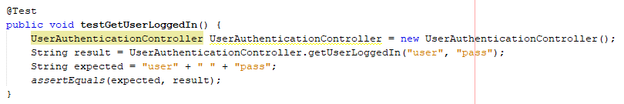

Figure 17.4.23 – User-Login Test Method

This test function compares if the string data from the text inputs such as username and password are the same as, the expected values. The text input data and expected data are compared using assert equals. After comparison, its seen that both string values are matching together therefore, this test has been passed which also can be witnessed in figure 17.4.21.



*Figure 17.4.24 – User-Registration Method*

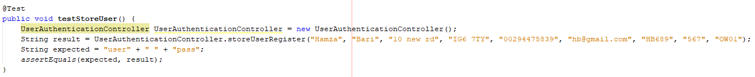

*Figure 17.4.25 – User-Registration Test Method*

This test function works the same way as, shown in figure 17.4.23. This time around the data from text input doesn’t match the expected value as, a result this test has failed which can be witnessed in figure 17.4.21. Therefore, this function needed a revisit for correction. The problem discovered later was, the data given to the expected result was invalid, which doesn’t match the store user register function.

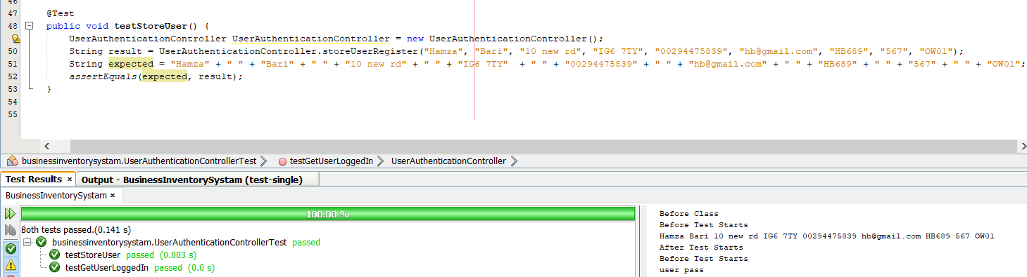

*Figure 17.4.26 – User-Registration Test Method Correction*

The valid data was given in the expected result therefore, this time around the test had passed.

### **Supplier Controller Test Class.**

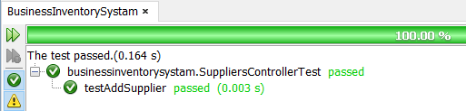



*Figure 17.4.27 – Suppliers Test Results*



*Figure 17.4.28 – Add-Supplier Method*

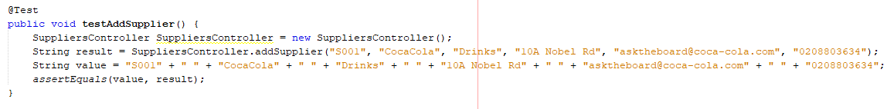

*Figure 17.4.29 – Add-Supplier Test Method*

This test function works the same way as, shown in figure 17.4.23. This test has been passed which is witnessed in figure 17.4.27.

## **Appendix 5 – User Testing Questionnaire & Results**

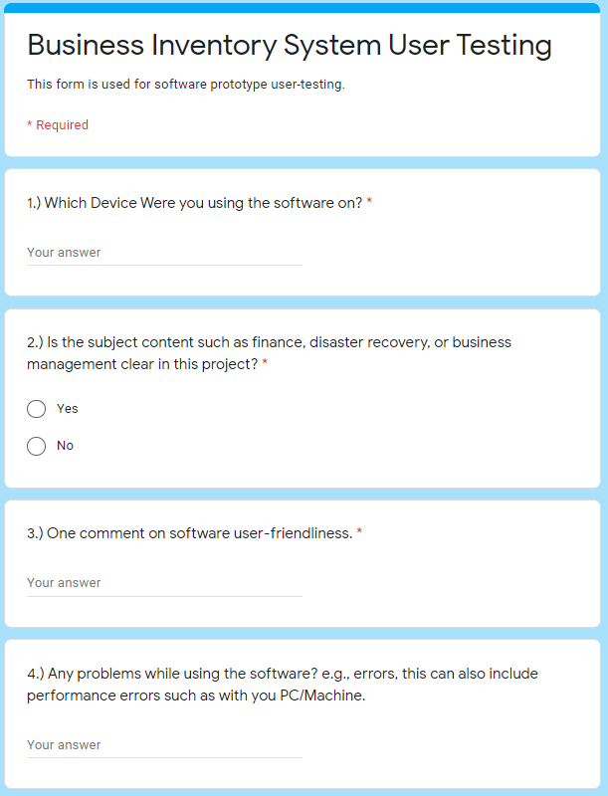

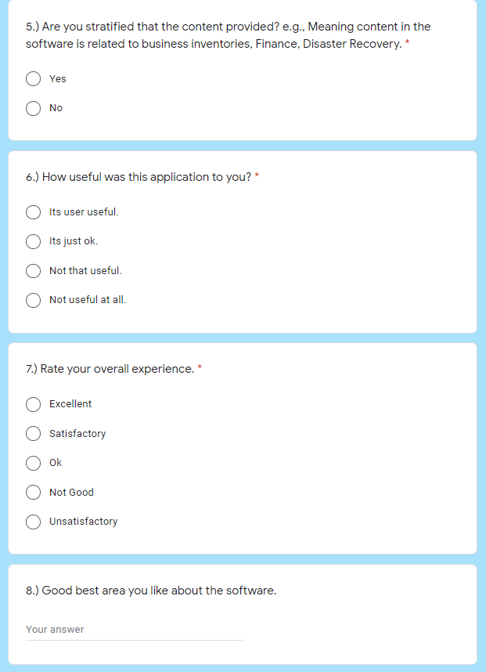

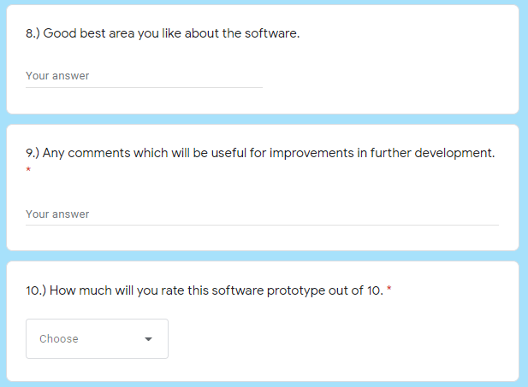

*Figure 19 – User Testing Questionnaire*

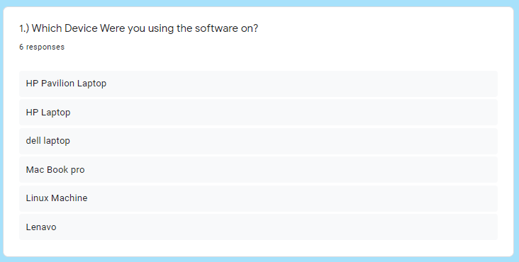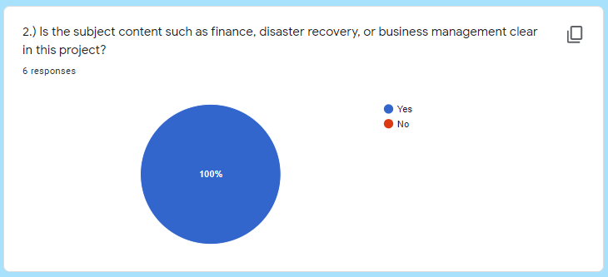

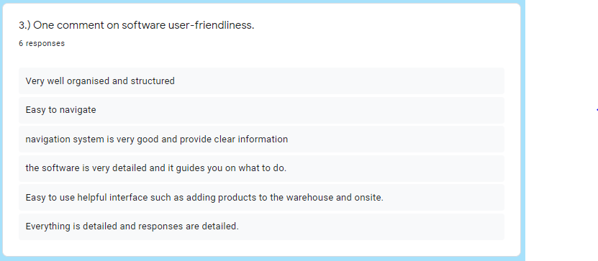

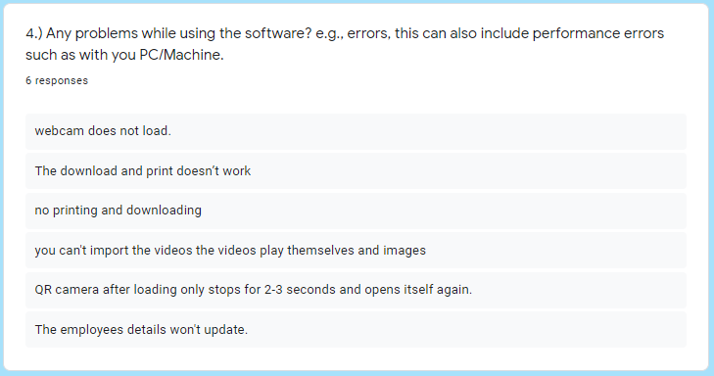

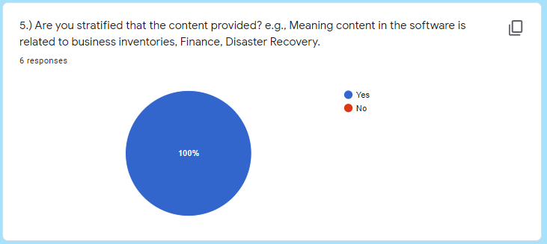

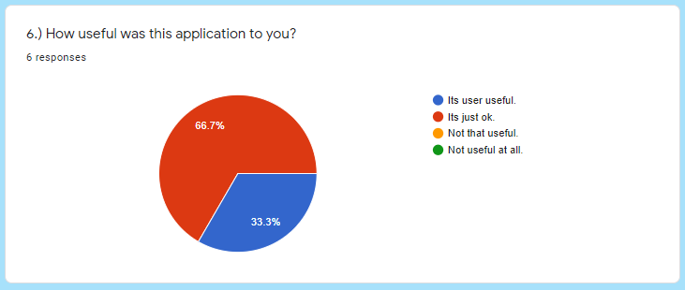

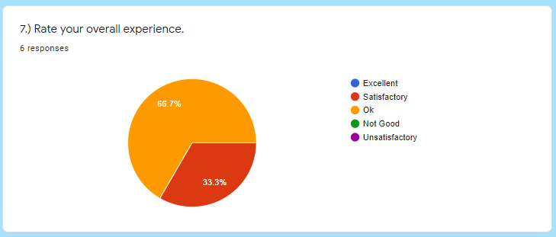

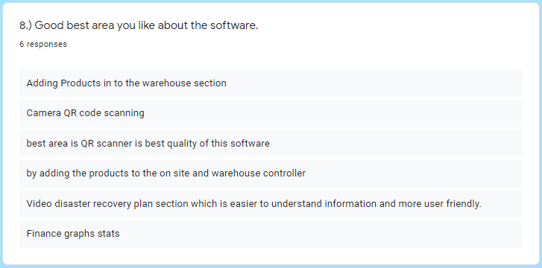

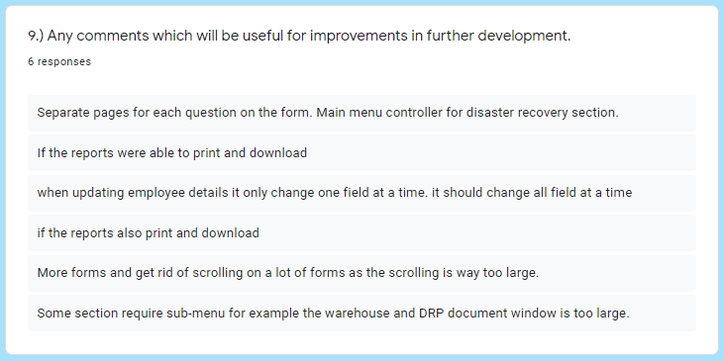

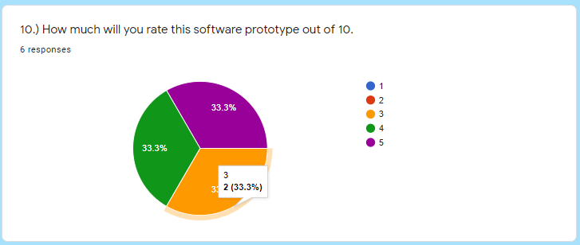

*Figure 20 – User Testing Questionnaire*

# ***References***

**[1]** Gough, O.G., (2017). UK independents still rely on pen and paper to manage their business. Available online: <https://smallbusiness.co.uk/independents-rely-paper-manage-business-2540481/>. Accessed: 15 Nov 2020.

**[2]** Thomas, T. UK independents still rely on pen and paper to manage their business. Available online: <https://www.inflowinventory.com/blog/still-keeping-spreadsheets-inventory-paper/>. Accessed: 15 Nov 2020.

**[3]** Moira, M.M., (2016). 11 Disadvantages of Using Excel To Manage Your Pricing. Available online: <https://blog.blackcurve.com/11-disadvantages-of-using-excel-to-manage-your-pricing> Accessed: 15 Nov 2020.

**[4]** Courtenay, C.S., (2020). The 14 Best Inventory Management Software for Small Businesses of 2020. Available online: <https://www.business.org/finance/inventory-management/best-inventory-management-software/>. Accessed: 16 Nov 2020.

**[5]** DISCOVER THE LEADING SAAS SOFTWARE COMPARISON SITE. Available online: <https://comparecamp.com/inflow-inventory-review-pricing-pros-cons-features/>. Accessed: 17 Nov 2020.

**[6]** (2018). Inventory Management Software | inFlow Inventory. Available online: <https://www.youtube.com/watch?v=x70A2JV1j64>. Accessed: 17 Nov 2020.

**[7]** inFlow Inventory Reviews. Available online: <https://www.getapp.com/operations-management-software/a/inflow-cloud/reviews/>. Accessed: 20 Nov 2020.

**[8]** Harinder, P.S., (2019). QuickBooks Software – What Does It Do? Available online: <https://www.cogneesol.com/blog/quickbooks-software-what-does-it-do>. Accessed: 20 Nov 2020.

**[9]** QuickBooks. Available online: <https://quickbooks.intuit.com/online/how-it-works/>. Accessed: 23 Nov 2020.

**[10]** inFlow Inventory vs QuickBooks Desktop Enterprise. Available online: <https://www.capterra.com/inventory-management-software/compare/174984-78431/QuickBooks-Enterprise-vs-inFlow-Inventory>. Accessed: 27 Nov 2020.

**[11]** Java Package. Available online: <https://www.javatpoint.com/package>. Accessed: 3 Dec 2020.

**[12]** 1.2.1 What is MySQL? Available online: <https://dev.mysql.com/doc/refman/5.7/en/what-is-mysql.html>. Accessed: 29 Dec 2020.

**[13]** Trust Radius. NetBeans Reviews. Available online: <https://www.trustradius.com/products/netbeans/reviews?qs=pros-and-cons>. Accessed: 3 April 2021.

**[14]** Class HybridBinarizer. Available online: <https://zxing.github.io/zxing/apidocs/com/google/zxing/common/HybridBinarizer.html>. Accessed: 3 April 2021.

***School of Science & Technology***

*"I hereby confirm that the work presented here in this report and in all other associated material is wholly my own work".*

**Signature:** HAMZA BARI

**Date:** 30th April 2021